RESEARCH ARTICLE

**DEVELOPMENT AND PERFORMANCE EVALUATION OF HAND OPERATED EGG SHELL BREAKER WITH EGG YOLK STRAINER**

|  |  |
| --- | --- |
|  | ABSTRACT The present work ~~article entitled “Development and performance evaluation of hand operated egg shell breaker with egg yolk strainer”~~ describes the development of an egg shell breaker device with egg yolk straining mechanism. To develop the egg shell breaking device, the important engineering properties of egg were calculated and used for the design calculations. This device reduces the risk of contamination of foods due to mixing of egg shell, during breaking of egg shell. The device cleanly makes the sharp cut in the egg shell, by which the egg liquid was separated from egg. Egg shell cut into two halves and was held by the device, egg liquid collected in the container.. This reduces the risk of contamination and collection ofegg liquid was an easy and hygienic one. The device was made of aluminium due to non-corrosive and rigidity properties. Egg yolk and egg white have separate uses in food industry, therefore, a strainer part included in the design When the egg content falls on the strainer, then due to space provided in the strainer, the egg white falls down and egg yellow remains above the strainer. The device is of high usage in home application and small business related to egg industry. The device has capacity of 30-40 eggs per hour with an efficiency of 90-95%. The cost of the device is ₹. 600.00.  **REVISED ABSTRACT**  The development of an egg shell breaker device with an egg yolk straining mechanism and its performance were presented in this paper. First, the breaking blades in the device makes a clean, sharp cut in the egg shell. Second, the device broke the egg shell into two halves, and the egg shells were retained by the device, allowing the egg liquid to reach the strainer by gravity. Third, the egg white falls through the strainer while the egg yellow remains above the strainer. Finally, the egg white liquid was collected in a container, and the yoke was collected in another. This operation reduces the possibility of contamination and the mixing of broken egg shell pieces in egg white liquid. The device has a wider range of applications in home applications and small egg industries. The device's operating capacity was 30-40 eggs per hour. The mechanical efficiency of the device was found to be between 90 and 95 percent. The device was made of aluminium metal. The main features of the developed device were lesser weight, non-corrosive and rigidity properties. The cost of the device was ₹. 600.00. |

Keywords: Egg shell breaker, contamination, Engineering properties of egg, and egg Strainer

## INTRODUCTION

Egg yolks and whole eggs contain significant amounts of proteins and choline, and are widely used for cooking purpose. Due to their biological material content, the United States Department of Agriculture (USDA) categorized eggs as Meat within the Food Guide Pyramid. In 2013, the overall world production of chicken eggs was 68.3 million tonnes (USDA, 2000). The largest four producers of the chicken eggs were China at 24.8 million, the United States at 5.6 million, India at 3.8 million, and Japan at 2.5 million (Ref.). A typical large egg factory ships a million dozen eggs per day (ref.). The avian eggshell structure is mainly consisting of shell and membrane and represents about 10% of the egg weight. The shell is a calcareous structure predominantly constituted of calcium carbonate (CaCO3) (95%) and an organic matrix composed of proteins, glycoprotein and proteoglycans (3.5%) (Tao et al., 2015) The chicken egg shell and membranes are inexpensive and abundant waste which gives interesting characteristics for many potential applications. The egg shell is formed mainly of calcium carbonate (CaCO3) and is used widely in an animal feed, lime substitute or a bio-fertilizer. More than that, the egg shell membranes have high content of bio-active components, as well as properties of moisture retention and biodegradability which have potential use for clinical, cosmetic, nutraceutical and nanotechnology applications (Ref).

Since, the egg is a poultry product, so it brings the disease with it. Generally, the egg shell is contaminated with faecal defect, harmful microorganisms, dust and dirt, which can cause harmful effect on health (Stadelman and William 1995). Majorly the egg shell particles (tiny size) enter the egg contents while breaking the shell. These minute particles contaminate the food and make it unsuitable for human health and also difficult while packaging the shell shows low resistance (Jacob et. Al., 2000). Egg is good source of protein, but due to unhygienic conditions at the food shops, it brings more harm than benefits. Separating egg liquid/mass from the shell is an inevitable process. Egg white is the clear liquid (also called the albumen or the glair/glaire) contained within an egg (Ref). Furthermore, egg white and yolk were separated and egg white was used for preparing different variety of foods (Ref) . This allows that one part of the egg to be used without the other part, or each part to be used in different ways. All methods for separating eggs make use of the same fact that the yolk can be holding itself while the white is runnier. Since the yolks of older eggs are more watery, this makes separation difficult. To reduce the contamination in food due to egg’s unhygienic shell mixture with food and to separate the egg yolk with egg white, an egg shell breaker with egg yolk separator was developed and tested its performance.

## MATERIAL AND METHODS

This section deals with the approach for development of hand operated egg shell breaker, materials and methodology adopted for developing the device and performance evaluation of manually operated egg shell breaker. The commercially available egg shell breaker are quite expensive. The hand operated egg shell breaker is easy to operate and can be utilized for small applications.

**2.1 Engineering properties of egg**

For design and development of any food processing machinery/device the knowledge of engineering properties of food materials plays an important role (Kabas et al., 2006). The following engineering properties of egg were considered for development of hand operated egg shell breaker with strainer.

**2.1.1. Shape index**

The shape index was calculated by the length and width of the egg dimensions. The egg length and width were measured using digital measuring Vernier calipers (mm), proposed (Anderson et al., 2004; Narushin et al., 2004).

Shape Index, SI=W**/**L×100 … (1)

L = length of the eggs (mm)

W = Width of the eggs (mm)

**2.1.2. Geometric mean diameter**

The geo-mean diameter was determined using the measured length and width of eggs, according to Mohsenin (1970). The geometric mean diameter was calculated as:

*Dg =*  …(2)   
Dg =Geometric mean diameter (mm)

L = length of the eggs (mm)

W = Width of the eggs (mm)

**2.1.3. Sphericity**

The sphericity of the egg was characterized according to the method of Baryeh and Mangope (2003) and Polat et al. (2007), by using the physical dimensions of length and width of the eggs as shown below;

Sphericity, S=Dg**/**L×100 … (3)

Dg = Geometric mean diameter (mm)

L= Length of the egg (mm)

**2.1.4. Surface area**

The method adopted by Baryeh and Mangope (2003) method was used to determine the surface area of the egg samples by firstly measuring the dimensions. The calculated geometric mean diameter was used to estimate the surface area of the samples.

S = π ${(D_{g})}^{2}$…(4)  
Dg = Geometric mean diameter (mm)

S= Surface area (mm2)

**2.1.5. Volume**

The volume of the egg was determined by using the method of Baryeh and Mangope (2003) by measuring the dimensions of length and width of the eggs. The volume of egg can be calculated as follows;

V=π**/**6LW² … (5)

L = Length of the eggs (mm)

W = Width of the eggs (mm)

**2.1.6. Weight**

The egg samples were selected randomly and the weight was recorded on electronic weighing balance (make, model and country details).

**2.1.7. Density**

The density of egg (g mm -3)was determined by using following equation..

d= w/V … (6)w = weight of eggs (g)

V = volume of eggs (mm3)

**2.1.8.** Breaking force of egg

The breaking force of egg was determined by using Texture Analyzer (Model TA HD Plus). The eggs were placed between the jaws and the breaking forces are drawn into graph. The force was measured in kg and time take was noted in seconds. (Anderson and Carter, 1976; Abdallah, et al., 1993; De Ketelaere et al., 2002)

**2.2**

Compression force for egg was determined using cylinder probe of 75 mm, 25 kg load cell. The texture analyzer (TA) (make, model and country details) settings are given in Table 1.

**Table 1: The TA settings for the compression force required to egg is as follows**

|  |  |  |  |
| --- | --- | --- | --- |
| **Sl. No.** | **Caption** | **Value** | **Units** |
| 1 | Test mode | Compression |  |
| 2 | Pre-test speed | 1.00 | mm/s |
| 3 | Test speed | 2.00 | mm/s |
| 4 | Post-test speed | 10.00 | mm/s |
| 5 | Target mode | distance |  |
| 6 | Distance | 5.000 | mm |
| 7 | Trigger type | Auto (force) |  |
| 8 | Trigger force | 0.005 | kg |
| 9 | Advanced options | off |  |

**2.3 Components of manually operated egg shell breaker**

* **Main angle frame:** It is in rectangular shape was fabricated using aluminium angle for supporting the components.
* **Handle:**  Itwas made of the angled aluminium piece. At the lower end of handle, a follower was joined by the nut and bolts. At the upper end one eggshell breaking blade was welded. (Blaza, et al., 2018 and Callister, 2007).
* **Holding mechanism:** It was used to hold egg firmly during operation.
* **Cutting blade:** The cutting blades were in triangular section and made up of mild steel. The two cutting blades were movable and fitted to the splitting portion with spring arrangement for splitting the eggshell. The blades were sharpened at the edges, hence it penetrates into the egg and split the eggshell at equal halves, respectively.
* **Splitting mechanism:** The egg from outer side was getting cut by the blades when it was operated by lifter. For shelling, the eggshell was splitted by blades. Splitting mechanism was also operated by the lifter. The two movable blades were hinged and connected to vertical to the lifter and these closed blades penetrates into egg shell. After penetration, movable blades split egg shell by moving outward.
* **Yolk strainer:** This yolk strainer was made up of mild steel and which was screwed down side of the device to separate the egg yolk from the egg white.
* **Accessories:** The were spring, screws, and nuts and bolts were used to assemble/attach the various parts in the device. These were used to complete the alignment of the device.

The various parts of the device are shown in the Fig.1 (a) handle, (b) H-bar, (c) cutting blade, (d) V-bar, (e) S-bar), the complete designed device is shown in Fig. 2 and 3 and the dimensions of the device are shown in Table 2.

|  |  |  |  |  |  |
| --- | --- | --- | --- | --- | --- |
| C:\Users\Kavan Kumar\Pictures\Screenshots\Screenshot (87).png  **(a) Handle** | **C:\Users\Kavan Kumar\Pictures\Screenshots\Screenshot (83).png**  **(b) H-bar** | | | **C:\Users\Kavan Kumar\Pictures\Screenshots\Screenshot (86).png**  **(c) Cutting blade** | |
| **C:\Users\Kavan Kumar\Pictures\Screenshots\Screenshot (85).png**  **(d) V-bar** | | | **C:\Users\Kavan Kumar\Pictures\Screenshots\Screenshot (84).png**  **(e) S-bar** | | |
| **Fig. 1 Different parts of the egg shell breaker** | | | | | |
| **D:\PROJECT\FV123.jpg** | | C:\Users\Kavan Kumar\AppData\Local\Microsoft\Windows\INetCache\Content.Word\IMG-20190318-WA0008.jpg | | |
| **Fig. 2 Egg shell breaker** | | **Fig. 3 Egg shell breaker with yolk strainer** | | |

**Table 2: Dimensions of the device**

|  |  |
| --- | --- |
| **Parameters** | **Dimensions (mm)** |
| **Tool** | |
| Length | 195 |
| Width | 100 |
| Height | 40 |
| **Blade** | |
| Length | 17.8 |
| Width | 10 |
| Hole diameter | 5 |
| **H-bar** | |
| Length | 120 |
| Width | 10 |
| Hole diameter | 4 |
| **s-bar** | |
| Length | 60 |
| Width | 10 |
| Hole diameter | 4 |
| **V-bar** | |
| Length | 60 |
| Width | 10 |
| Hole diameter | 4 |

**Details on performance testing of machine was missing**

## RESULTS AND DISCUSSION

The engineering properties like shape index, geometric mean diameter, sphericity, surface area, weight, volume, density, force, duration and time were measured during the work are shown in the below Table 3 and Table 4.

**Table 3:** **Engineering properties of indigenous egg**

|  |  |  |  |  |  |  |
| --- | --- | --- | --- | --- | --- | --- |
| **Sl. No.** | **Properties** | **Indigenous egg** | | | | **Average** |
| 1 | Shape index | 62.83 | 67.22 | 66.89 | 64.82 | 65.44 |
| 2 | Geometric mean diameter (mm) | 37.36 | 37.02 | 36.74 | 36.04 | 38.35 |
| 3 | Sphericity | 73.35 | 76.79 | 76.49 | 74.97 | 75.40 |
| 4 | Surface area (mm²) | 4382.71 | 4303.30 | 4238.45 | 4078.48 | 4250.73 |
| 5 | Weight (g) | 42.5 | 38.5 | 38.5 | 38.6 | 39.52 |
| 6 | Volume (mm3) | 27.31 | 26.58 | 25.97 | 24.43 | 26.07 |
| 7 | Density (g/mm3) | 1.55 | 1.45 | 1.48 | 1.57 | 1.5125 |
| 8 | Force (g) | 3720.2 | 4721.3 | 5935.6 | 3928.4 | 4576.37 |
| 9 | Duration (s) | 44.65 | 38.07 | 38.05 | 38.22 | 39.74 |
| 10 | Time (s) | 5.62 | 6.64 | 6.59 | 6.42 | 6.31 |

**Table 4: Engineering properties of broiler egg**

|  |  |  |  |  |  |  |
| --- | --- | --- | --- | --- | --- | --- |
| **Sl. No** | **Properties** | **Broiler egg** | | | | **Average** |
| 1 | Shape index | 61.29 | 64.85 | 65.27 | 65.44 | 64.21 |
| 2 | Geometric mean diameter (mm) | 42.71 | 43.44 | 42.56 | 43.02 | 42.93 |
| 3 | Sphericity | 72.19 | 74.95 | 75.25 | 75.42 | 74.45 |
| 4 | Surface area (mm²) | 5727.81 | 5925.28 | 5687.65 | 5811.26 | 5788.0 |
| 5 | Weight (g) | 63.5 | 62.0 | 59.0 | 59.8 | 61.07 |
| 6 | Volume (mm³) | 40.72 | 44.39 | 40.18 | 41.61 | 41.72 |
| 7 | Density (g/mm³) | 1.585 | 1.396 | 1.366 | 1.439 | 1.44 |
| 8 | Force (g) | 2585.7 | 2861.2 | 2327.6 | 2585.7 | 2590.05 |
| 9 | Duration (s) | 44.46 | 44.04 | 43.32 | 44.46 | 44.07 |
| 10 | Time (s) | 2.193 | 1.910 | 2.32 | 2.327 | 2.17 |

A texture analyzer was used to record the load response of food materials to the mechanical conditions imposed. To develop an egg shell breaker, compression load (force) plays an important role; hence this force was measured for the eggs by using texture analyzer (Fig. 5) (De Ketelaere et al., 2002; Mamman et al., 2005). The egg compression force results for indigenous and broiler eggs are shown in (Fig. 6 and 7).the peak in the graph represents the force required to break the eggshell and it is depends on the thickness of the eggshell.

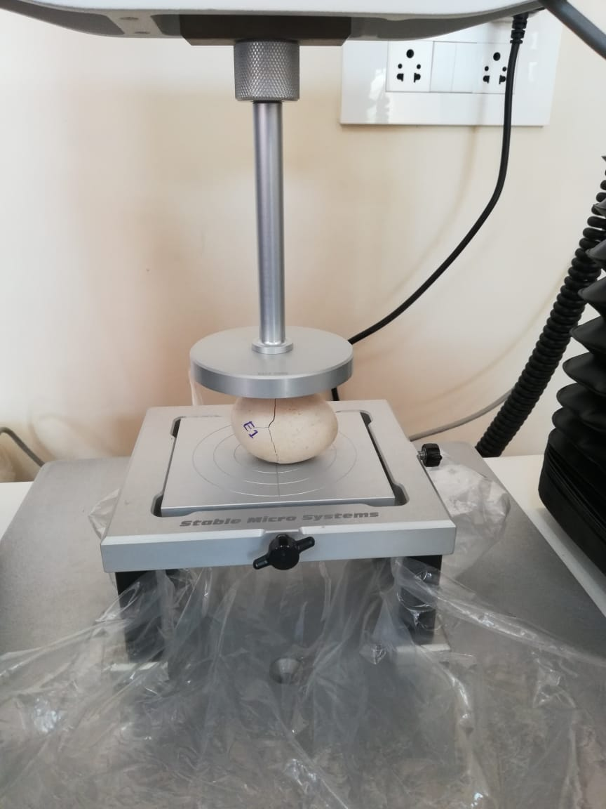

**Fig. 5 Egg compression in texture analyzer**

|  |  |
| --- | --- |
|  |  |
| **Egg 1** | **Egg 2** |
|  |  |
| **Egg 3** | **Egg 4** |
| **Fig.6 Texture profile of indigenous eggs** | |
| |  |  | | --- | --- | |  |  | | **Egg 1** | **Egg 2** | |  |  | | **Egg 3** | **Egg 4** |   **Fig. 7 Texture profile of broiler eggs** | |

A newly developed egg shell breaker was hand operated device for breaking egg, it was held horizontally in the holding bowl. By hand, the handle with blade was operated and the blades penetrated in the egg while moving horizontal at the same time splitting action was done. The splitting mechanism split the eggshell on outside the egg. Then the de shelled egg was unloaded from the device and eggshells were removed by hand. They are shown in the (Fig. 8, Fig. 9 and Fig.10). Finally, the performance of the eggshell breaker was done for broiler eggs in Table 5.

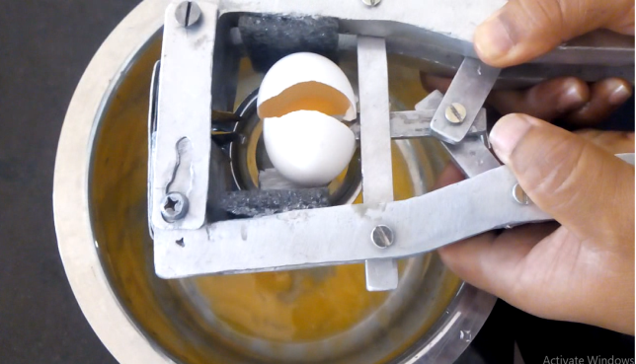 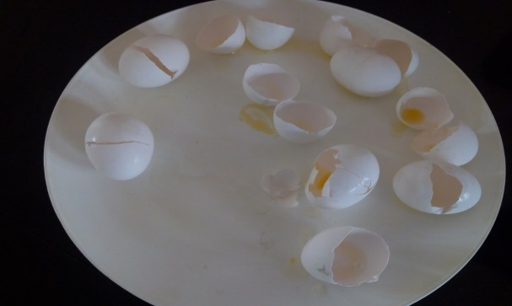

**Fig. 8 Egg shell breaking Fig. 9 egg shells split into two halves by tool**

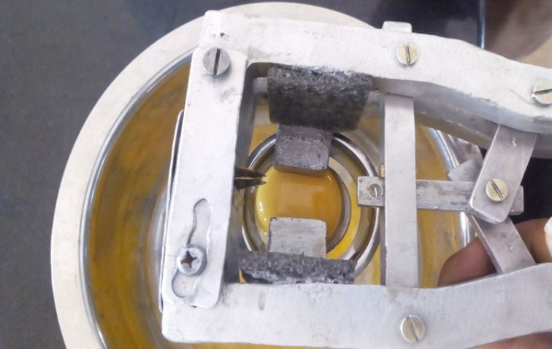

**Fig. 10 Egg yellow strained by strainer**

**Table 5: Performance evaluation of the device**

|  |  |  |
| --- | --- | --- |
| **Sl. No.** | **Parameters** | **Results** |
| 1 | Number of eggs taken | 10 |
| 2 | Number of eggs break evenly | 8 |
| 3 | Number of eggs break unevenly | 2 |
| 4 | Time taken to break one egg | 20-30 (s) |
| 5 | Capacity of device | 30-40 (eggs/h) |
| 6 | Mechanical damage of eggs by device | 5-10% |
| 7 | Mechanical efficiency | 90-95% |

**CONCLUSION**

The egg white is more uses in the food industries and separation of egg white and yolk is challenging task.. . The essential engineering properties of egg were studied and developed a hand operated egg shell breaker with egg yolk separator for easy separation of egg white from egg mass. luminum was used to fabricate the unit due to less weight, rust free, non corrosive and easy to carry the device. This device helps to avoid the fecal matter entering into the edible part and separation of yolk and albumen can be done at cheap cost. This device is simple in use. The cost of the device was ₹.600=00, and its operational capacity was 30-40 eggs/h and 90-95% efficiency and 5-10% mechanical damage. Compare to the commercially available eggshell breakers, this device can be operated easily and no skills required. The cost may be reduced by mass production of devices. The same concept can be used to break two eggs or more at the same time by combining additional number of devices.

## REFERENCES

|  |
| --- |
|  |

Abdallah, A. G., Harms, R. H., and El- Husseiny, O. (1993). Various methods of measuring shell quality in relation to percentage of cracked eggs. *Poultry Science*, **72(11):** 2038–2043.

Anderson G. B. and Carter T. C. (1976) The hen's egg: Shell cracking at impact on a heavy, stiff body and factors that affect it, *British Poultry Science*, **17(6):**613-626.

Anderson, K. E., Tharrington, J. B., Curtis, P. A., and Jones, F. T. (2004). Shell characteristics of eggs from historic strains of single comb white leghorn chickens and relationship of egg shape to shell strength. *International Journal of Poultry Science*. **3(1)**:465-468.

Baryeh, E. A., and Mangope, B. K. (2003), Egg physical characteristics and the measurement of length and breadth.[*Journal of Food Engineering*](https://www.researchgate.net/journal/0260-8774_Journal_of_Food_Engineering)**104 (1):** 28–36.

Blaza Stojanovic, Мilan Bukvic and Igor Epler (2018). Application of aluminum and aluminum alloys in engineering. *Journal of Engineering and Applied Sciences* **3(2):**52-62.

Callister, W. D. (2007) Materials science and engineering: An Introduction. New York: *John Wiley & Sons.*

De Ketelaere, B., Govaerts, T., Couke, P., Dewil, E., Visseher, T., and Decuypere, L., (2002). Measuring the eggshell strength of 6 different strains of laying hens: Techniques and comparison. *British Poultry Science,* **43(2):**238–244.

Jacob, J. P., Milles, R. D., and Mather, F. B. (2000). Egg quality. University of Florida Extension, *Institute of Food and Agricultural Science*, p. 11.

Kabas, O., Ozmerzi, A., and Akinci, I. (2006). Physical properties of cactuspear (Opuntia ﬁcus India L.) grown wild in Turkey. *Journal of Food Engineering,* **73(2)**:198–202.

Mamman, E., Umar, B., Aviara, N. (2005). Effect of moisture content and loading orientation on the mechanical properties of Balanites Aegyptiaca nuts. Agricultural Engineering International. *The CIGRE Journal, Vol. VII.* **Manuscript FP 04 015**. December 2005.

Mohsenin, N.N. (1970) Physical Properties of Plant and Animal Materials. *Gordon and Breach Science Publishers, New York.* **ISBN-13: 978-0677023007**

Narushin, V. G., Van Kepmen, T. A., Wineland, M. T., and Christensen, V. L. (2004). Comparing infrared spectroscopy and egg size measurements for predicting egg shell quality. *Biosystems Engineering*, **87(3):**367–373.

Polat, R., Cetin, M., and Atay, U., (2007) Mechanical behaviour under compression loading and some physical parameters of Japanese quail eggs. *Czech Journal of Animal Science.* **52(2):**50-56.

Stadelman and William (1995). Egg Science and Technology. *Haworth Press.* [**ISBN**](https://en.wikipedia.org/wiki/International_Standard_Book_Number)[**978-1-56022-854-7**](https://en.wikipedia.org/wiki/Special:BookSources/978-1-56022-854-7)pp. 221–223.

Tao Yang, Yan Li, Meihu Ma, Qinlu Lin, Shuguo Sun, Bin Zhang, Xi Feng and Junwen Liu (2015). Protective effect of soluble egg shell membrane protein hydrolysate on cardiac ischemia/reperfusion injury. *Food and Nutrition Research.* **59(1):**28870.

USDA (2000). Egg grading manual USDA AA grade. Washington: *The US Department of Agriculture (USDA).*