RESEARCH ARTICLE
Extraction Of Oil From Chrysalis Of Mulberry And Eri Silkworm Pupae And Analyzing The Physico-Chemical Properties

ABSTRACT
Oil was extracted from chrysalis of mulberry and eri silkworm pupae by column extraction and soxhlet method. Using different solvents and solvent, hexane was found to be significantly better. Among the two methods, the maximum oil recovery (g/100 g) was obtained in column extraction method (25.90, 24.01) compared to soxhlet extraction (24.57, 21.55) from both mulberry and eri silkworm pupae respectively using hexane as solvent. When comparing the oil yield from mulberry and eri silkworm pupae in column extraction method higher amount of oil was recovered from mulberry silkworm pupae than eri silkworm pupae. Studies on physico-chemical properties revealed that the density (0.943), specific gravity (0.991), saponification value (235.147), iodine value (131.653) and free fatty acids (5.057) were found to be higher in eri silkworm pupal oil. Mulberry silkworm pupal oil had higher values for acid number (1.966) and peroxide value (2.424). There is larger scope for exploration of silkworm pupal oil for nutraceutical, cosmetics and biodiesel production.

Keywords: Silkworm chrysalis, oil extraction, physico-chemical properties, edible oil, cosmetics.

INTRODUCTION
Insects played a crucial role as a source of edible by-products in the history of human nutrition in developing countries. Consumption of insects has been documented in Japan, Thailand, Africa, Latin America, Australia, Mexico and other parts of the world where they represent a cheaper source of good quality protein and fat (Deori et al., 2014). Pupae of sericigenous insects viz., mulberry silkworm, Bombyx mori and eri silkworm, Samia ricini are valued as food material in north eastern parts of India, apart from exploitation for silk. The pupae remaining after reeling the silk from cocoon, goes as waste and often discarded in the open environment or used for fertilizers (Wei et al., 2009). Sing and Suryanarayna (2003) reported that silkworm pupae is rich in protein and fat content and is a delicacy among tribal populations. Silkworm chrysalis constitutes 60 per cent of dry cocoon weight and in a year 23,334 tonnes of dry spent silkworm chrysalis is available in the country (Udayasekhara, 1994). Winitchai et al. (2011) reported that silkworm pupal (chrysalis) oil contains various essential fatty acids with good bioactivity and thus can be used for alternative raw material for food and cosmetic industries.
However, owing to the operational complexity and high cost of the apparatus, supercritical fluid extraction is limited in practice (Chen et al., 2016). Searching for an efficient technique with low cost is vitally important for the extensive utilization of spent silkworm pupae and hence in the present study, attempts were made for value addition of both mulberry and eri silkworm pupae by extraction of oil and studying the physico-chemical properties.

MATERIAL AND METHODS
Collection of silkworm pupae
Spent mulberry silkworm pupae were collected from multiend silk reeling unit, Vadavalli, Coimbatore district and silver mine silk processors Udumalapet, Tirupur district, Tamil Nadu. Eri silkworm pupae were procured from Central Sericultural Germplasm Resource Center, Hosur, Tamil Nadu.
The collected fresh spent silkworm pupae were subjected for drying process in hot air oven at 70-80°C for every 2 hours until 72-75 per cent loss in weight was achieved.
Extraction of oil from silkworm pupae
The dried pupae were ground to powder and oil extraction was done using solvents, viz., acetone, chloroform, xylene, hexane and petroleum ether through soxhlet extraction method (Thirupathaiah et al., 2016).
Soxhlet extraction: The cellulose thimbles were loaded with dried silkworm pupal powder and kept into the main chamber of soxhlet extractor and refluxed for 8 hours at 65-70°C. The above mentioned solvents were used for oil extraction and the oil was separated from solvent using rotary vacuum evaporator.
Column extraction method: 100 gram of dried silkworm pupal powder was filled in 500 mL column and 300 mL of solvent was added. To prevent the solvent evaporation, the column was covered with lid and kept undisturbed at room temperature for seven days. After seven days, the contents were filtered with cellulose thimble and oil separated from solvent by rotary vacuum evaporator.
Estimation of physicochemical properties
The specific gravity was examined at 25 °C using specific gravity bottle. Acid value, peroxide value and iodine value of the extracted oil were examined by American Oil Chemists’ Society standard methods Cd 3d–63, Cd 8–53 and Cd 1–25, respectively (AOCS, 1997). Solubility test, colour, moisture content, free fatty acids and saponification value were determined by AOCS method (2003). Density was examined by ASTM - D4052 method.

RESULTS
Effect of drying time of silkworm pupae
The effect of drying time at the temperature of 70 – 80°C was determined by drying the pupae for every two hours until constant weight was obtained and results obtained are presented in Figure 1. Reduction of moisture content gradually at every 2 hours was observed. After 8 hours, moisture content of mulberry and eri silkworm pupae completely reduced to 98.76 and 96.78 per cent respectively. Gradual reduction in weight of silkworm pupae were observed from 2 hours to 8 hours. The results showed that 8 hours of drying time is necessary to reduce the moisture content of silkworm pupae for oil extraction.
Standardization of solvent and method of extraction for oil recovery from mulberry silkworm pupae
Amount of oil recovered from mulberry silkworm pupae by soxhlet and column extraction method using different solvents is listed in Figure 2. There was significant variation in oil recovery from soxhlet and column extraction methods. Among different solvents, significantly higher amount of oil (24.57, 25.90 g/100g) was recovered from mulberry silkworm pupae by soxhlet and column extraction methods respectively using hexane as solvent which was found to be statistically superior over all other solvents. In respect to different extraction method, significantly more amount of pupal oil (g/100g) was recovered from the column extraction method using hexane solvent (25.90) followed by acetone (22.02), xylene (20.90) and chloroform (20.05). Least amount (14.98) of oil was recovered in petroleum ether solvent. Similar observations were found in soxhlet extraction method from mulberry silkworm pupae. Comparison of two extraction methods using different solvents, the maximum oil yield was recovered from the column extraction method using hexane solvent than soxhlet extraction method.
Standardization of solvent and method of extraction for oil recovery from eri silkworm pupae
Standardization of solvent and method of extraction for oil recovery from eri silkworm pupae was presented in Figure 3. There was significant variation observed in oil yield from eri silkworm pupae with soxhlet and column extraction method. The maximum amount of oil (g/100g) was recorded from solvent hexane (24.01) followed by acetone (21.14), xylene (19.20), chloroform (18.08) and petroleum ether (11.68) in column extraction method. In case of soxhlet extraction, hexane yielded (21.55) grams of oil followed by acetone (14.83), xylene (10.78), chloroform (9.80) and least amount of oil (6.94) was recorded from petroleum ether solvent.
Among the two methods, column extraction method yielded higher amount of oil when compared to soxhlet extraction method. The best solvent for oil extraction was found to be hexane. Oil extracted using hexane as solvent showed clear and pleasant odour when compared to other solvents.
Comparison of oil recovery from mulberry and eri silkworm pupae by column extraction method
Oil recovery from mulberry and eri silkworm pupae were compared and presented in Figure 4. Oil recovery from mulberry and eri silkworm pupae by column extraction method showed the significant difference. The maximum oil yield (g/100g) was recovered from mulberry silkworm pupae using hexane (25.90), acetone (22.02), xylene (20.97), chloroform (20.05) and petroleum ether (14.98) compared to eri silkworm pupae oil using hexane (24.01), acetone (21.14), xylene (19.20), chloroform (18.08) and petroleum ether (11.68).
Physio - chemical properties
The estimated physico-chemical properties of mulberry and eri silkworm pupal oils were presented in Table 1. There was significant variation in the physico-chemical properties of mulberry and eri silkworm pupal oils. Physico-chemical properties viz., density (0.880, 0.943), specific gravity (0.892, 0.991), saponification value (187.784, 235.147), iodine value (104.651, 131.653), acid number (1.966, 1.990), peroxide value (2.424, 2.229) and free fatty acids (3.913, 5.057) was observed in the mulberry and eri silkworm pupal oils. Whereas, moisture content of mulberry silkworm pupal oil was 0.100 per cent which was found to be on par with eri (0.090) silkworm pupal oil.
Some of the physico-chemical properties such as density, specific gravity, saponification value, iodine value and free fatty acids were found to be higher in eri silkworm pupal oil (0.943, 0.991, 235.147, 131.653 and 5.057) than mulberry silkworm pupal oil. Significantly higher acid number (1.966) and peroxide value (2.424) were noted in mulberry silkworm pupal oil when compare to eri silkworm pupal oil (1.190, 2.229).
Discussion
Oil recovery from chrysalis of mulberry and eri silkworm pupae
In the present study, maximum oil recovery (g/100g) was obtained from mulberry and eri silkworm pupae respectively in column extaction method (25.90, 24.01) than soxhlet extraction method (24.57, 21.55) using hexane as solvent. Present result corroborates with Thirupathaiah et al. (2016) who reported that column extraction method yielded higher oil content from mulberry silkworm pupae than soxhlet extraction method. Supanida et al. (2008) reported oil content varying from 24-29 per cent in five native varieties of B.mori. recovery from silkworm pupae were also reported by Ravinder et al. (2015). There is larger scope for utilization of silkworm pupal oil in industries such as pharmaceutical, human nutrition, cosmetic and biodiesel production.
Standardization of solvents for oil recovery
In the present investigation, hexane was identified as the best solvent for extraction of oil from both mulberry and eri silkworm pupae.
Physico-chemical properties
Physico-chemical properties of mulberry and eri silkworm pupal oil showed significant difference in density, specific gravity, saponification value, iodine value. Free fatty acids were found to be higher in eri silkworm pupal oil compared to mulberry silkworm pupal oil whereas, mulberry silkworm pupal oil had higher values for acid number and peroxide value. Sarma and Ganguly (2016) reported the physico-chemical properties viz., specific gravity, moisture content, acid value, saponification value and iodine value for muga silkworm pupal oil.
Hu et al. (2017) analyzed physico-chemical properties of mulberry silkworm pupal oil and recorded lower acid value and peroxide value and can be regarded as good quality oil. Similar results of reduced acid value (1.190, 1.966) and peroxide values (2.229, 2.424) were also reported in the present study for mulberry and eri silkworm pupal oil. Hence, can be considered as a good quality oil. In the present study, both the silkworm pupal oils had lowest acid and peroxide values of less than three.
Significantly, both the oils had good amount of saturated fatty acids (5.057 %, 3.913 %) in the form of oleic acid. Results from the present study fall in line with the results of Azlan et al. (2010).

CONCLUSION
The present study concluded that eight hours drying period at a temperature of 70-80°C is required to reduce the weight of pupae to 70-75 per cent. Oil extracted from mulberry and eri silkworm pupae using column and soxhlet extraction method showed higher oil recovery from column extraction method compared to soxhlet extraction method by using hexane as solvent. Among the solvents used for extraction of oil from both mulberry and eri silkworm pupae hexane was found to be best. Significant change in physico-chemical properties were observed between mulberry and eri silkworm pupal oil. Physico-chemical properties of oil exhibited significant difference between mulberry and eri silkworm pupae with optimum ranges. Based on these results, both mulberry and eri silkworm pupal oil could be used as a potential edible oil and for development of by-products.

REFERENCES
American oil chemists society. 1997. Official methods and recommended practices of the American oil chemists society. (5th ed.). Champaign.
AOCS. D. Firestone. 2003. Official methods and recommended practices, 5th ed. AOCS Press, Champaign, Methods, Ca 5a-40; Ca 2c-25; Cd 1–25; Cd 8-53; Ca 6a-40; Cd 3-25; Cc 17-95; Cc 13e-92; Cc 7-25.
ASTM. D4052, Standard test method for determination of Density, according to American Society for Testing and Materials International, West Conshohocken.
Azlan, A., Prasad, K. N., Khoo, H. E., Abdul-Aziz, N., Mohamad, A., Ismail, A. and Amom, Z. 2010. Comparison of fatty acids,vitamin E and physicochemical properties of Canarium odontophyllum Miq. (dabai), olive and palm oils. J Food Compost Anal., 23: 772–776.
Chen, F. L., Du, X., Zu, Y. G., Yang, L. and Wang, F. 2016. Microwave-assisted method for distillation and dual extraction in obtaining essential oil, proanthocyanidins and polysaccharides by one-pot process from Cinnamomi Cortex. Sep. Purif. Technol., 164: 1–11.
Hu, B., Li, C., Zhang, Z., zhao, Q., Zhu, Y., Su, Z. and Chen, Y. 2017. Microwave-assisted extraction of silkworm pupal oil and evaluation of its fatty acid composition, physicochemical properties and antioxidant activities, Food Chem., 1-28.
Manoj Sarma and Mausumi Ganguly. 2016. Production of high quality biodiesel from desilked muga pupae (Antheraea assamensis). RJCES., 4 (4): 40- 45.
Meetali Deori, Dipali Devi and Rajalakshmi Devi. 2014. Nutrient composition and antioxidant activities of muga and eri silkworm pupae. IJSN., 5(4): 636-640.
Singh, K. C. and Suryanarayna, N. 2003. Eri pupae: A popular cuisine too. Indian Silk., 41: 57-58.
Supanida, W., Aranya, M. and Jiradej, M. 2008. Effect of native Thai silk varieties (Bombyx mori L.) and extraction method on chemical compositions of silkworm oil for food and cosmetics applications. Kasetsart University Annual Conference, Bangkok (Thailand).
Thirupathaiah, Y., Sivaprasad, V., Bhuvaneshwari, E., Munirathnam Reddy, M., Vineet kumar, Chandrashakhraiah, M. 2016. Extraction and characterization of mulberry silkworm, Bombyx mori L., pupae oil. Indian J. Seric., 55 (1): 31-37.
Thumu Ravinder, Shiva Shanker Kaki, Sanjit Kanjilal, Bhamidipati Venkata Surya Koppeswara Rao, Sarat Kumar Swain and Rachapudi Badari Narayana Prasad. 2015. Refining of castor and tapioca leaf fed eri silkworm oils. Int. J. Chem. Sci. Technol., 5(2): 32-37.
Udayasekhara, P. R. 1994. Chemical composition and nutritional evaluation of spent silk worm pupae. J Agr Food Chem., 42: 2201–2203.
Wei, Z.J., Liao, A.M., Zhang, H.X., Liu, J. and Jiang, S.T. 2009. Optimization of supercritical carbon dioxide extraction of silkworm pupal oil applying the response surface methodology. Bioresour Technol., 100: 4214-4219.
Winitchai S., Manosroi, J., Masahiko, A.B.E., Boonpisuttinant, K and Manosroi, A. 2011. Free radical scavenging activity, tyrosinase inhibition activity and fatty acids compositions of oils from pupae of Native Thai Silkworm (Bombyx mori L.). Kasetsart J (Nat Sci)., 45: 404-412.
Table
Table 1. Physio - chemical properties of mulberry and eri silkworm pupal oil
S. No | Properties | Mulberry silkworm pupal oil | Eri silkworm pupal oil
1. | Density (g/ml) | 0.880 ^{B}  ± 0.01 | 0.943 ^{A}  ± 0.01
2. | Specific gravity (g/ml) | 0.892 ^{B}  ± 0.01 | 0.991 ^{A}  ± 0.01
3. | Moisture content (%) | 0.100 ^{A}  ± 0.00 | 0.090 ^{A}  ± 0.00
4. | Saponification value (g KOH/g oil) | 187.784 ^{B}  ± 1.08 | 235.147 ^{A}  ± 0.38
5. | Iodine value (g I/100 g) | 104.651 ^{B}  ± 0.49 | 131.653 ^{A}  ± 1.87
6. | Acid number (mg KOH/g oil) | 1.966 ^{A}  ± 0.00 | - ^{B}  ± 0.10
7. | Peroxide value (ppm) | 2.424 ^{A}  ± 0.07 | 2.229 ^{B}  ± 0.01
8. | Free fatty acid (%) | 3.913 ^{B}  ± 0.08 | 5.057 ^{A}  ± 0.03

The values are expressed in mean ± sd with three replications (n=3) followed by analyzes with two tailed paired t – test at p≤0.05 level of significance.

Figures
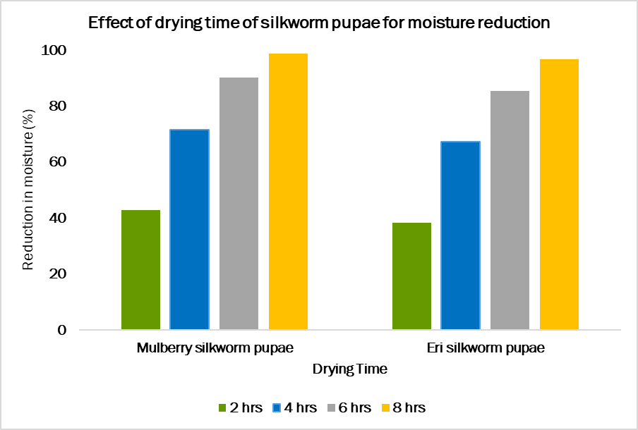
Figure 1. Effect of drying time of silkworm pupae for moisture reduction

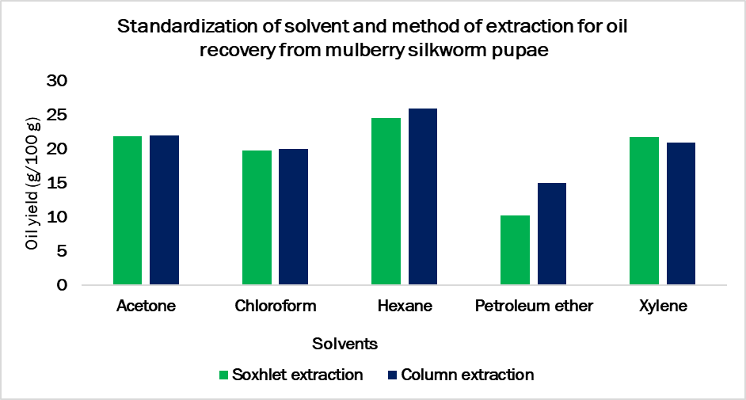
Figure 2. Standardization of solvent and method of extraction for oil recovery from mulberry silkworm pupae
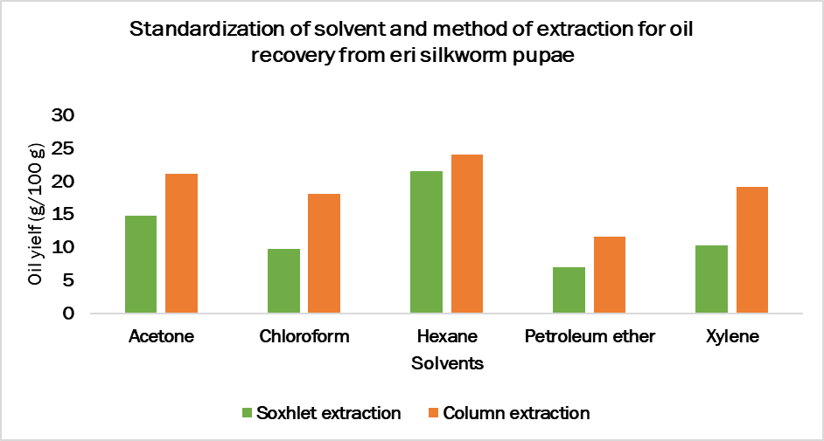
Figure 3. Standardization of solvent and method of extraction for oil recovery from eri silkworm pupae

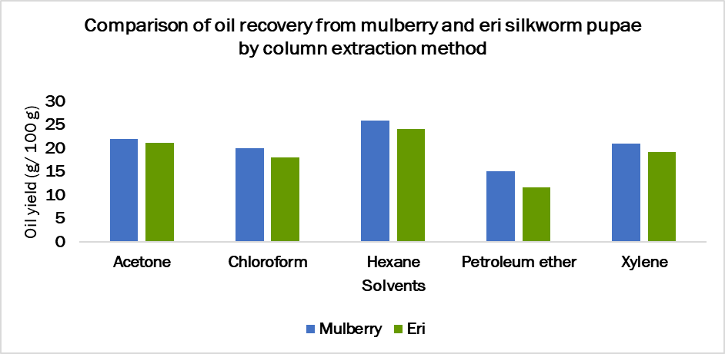
Figure 4. Comparison of oil recovery from mulberry and eri silkworm pupae by column extraction method

