RESEARCH ARTICLE
Influence of bioregulators on latex yield and proteolytic activity of papain extracted from field-grown TNAU Papaya CO. 8 under the natural incidence of Papaya Ring Spot Virus

ABSTRACT
The cultivation of papaya for both fruits or commercial papain extraction drastically suffers often due to devastating incidence of papaya ringspot virus disease. To find out whether the papain yield and quality are influenced when bioregulators are applied to manage PRSV incidence or as a measure to limit the height of the crop, the present study was undertaken in TNAU Papaya CO.8 variety grown in the open field with the natural incidence of PRSV. Three growth retardants [250 ppm of prohexadione calcium (G₂), 500 ppm of mepiquat chloride (G₃) and 500 ppm of chlormequat chloride (G₄)] and three stress tolerance promoting bioregulators [100 ppm of methyl jasmonate (S₂), 100 ppm of salicylic acid (S₃) and 0.6 g/ l of strobilurins (S₄)] were employed in the study. Water spray (G₁ and S₁) was kept as control.The treatments were imposed at 4th and 8th months after planting. The growth retardants were initially sprayed and subsequently, a week after the stress tolerance promoting bioregulators were sprayed as per the doses.Among the combinations tried, spraying of 250 ppm of prohexadione calcium followed by water spray (G₂S₁) a week later recorded the lowest plant height (140.79 cm) at the time of fruiting. The treatment combination G₂S₂ involving 250 ppm of prohexadione calcium and 100 ppm of methyl jasmonate registered higher number of fruits (42.17). The combination of 250 ppm of prohexadione calcium along with 100 ppm of salicylic acid (G₂S₃) was found to be the most effective to manage PRSV without compromising papain production and to enhance the proteolytic activity significantly (44378.36 TU g⁻¹) as compared to others combinations. The treatment combination of 500 ppm of mepiquat chloride and 100 ppm of salicylic acid (G₃S₃) favored higher dry latex yield apart from a significant reduction in PRSV symptoms. Both these treatment combinations (G₂S₃ and G₃S₃) merit due consideration in PRSV management for commercial fruit and papain production in papaya.

Keywords: papaya, bioregulators, prohexodione calcium, mepiquat chloride, salicylic acid, methyl jasmonate, papain, latex yield, proteolytic activity

INTRODUCTION
Papaya, commercially grown for its nutritious fruits and besides, it is an excellent source of a proteolytic enzyme ‘papain’ present in the latex of unripe fruits. The latex contains a mix of proteolytic enzymes including papain, chymopapain A and B, endopeptidase papain III, endopeptidase papain IV and endopeptidase papain omega (Azarkan et al., 2003). Papain is a single-chain non-glycosylated polypeptide of 212 amino acids (23, 429 Da) containing three disulfide bonds (Mamboya, 2012). Papain is used for many pharmaceutical, food and beverage, meat, dairy, textile, photographic, optical, tanning, cosmetic, detergent and leather industries and there is a growing demand for the papain (Shouket et al., 2020).
Papaya crop is often devastated by the disease caused by Papaya Ring Spot Virus (PRSV), in most of the countries where it is commercially grown. In India also, PRSV disease significantly affects fruit and papain production leading to huge economic losses (Mishra et al., 2019). The symptoms of PRSV include distortion of young leaves, development of a shoestring appearance, stunted plant and ring spots on the surface of the fruit (Gonsalves et al., 2010).The crop loss due to PRSV can be to the extent of 70 to 95 % (Singh and Shukla, 2009). Since there is no genetic resistance to PRSVpresently available in commercial papaya varieties grown in India, the management of PRSV through the use of bioregulators is a possible alternative option as the growth regulators can modulate the physiology of the crop to overcome the cellular stress caused by PRSV. When plants are tall, the access to fruits for papain extraction is often difficult and growth retardants may be helpful in limiting the crop height. Growth manipulation to reduce height and to overcome stresses caused by invasive pathogens have been earlier attempted in many crops (Abdi et al., 2016; Mouca et al., 2013; Le Roux and Barry, 2010) but such studies are lacking in papaya. The present study was therefore taken up to find out whether the papain yield and quality are compromised when growth retardant bioregulators when used in combination to manage plant height and to promote physiological tolerance to PRSV.

MATERIAL AND METHODS

The trial was carried out at the University orchard, Horticultural College and Research Institute, Tamil Nadu Agricultural University, Coimbatore, Tamil Nadu. Among the papaya varieties released from Tamil Nadu Agricultural University, the variety TNAU Papaya CO. 8 was used in this study, as it is gaining importance among the growers. It is a dioecious variety with red pulp and having a high yield potential of 200 – 220 t/ ha. This variety is recommended for both table purpose and industrially valued papain.

Treatment details

For the study, three growth retardants as one factor and three stress regulating bioregulators as another factor was employed. The growth retardants used for the study were 250 ppm of prohexadione calcium (G2), 500 ppm of mepiquat chloride (G3) and 500 ppm of chlormequat chloride (G4) and the three stress tolerance promoting bioregulators viz., 100 ppm of methyl jasmonate (S2), 100 ppm of salicylic acid (S3) and 0.6 g/ l of strobilurins (S4). In both the factors, water spray (G1 and S1) was kept as control. The bioregulator treatments were applied as foliar spray at fourth and eighth month after transplanting as per the treatment details. Initially growth retardants were sprayed as per the treatment details and one week after the application stress tolerance promoting bioregulators were sprayed along with water spray as control for both the factors.
Papain extraction
The papaya latex (crude papain) was extracted from each treatments of papaya variety TNAU papaya CO.8 at 3-4 days intervals commencing from 70 days to 90 days after fruit set. The collection of latex was done between 6.30 and8.30 am. The latex was collected in polythene covers to quantify the wet latex yield.To the fresh latex, potassium metabisulphiteat the concentration of 0.5% was added to avoid the loss of enzyme activity and kept for drying in shade. After drying, the crude papain was weighed as dry latex and stored in freezer at -20 °C.

Observations recorded

Plant height (cm)

The height of the plant was measured 15 cm from ground level to the terminal of the crown at the time of fruiting and expressed in centimetres.

First bearing height (cm)

The height of the plant from the 15 cm level to the height at which first mature fruit appeared was measured as first bearing height and expressed in centimetres.

Number of fruits / tree

The total number of fruits set on the plant was counted when first harvest commenced and expressed in numbers.

Fruit length (cm)

The length of the fruit was measured from the stylar end to pedicel end of the fruit along the curve by using a measuring tape and expressed in centimetres.

Fruit circumference (cm)

The circumference of the fruit was measured at midpoint of the length along the curve by using a thread and expressed in centimetres.

PRSV incidence

Papaya Ring Spot Virus (PRSV) disease incidence was recorded using the following score chart (Table 1) having six delineating scores (Dhanam, 2006).

Table 1. Symptoms and score chart of PRSV
S. No | Description of the symptoms | Score
1. | No symptoms | 0
2. | Mild mosaic (or) oily spots, streaks on petiole (or) stem, oily spots on fruits | 1
3. | Mild mosaic and oily streaks/ spots on petiole/ stem and ring spots on fruits | 3
4. | Oily spots/ streaks on petiole (or) stem (or) ring spots on fruits | 5
5. | Oily spots/streaks on petioles, stem or on fruits (ring spots), severe mosaic or blistening on leaves and leaf deformation + severe leaf reduction / mild fruit deformation with ring spots | 7
6. | Oily spots/ streaks on petiole or stem and shoe string formation or severe fruit development with ring spots and stunted plants | 9

The disease severity was calculated by using the following formula:

PRSV (per cent) = (Total score of all plants / Total number of plants) x (100/ max score)

Wet latex yield (g)

The fresh latex collected from each fruit was weighed using weighing balance and expressed in grams.

Dry latex yield (g)

The wet latex was then allowed to dry in partial shade for 7-8 hrs. The dried latex (crude papain) was then collected, weighed and expressed in grams.

Papain enzyme activity (TU mg⁻¹)

The papain activity was assayed by using the method described by Weisslerand Garza (1965). In this method, casein was used as substrate and the amount oftyrosine released from a standard casein solution was measured and reported astyrosine units per gram of papain.

Statistical analysis

The experiment was laid out in Factorial Randomized Block Design (FRBD) with four treatments in each of the two factors (16 treatment combinations + one absolute control) and replicated thrice. The mean effects were compared after subjecting the data collected by Factorial ANOVA test with SPSS 16.0 software and critical differences were worked out at five percent probability level.

RESULTS AND DISCUSSION
Influence of bioregulators on plant height (cm) and first bearing height (cm) of TNAU Papaya CO.8
Lower plant height is advantageous for many cultural operations including spraying of micronutrients, plant protection chemicals, harvesting and for papain extraction. Significant differences were observed in plant height and as well for first bearing height due to the main effects of growth retardant treatments but not for main effects of stress tolerance promoting bioregulators. But the interaction effects were significant. When the main effects of growth retardants are considered, 250 ppm of prohexadione calcium (G₂ – 147.54 cm) and 500 ppm of chlormequat chloride (G₄ – 147.05 cm) recorded the lowest plant height. Mepiquat chloride (G₃) also resulted in restricting plant height (152.32 cm) as compared to control (G₁-173.35 cm) (Figure 1). Among the combinations, spraying of 250 ppm of prohexadione calcium followed by water spray (G₂S₁) recorded the lowest plant height (140.79 cm) at the time of fruiting (Table 4). Higher plant heights were observed with spraying of stress tolerance promoting bioregulators alone without growth retardants (G₁S₁ – 171.25 cm, G₁S₂ – 174.37 cm, G₁S₃ – 175.48 cm and G₁S₄ – 172.30 cm respectively).
Similar to plant height, first fruiting height or bearing height is an important trait in papaya cultivation as it directly corresponds to early harvest of fruits and economic life of plantation. When the main effects of growth retardants are considered, 250 ppm of prohexadione calcium (G₂ – 69.44 cm) and 500 ppm of chlormequat chloride (G₄ – 69.49 cm) recorded lower fruiting heights (Figure 1). When both the factors are combined, 500 ppm of chlormequat chloride along with 100 ppm of salicylic acid (G₄S₃ – 68.17 cm) and 250 ppm of prohexadione calcium followed by water spray (G₂S₁ – 68.43 cm) recorded significantly lower fruiting heights as compared to the higher bearing height (102.71 cm) of absolute control (Table 2).
The reason for height reduction in the treatment involving G₂ can be attributed to the action of prohexadione calcium, a gibberellin biosynthesis inhibitor that acts as a co-substrate for catalyzing hydroxylations involved in the late stages of GA biosynthesis. This retardant has been reported to mainly target an enzyme 3b-hydroxylase, which helps in the conversion of inactive GA₂₀/GA₉ into highly active GA₁/GA₄, leading to reduced plant height and shoot length (Kim et al., 2019). It was reported that chlormequat chloride used in G₄ is also an anti-gibberellin limiting stem elongation and causing height reduction (Rademacher, 2000). Although mepiquat chloride is an onium type compound similar to chlormequat chloride, it did not reduce the height as effectively as the other two retardants.
Influence of bioregulators on number of fruits of TNAU Papaya CO.8
When the main effect of bioregulatorsare considered, significantly more number of fruits were observed in G₂ (38.88) among growth retardants and with strobilurins (S₄- 37.84) among the stress tolerance promoting bioregulators (Figure 1 and 2). Increased number of fruits is generally observed in the plants, when treated with salicylic acid along with growth retardants. Significantly higher number of fruits were recorded in the treatment combinations involving 250 ppm of prohexadione calcium and 100 ppm of methyl jasmonate (G₂S₂-42.17), 500 ppm of mepiquat chloridewith 100 ppm of salicylic acid (G₃S₃ - 42.01) and 250 ppm of prohexadione calcium with 100 ppm of salicylic acid (G₂S₃ - 41.13) (Table 2) as compared to control.
The reason for increase in number of fruits in strobilurins treated plants can be attributed to possible improvement of cytokinin activity leading to improved synthesis of photosynthetic pigments and promoting source to sink mobilization (Fletcher et al., 2000).The increase in number of fruits in plants treated with salicylic acid could be due to the modulation of physiological attributes leading to reduced PRSV disease expression during the fruit developmental phase. A similar finding of an increased number of fruits and yield in papaya cv. Red Lady was reported with the application of salicylic acid (150 ppm) at 45 and 120 days after transplantingand this was attributed to increased chlorophyll accumulation, carbonic anhydrase and rubisco activity which in turn accelerated the translocation of assimilates to developing fruits (Devarakonda et al., 2020).Favorable effects of foliar application of salicylic acid in other fruit crops also reported previously lends support to the present observation (Gioushy (2016);Faissal et al., 2014; Ngullie et al., 2014; Kassem et al., 2011and Bindhyachalet al., 2016).
Influence of bioregulators on fruit length and circumference (cm) of TNAU Papaya CO.8
Fruit length and fruit circumference are important parameters as they have a positive association with papain yield by offering more surface area for the extraction of latex (Seemanthini, 1967). In the present study, the combination of 500 ppm of chlormequat chloride with 100 ppm of salicylic acid (G₄S₃) resulted in higher fruit length (29.40 cm) and circumference (46.05 cm) (Table 2) when compared to other treatments. In all the combinations with chlormequat chloride, the fruits were relatively longer in the present study. This could be due to enhanced availability of more assimilates to developing fruits as the vegetative growth becomes limitedby chlormequat chloride. Besides, the reduction in PRSV symptom expression promoted by stress regulators could have also helped in the better mobilization of available photosynthetic assimilates for fruit development. The main effects of stress regulating growth regulators were not significant on fruit circumference
Influence of bioregulators on PRSV incidence
The PRSV incidence at 7th month has a direct bearing on the crop load and yield as the fruit development is rapid at 7th and 9thmonth. In the present study, the PRSV disease severity ranged from 33.33 per cent (G₂S₃) to 77.77 per cent (G₁S₁ and Absolute control mean) at seventh month after transplanting (Table 2). When the main effects are considered, among the growth retardants, 250 ppm of prohexadione calcium (G₂ – 51.85 per cent) andsalicylic acid at 100ppm level among the stress tolerance promoting bioregulators (S₃ – 44.44 per cent) resulted in significantly lower PRSV disease incidences (Figure 3). Among the treatment combinations, the lowest disease incidence was recorded in the combination of 250 ppm of prohexadione calcium with 100 ppm of salicylic acid (G₂S₃– 33.33 per cent)while the incidence was significantly in water sprayed plants (G₁S₁ – 77.77 per cent). The reduced disease expression of PRSV in prohexadione calcium treated plants could be attributed to the content of calcium, which is known to provide integrity to cell walls and membranes and thus possibly delaying early degeneration during the pathogen infection. It has been reported that exogenous calcium supply improved the plant’s resistance including virus infection (Eraslan et al., 2007 and Thor, 2019). In general, in the plants sprayed with salicylic acid also the PRSV incidence was lower as compared to the other treatments. Salicylic acid has been known to induce resistance to viruses and inhibit the development of viral diseases in plants (Naylor et al., 1998). In an earlier study, Guan (2007) reported improved resistance to PRSV by salicylic acid application. As PRSV drastically reduces fruit production and also markedly reduces papain production (Khurana, 1970 and Singh et al., 2005), spraying with 100 ppm of salicylic acid could be recommended for the management of the disease either for fruit production and papain extraction in combination with prohexadione calcium.
Influence of bioregulators on wet latex yield of TNAU Papaya CO.8
When the main effects are considered, among the growth retardants, significantly higher wet latex yield were recorded by 250 ppm of prohexadione calcium (G₂ – 26.40 g fruit⁻¹) and 500 ppm of mepiquat chloride (G₃ – 26.29 g fruit⁻¹). Similarly, 100 ppm of salicylic acid (S₃ – 32.60 g fruit⁻¹) treated plants registered higher wet latex yield among the stress tolerance promoting bioregulators (Figure 5a). Among the combinations, the highest wet latex yield was recorded in plantssprayed first with water spray and a week later with100 ppm of salicylic acid (G₁S₃ – 42.08 g fruit⁻¹) indicating the beneficial effect of salicylic acid. It was followed by the combinations 250 ppm of prohexadione calcium in combination with either 100 ppm of salicylic acid (G₂S₃ – 33.45 g fruit⁻¹) or just water spray (G₂S₁ - 33.14 g fruit⁻¹) (Table 3).
As similar to wet latex yield per fruit, the combination of 250 ppm of prohexadione calcium along with 100 ppm of salicylic acid (G₂S₃-1376.07 g tree⁻¹) recorded the highest wet latex yield per tree. The combination of 100 ppm of methyl jasmonate with 500 ppm of mepiquat chloride resulted in a moderately higher quantity of wet latex yield (G₃S₂- 905.62 g tree⁻¹ and G₃S₄- 977.24 g tree⁻¹) but when methyl jasmonate was combined with water spray (G₁S₂) latex yield was lower than control, indicating methyl jasmonate may be detrimental for papain production. Although methyl jasmonate is known for imparting defense mechanisms against many biological stresses in plants (Ahmad et al., 2016), its utility in papaya for managing PRSV should be weighed carefully as the papain yield gets reduced.
The possible higher and improved availability of calcium contributed by prohexadione calcium could be also influential in higher papain latex yield as calcium is responsible for cell wall integrity and protecting the lactiferous cells and channels from disintegration due to PRSV. In the combinations involving salicylic acid also generally a higher amount of wet latex were observed in the present study. Besides the induced resistance, the phenolic nature of salicylic acid may promote the expression of cysteine protease gene which is responsible for the production of papain (Kovacs et al., 2016).
Influence of bioregulators on dry latex yield of TNAU Papaya CO.8
Dry latex yield per fruit was also significantly influenced by the foliar application of bioregulators (Table 3). Among the growth retardants, 500 ppm of mepiquat chloride (G₃ – 5.51 g fruit⁻¹ and 206.89 g tree⁻¹) recorded higher dry latex yield.
While considering the stress tolerance promoting bioregulators, 100 ppm of salicylic acid (S₃) recorded the highest dry latex yield (6.27 g fruit⁻¹ and 223.17 g tree⁻¹) and the lowest dry latex yield (3.20 g fruit⁻¹ and 121.36 g tree⁻¹) was recorded in 100 ppm of methyl jasmonate treated fruits (S₂) (Figure 5b and 5d).
Among the combinations, a higher quantity of dry latex per fruit (7.39 g fruit⁻¹) was recorded in G₁S₃ combinations (water with 100 ppm of salicylic acid) and it was followed by the combinations 250 ppm of prohexadione calcium with water (G₂S₁ - 6.34 gfruit⁻¹), 500 ppm of mepiquat chloride with 100 ppm of salicylic acid (G₃S₃ - 6.28 gfruit⁻¹) and 500 ppm of chlormequat chloride with 100 ppm of salicylic acid (G₄S₃ - 6.22 gfruit⁻¹). As the wet latex yield was found to be more in salicylic acid and prohexadione calcium treated plants, the dry latex yield per fruit was also proportionately higher in these treatments.
Among the combinations, application of mepiquat chloride (500 ppm) and salicylic acid (100 ppm) at fourth and eighth month after transplanting significantly increased the dry latex yield per tree (G₃S₃ - 263.63 g tree⁻¹) as compared to control. Prohexadione calcium (G₂) or salicylic acid (S₃) yielded moderately higher content of dry latex per tree (222.36 and 222.81 g tree⁻¹) when it was combined with water. The estimated yield of dry latex per acre was also higher (G₃S₃ – 210.91 kg acre⁻¹) in the combination 500 ppm of mepiquat chloride with 100 ppm of salicylic acid (Figure 6).
In the present study, foliar application of methyl jasmonate (G₁S₂) was found to limit the dry latex yield (31.94 g tree⁻¹) as the wet latex yield itself was reduced. Application of jasmonate or its methyl ester was reported to strongly induce local and systemic expression of protease inhibitor genes in a variety of plant species (Koiwa et al., 1997) and whether such inhibitory process is involved in papain yield as in the present study needs to be further explored.
Influence of bioregulators on proteolytic activity (TU g⁻¹)
Among the growth retardants, higher proteolytic activity was observed in 250 ppm of prohexadione calcium (G₂- 42640.48 TU g⁻¹) and in stress tolerance promoting bioregulators, 100 ppm of salicylic acid recorded the highest proteolytic activity (S₃ - 42061.82 TU g⁻¹) (Figure 4).
In the treatment with prohexadione calcium alone or its combination with salicylic acid generally higher proteolytic activity (G₂S₁ - 44378.15 TU g⁻¹, G₁S₃ - 44178.21 TU g⁻¹ and G₂S₃ - 44378.36 TU g⁻¹) (Table 3) was recorded.However, the dry papain yield was comparatively lower in these treatments as compared to G₃S₃. The proteolytic activity of the dry papain recovered from the treatment G₃S₃ was moderate (39794.04 TU g⁻¹ ) but as the number of fruits and as well as papain yield was higher, this combination would be commercially more beneficial as compared to other treatments. Although in G₂S₂ and G₃S₂, the number of fruits were comparable to G₃S₃and plant heights were moderately lower, these treatment combinations fared poorer than G₃S₃ for dry latex yield per tree. In the other treatment combinations either the papain recovery was low or the papain activity was not high. The fruit yield was also not as high as G₃S₃in the other combinations.
Application of 500 ppm of mepiquat chloride at fourth and eighth month after transplanting followed by a spray of 100 ppm of salicylic acid could help to achieve a higher dry latex yield, moderately high proteolytic activity with a significant reduction in PRSV symptoms In economic terms, the growers need a balance between fruit yield as well as papain yield. Since, the income derived from fruit yield is primary, considering the overall yield as well as moderately high papain recovery, this treatment has to be further manipulated to achieve the higher proteolytic activity.

Tables
Table 2. Influence of bioregulators on morphological, fruit physical parameters and PRSV incidence of TNAU Papaya CO.8
Treatment | Plant height at fruiting  (cm) | First Fruiting height (cm) | Number of fruits | Fruit length (cm) | Fruit circumference (cm) | PRSV  incidence  (%)
G₁S₁ | 171.25 | 97.10 | 28.44 | 23.16 | 37.96 | 77.77  (61.87)
G₁S₂ | 174.37 | 100.88 | 33.07 | 24.71 | 38.68 | 62.95  (52.51)
G₁S₃ | 175.48 | 98.91 | 30.13 | 25.34 | 39.41 | 55.55  (48.19)
G₁S₄ | 172.30 | 99.89 | 38.01 | 22.82 | 36.13 | 62.95  (52.51)
G₂S₁ | 140.79 | 68.43 | 35.07 | 27.16 | 40.39 | 62.95  (52.51)
G₂S₂ | 147.51 | 69.66 | 42.17 | 26.18 | 38.06 | 55.55  (48.19)
G₂S₃ | 149.27 | 69.05 | 41.13 | 27.11 | 40.07 | 33.33  (35.26)
G₂S₄ | 152.60 | 70.66 | 37.17 | 25.81 | 40.74 | 55.55  (48.19)
G₃S₁ | 150.34 | 81.23 | 33.03 | 27.34 | 41.87 | 70.36  (57.01)
G₃S₂ | 151.08 | 88.37 | 36.34 | 24.34 | 41.44 | 62.95  (52.51)
G₃S₃ | 154.57 | 82.60 | 42.01 | 29.40 | 39.13 | 48.14  (43.93)
G₃S₄ | 153.29 | 81.53 | 38.04 | 25.75 | 38.94 | 48.14  (43.93)
G₄S₁ | 148.90 | 69.71 | 32.16 | 27.30 | 37.56 | 70.36  (57.01)
G₄S₂ | 150.54 | 70.12 | 34.67 | 28.52 | 41.33 | 62.95  (52.51)
G₄S₃ | 144.76 | 68.17 | 31.13 | 29.18 | 46.05 | 40.73  (39.66)
G₄S₄ | 144.02 | 69.56 | 38.17 | 26.68 | 44.25 | 55.55  (48.19)
Absolute control mean | 168.74 | 102.71 | 30.14 | 25.18 | 38.72 | 77.77  (61.87)
SEd | 2.57 | 1.75 | 0.65 | 1.02 | 2.17 | 2.02
CD (0.05) | 5.25 | 3.58 | 1.34 | 2.09 | 4.46 | 4.13
(The values in the parenthesis are arc sine transformed)

Table 3. Influence of bioregulators on wet, dry latex yield (g) and papain proteolytic activity (TU g⁻¹) of TNAU Papaya CO.8
Treatment | wet latex yield/ fruit  (g) | Dry latex yield/ fruit (g) | wet latex yield/ tree  (g) | Dry latex yield/ tree (g) | Ratio of dry and wet latex yield | Proteolytic activity  (TU g⁻¹)
G₁S₁ | 22.84 | 3.05 | 649.35 | 86.70 | 0.13 | 39296.16
G₁S₂ | 11.57 | 0.97 | 382.61 | 31.94 | 0.08 | 34916.58
G₁S₃ | 42.08 | 7.39 | 1268.04 | 222.81 | 0.18 | 44178.21
G₁S₄ | 13.49 | 2.33 | 512.82 | 88.67 | 0.17 | 36813.92
G₂S₁ | 33.14 | 6.34 | 1161.97 | 222.36 | 0.19 | 44378.15
G₂S₂ | 19.13 | 4.57 | 806.82 | 192.87 | 0.24 | 41693.22
G₂S₃ | 33.45 | 5.17 | 1376.07 | 212.66 | 0.15 | 44378.36
G₂S₄ | 19.89 | 2.18 | 739.32 | 81.10 | 0.11 | 40112.17
G₃S₁ | 26.68 | 5.36 | 881.40 | 177.03 | 0.20 | 39168.37
G₃S₂ | 24.92 | 5.11 | 905.62 | 185.83 | 0.21 | 34108.23
G₃S₃ | 27.87 | 6.28 | 1170.95 | 263.63 | 0.23 | 39794.04
G₃S₄ | 25.69 | 5.29 | 977.24 | 201.06 | 0.21 | 35281.19
G₄S₁ | 24.87 | 5.23 | 800.00 | 168.25 | 0.21 | 39452.18
G₄S₂ | 17.52 | 2.16 | 607.43 | 74.81 | 0.12 | 36781.08
G₄S₃ | 26.98 | 6.22 | 840.10 | 193.56 | 0.23 | 39896.67
G₄S₄ | 21.91 | 3.09 | 836.04 | 118.05 | 0.14 | 36917.37
Absolute control mean | 24.18 | 4.34 | 673.33 | 120.92 | 0.18 | 38726.26
SEd | 1.61 | 0.31 | 25.27 | 4.63 | 0.01 | 785.37
CD (0.05) | 3.31 | 0.64 | 51.61 | 9.46 | 0.02 | 1603.96

Figures
Figure 1. Main effects of growth retardants on plant morphological and fruit physical parameters
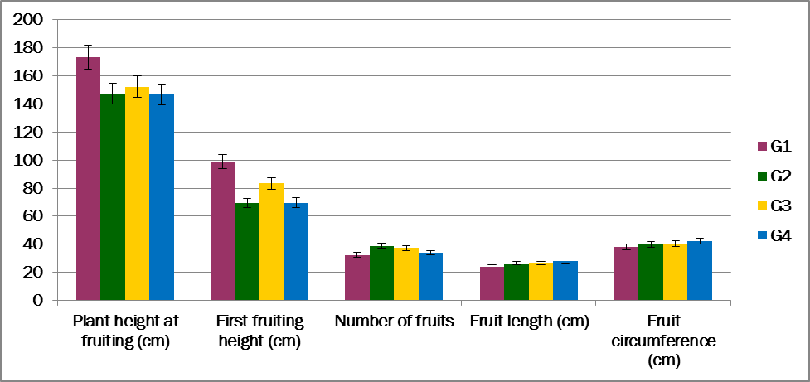
Figure 2. Main effects of stress tolerance promoting bioregulators on plant morphological and fruit physical parameters
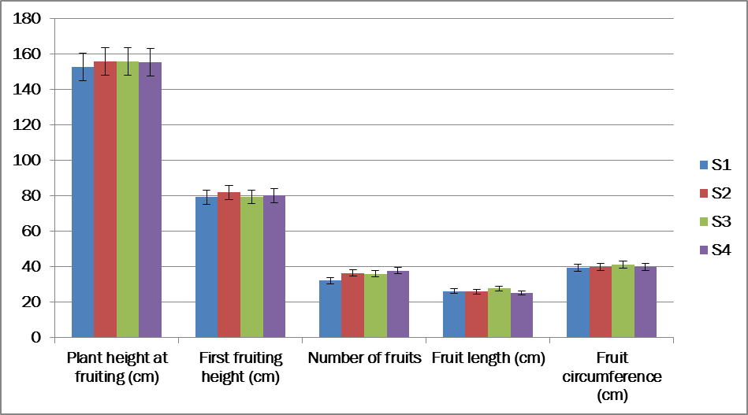

Figure 3. Main effects of bioregulators on PRSV disease incidence
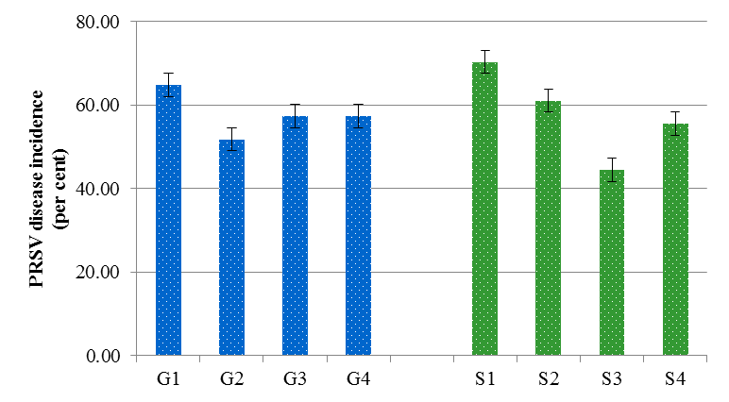
Figure 4. Main effects of bioregulators on proteolytic activity (TU g⁻¹)
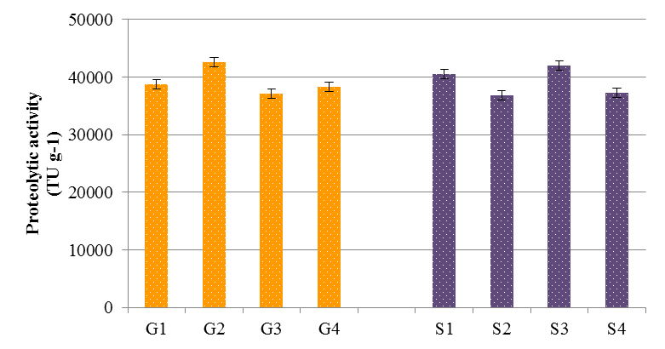
Factor 1: Growth retardants | Factor 2: Bioregulators for Stress tolerance
G₁ – Control ( water spray); G₂–250 ppm of pro hexadione calcium; G₃–500 ppm of mepiquat chloride; G₄–500 ppm of chlormequat chloride | S₁ – Control (water spray); S₂–100 ppm of methyl Jasmonate; S₃–100 ppm of salicylic acid; S₄–0.6 g/ L of strobilurins

Figure 5. Main effects of bioregulators on wet, dry latex yield (g) and proteolytic activity (TU g⁻¹)
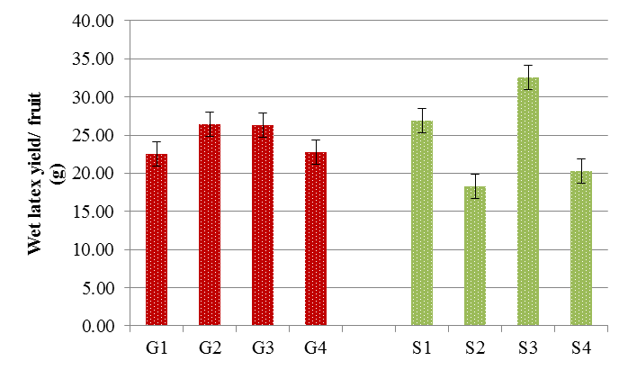a | b
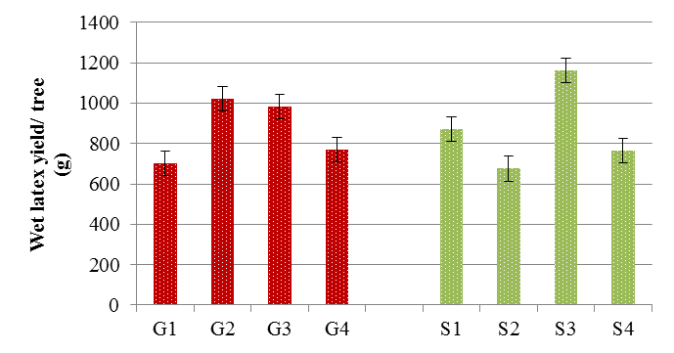c | 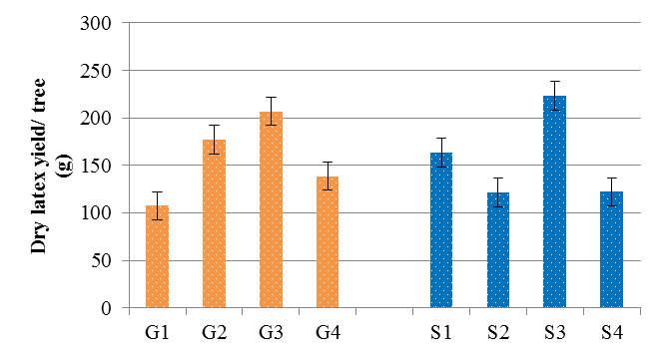d
a - Main effects of bioregulators on wet latex yield/ fruit  c – Main effects of bioregulators on dry latex yield/ tree | b - Main effects of bioregulators on dry latex yield/ fruit  d- Main effects of bioregulators on dry latex yield/ tree

Figure 6. Influence of bioregulators on wet and dry latex yield (kg acre⁻¹) of TNAU Papaya CO.8
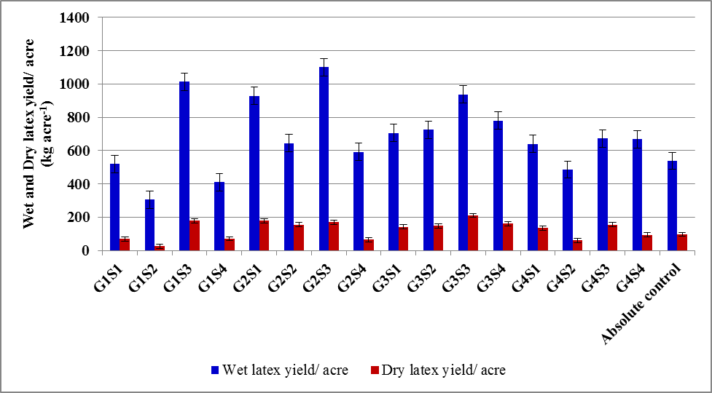

Factor 1: Growth retardants | Factor 2: Bioregulators for Stress tolerance
G₁ – Control ( water spray); G₂–250 ppm of pro hexadione calcium; G₃–500 ppm of mepiquat chloride; G₄–500 ppm of chlormequat chloride | S₁ – Control (water spray); S₂–100 ppm of methyl Jasmonate; S₃–100 ppm of salicylic acid; S₄–0.6 g/ L of strobilurins
Conclusion
Considering the remarkable reduction PRSV disease incidence as compared to control, moderate tree height coupled with a higher number of fruits and higher papain activity which are primary deciding factors in generating farmers income, the treatment combination of 250 ppm of prohexadione calcium with 100 ppm of salicylic acid (G₂S₃) can be adjudged as favorable treatment for fruit and papain production. The results also show that the treatment of 500 ppm of mepiquat chloride at fourth and eighth month after transplanting followed by a spray of 100 ppm of salicylic acid (G₃S₃) is favorable to achieve higher yield and effectively reduce PRSV incidence but the proteolytic activity of papain is moderate in this treatment and hence this combination could be effective when papayas are predominantly grown for fruits for table purpose and not necessarily for papain. These two treatment combinations (G₂S₃ and G₃S₃) are to be further studied for their effects on post-harvest quality of fruits and as well as on different varieties of papaya to manage PRSV without compromising yield and papain production.

REFERENCES
Abdi, S., Abbaspur, N., Avestan, S. and A.V.Barker. 2016. Sana physiological responses of two grapevine (Vitis vinifera L.) cultivars to CycocelTM treatment during drought.The J Hort. Sci. Biotechnol, 91(3), pp.211-219.
Azarkan, M., Moussaoui, A.E. Wuytswinkel, D.,Dehon, G. and Y. Looze. 2003. Fractionation and purification of the enzymes stored in the latex of Carica papaya. J. Chrom. B., 790: 229-238.
Ahmad, P., Rasool, S., Gul, A., Sheikh, S.A., Akram, N.A., Ashraf, M., Kazi, A.M. and S. Gucel. 2016.Jasmonates: multifunctional roles in stress tolerance. Frontiers in pl. sci., 7,813.
Bindhyachal R, Bipul K. M, Kumar,U.,and R. K. P. Kumar. 2016. Response of Guava to Boron and Growth Regulators Spray. Asian J Hort.11(1):146-150.
Bolter C. J. 1993. Methyl Jasmonate Induces Papain Inhibitor(s) in Tomato Leaves. Pl Physiol.103(4):1347-1353. doi: 10.1104/pp.103.4.1347.
Devarakonda, S., Madhumathi, C., Umamahesh, V., Mukunda, L., Lakshmi, M., Bhaskar, V.V. and T. Rajasekharam. 2020. Growth, flowering and yield Response of papaya (Carica papaya L.) cv. red lady to exogenous application of salicylic acid and Jasmonic acid.The Pharma Innovation J. 9(5): 160-165
Dhanam, S. 2006. Studies on papaya ring spot disease. M.Sc. thesis submitted to Tamil Nadu Agric. Univ.
do C. Mouco, M.A., Ono, E.O., Rodrigues, J.D. and G.J.N. Silva. 2010.Plant regulators on vegetative growth oftommyatkinsmangoes. In IX International Mango Symposium 992:187-192
Eraslan, F., B. Akbas, A. Inal, and C. Tarakcioglu. 2017. Effects of foliar sprayed calcium sources onTomato mosaic virus (ToMV) infection in tomato plants grown ingreenhouses. Phytoparasitica 35, 150. https://doi.org/10.1007/BF02981110
FaissalF, Ahmed Mohamed, KamelKH,Hamdy M. The Synergistic Effects of Using Plant Extracts and Salicylic Acid on Yield and Fruit Quality of Keitte Mango Trees.Stem Cell. 2014; 5(2):30-39
Fletcher, R.A., Gilley, A., Sankhla, N. and Davis, T.D., 2000. Triazoles as plant growth regulators and stress protectants. Horticultural reviews, 24, pp.55-138.
Gioushy SFE. Productivity, fruit quality and nutritional status of Washington navel orange trees as influenced by foliar application with salicylic acid and potassium silicate combinations. 2016. J Hort. Sci.Orn. Plants. 8(2):98-107.
Gonsalves, D., Tripathi, S., Carr, J. B., andJ. Y. Suzuki. 2010. Papaya ringspot virus. The Plant Health Instructor, 10, 1094.
Guan, Z. 2007.Effect of Salicylic Acid on Papaya Ringspot Virus Disease. Chinese J.Tropical Agric., (https://www.semanticscholar.org/paper/Effect-of-Salicylic-Acid-on-Papaya-Ringspot-Virus-Guan/1b7ce4bb84d502b399604c9e62a68f9ec5e2652e)
KassemHA, Al-ObeedRS, AhmedMA and AKH Omar. 2011. Productivity, fruit quality and profitability of jujube trees improvement by pre-harvest application of agro-chemicals. Middle-East Journal of Scientific Research.; 9(5):628-637.
Khurana S M P. 1970. Effect of virus diseases on the latex and sugar contents of papaya fruits. J. Hort. Sci.45: 295–7.
Kim, H.M., Lee, H.R., Kang, J.H. and S. J. Hwang. 2019. Prohexadione-calcium application during vegetative growth affects growth of mother plants, runners, and runner plants of Maehyang strawberry. Agronomy, 9(3) :155.
Koiwa, H., R. A. Bressan and P. M. Hasegawa. 1997. A review: Regulation of protease inhibitors and plant defense. Trends pl. sci. 2 (10), 379-384
Kovacs, J., Poor, P., Szepesi, A., and I. Tari. 2016. Salicylic acid induced cysteine protease activity during programmed cell death in tomato plants. Acta Biologica Hungarica, 67(2), 148–158. doi:10.1556/018.67.2016.2.3
Le Roux, S. and G.H.Barry.2010. Vegetative growth responses of citrus nursery trees to various growth retardants. HortTechnol, 20(1), 197-201.
Mamboya, E.A.F., 2012. Papain, a plant enzyme of biological importance: a review. American J. of Biochem.andBiotechnol., 8(2), pp.99-104.
Mishra R, Patil S, Patil A, Patil BL. 2019. Sequence diversity studies of papaya ringspot virus isolates in South India reveal higher variability and recombination in the 5'-terminal gene sequences. Virusdisease. 30(2):261-268. doi: 10.1007/s13337-019-00512-x.
Naylor, M., A. M. Murphy, J. O. Berry and J. P. Carr. 1998. Salicylic Acid Can Induce Resistance to Plant Virus Movement. Molecular Plant-Microbe Interactions. 11 (9): 860-868
NgullieC.R., TankT. V and D. R. Bhanderi.2014. Effect of salicylic acid and humic acid on flowering, fruiting, yield and quality of mango (Mangiferaindica L.) cv. Kesar.Advance Research Journal of Crop improvement. 5(2):136-139.
Puig, A., Gil,I. and O. Sanchez. 2008. Evaluation of drying techniques measuring proteolytic activity of papain obtained from unripe fruit and skin juice. Ind.Biotech. Intern. Conference.June 8-11, Italy.
Rademacher, W. 2000. Growth retardants : Effects on Gibberellin Biosynthesis and Other Metabolic Pathways. Annu. Rev. Plant Physiol. Plant Mol. Biol. 51:501–31
Seemanthini, B. 1964.A study of the influence of fruit size on the yield of papain in certain inbred selections of papaya (Carica papaya L.). Indian J. Hort., 24 : 141-154.
Shouket, H.A., Ameen, I., Tursunov, O., Kholikova, K., Pirimov, O., Kurbonov, N., Ibragimov, I. and B. Mukimov. 2020. Study on industrial applications of papain: A succinct review. In IOP Conference Series: Earth and Environmental Science (Vol. 614, No. 1, p. 012171). IOP Publishing.
Singh, V.and K.Shukla 2009. Effect of PRSVinfection on pigment content and assimilation ofcarbohydrates on Carica papaya. Ann. Pl. Protec.Sci. 17: 152-156.
Singh, Rao G P and Shukla K. 2005.Response of commercially important papaya cultivars to papaya ringspot virus in eastern U.P. conditions. Indian Phytopathology 58(2): 212–6.
Song, Y. J., H. H. Yu, Y. J. Kim, N. K. Lee and H. D. Paik. 2020. The use of papain for the removal of biofilms formed by pathogenic Staphylococcus aureus and Campylobacter jejuni. LWT - Food Sci. Technol. 127 – 109383
Thor, K. 2019. Calcium—Nutrient and messenger.Frontiers in pl. sci., 10, p.440.
Varisha, A., A.S. Husain, A. S. Javed, N. K. and A. Poonam. 2013. Physico-chemical and phytochemical evaluation of Carica papaya Linn. Unripe fruits.Int. Res. J. Pharm., 4(8): 101 – 106.
Weissler, H.E and A.C. Garza. 1965. Some physical and chemical properties of commercial chillproofing compounds. A.S.B.C. Proc.:225-228.

