RESEARCH ARTICLE
Effect of Graded levels of Magnesium on Dry matter production and yield of Maize cultivated in soils of maize growing tracts in Pudukkottai district of Tamil Nadu

ABSTRACT
In order to assess the effect of graded levels of applied Mg (0, 5, 10, 15, 20 and 25 kg ha⁻¹) on the Soil Available Major Nutrients, field experiments were conducted in 14 farmer’s holdings at Pudukkottai district with Hybrid Maize (NK 6240) as a test crop. Dry matter production (DMP) of whole plant (above ground) at harvest stage of maize was significantly influenced by the application of 100% NPK + 10 kg Mg ha⁻¹ (T₃) and recorded the highest mean as 25620 kg ha⁻¹ at harvest stage. A noticeable increase in grain and stover yield of maize crop was manifested by the application of 100% NPK + 10 kg Mg ha⁻¹ (T₃) which recorded the highest mean yield as 11.6 t ha⁻¹ and 14.0 t ha⁻¹, respectively. It reported a 14.31 and 22.25 per cent increase in grain and stover yields, respectively over control.
Keywords: Available magnesium, graded levels, critical limit, Maize, Pudukottai

INTRODUCTION
Maize is a versatile crop having higher yield potential among cereals and it is cultivated over a wide range of agro climatic zones, hence popularly called as “Queen of Cereals”. India is the fifth largest producer of maize in the world contributing 3 per cent of global production and cultivated in 9.20 million ha with the production of 23.67 million tonnes and an average yield of 5564 Kg ha⁻¹. In Tamil Nadu, it is cultivated in 3.42 lakh ha area with a production of 18.33 lakh tonnes and an average yield of 5359 Kg ha⁻¹ (Anon, 2019). By 2022, the requirement of maize for various sectors is around 100 million tonnes, of which nearly 28 per cent of maize to be produced is needed for food purpose, 11 per cent, as livestock feed, 48 per cent as poultry feed, 12 per cent for starch in wet milling industry and oil production and one per cent as seed. Maize is the important food grain crop in India and one of the most important cereal crops in the world’s agricultural economy, which is gaining popularity among the Indian farmers due to its high yielding potential. Magnesium is a component of the chlorophyll molecule and is essential for photosynthesis. It is also a phosphorus carrier in plants. Plants without Magnesium would not be able to take up Phosphorus. It is essential for phosphate metabolism, plant respiration, and the activation of enzyme systems in plants (Beegle, 2013). The plant as the Mg²⁺ divalent cation takes up magnesium. As Magnesium containing minerals in the soil slowly weather, some Magnesium is made available to plants. The supply of available Magnesium can be lost or deleted through leaching, plant uptake and removal processes. The availability of Magnesium to plants is often related to soil pH, with supply decreasing in both low and high pH soils. Soil tests can estimate available Magnesium by measuring the cation on the soil Cation Exchange Capacity (Oldham, 2019).
Magnesium plays an important role in chlorophyll molecules, which is the key plant component responsible for carbon di oxide fixation (Grzebisz et al., 2010). Magnesium is the central core of the chlorophyll molecule in plant tissue. Thus, if Magnesium is deficient, the shortage of chlorophyll results in poor and stunted plant growth. Magnesium is also an integral component of large number of enzymes in plants viz., alcohol dehydrogenase, carbonic anhydrase, Cu-Magnesium super oxide dismutase, alkaline phosphatase, phospholipases, carboxy peptidases and RNA polymerases. Magnesium serves as a co factor in most enzymes that activate phosphorylation processes as a bridge between phyrophosphate structures of ATP or ADP, DNA, RNA and the enzyme molecules, essential for amino acid and fat synthesis. (Mengel and Kirkby, 2001). It is also required for maintaining the integrity of biomembranes in the plants (Hafeez et al., 2013). Magnesium is absorbed as Mg 2+ and is mobile in plants, moving from the older to the younger leaves. Low Cation exchangeable capacity (Cation Exchange Capacity), cation competition and particularly long term imbalanced fertilization of nitrogen, phosphorus and potassium (NPK) are possible reasons of Mg deficiency in highly weathered, sandy and acidic soils. (Sreedhara and Cowan, 2002; Cakmak and Yazici, 2010; Gransee and Fuhrs, 2013). Among the cereal crops, Maize and wheat are highly susceptible to Magnesium deficiency. The most distinct Magnesium deficiency symptoms are stunted growth and little leaf, which are presumably related to disturbance in the metabolism of auxin and indole acetic acid in particular. The study revealed that the yield of maize could be enhanced by the early application of fertilizer at two weeks after planting. These results are discussed in the light of time of fertilizer application on growth and yield attributes of maize.
Magnesium sulphate fertilizer is designed to easily correct or event magnesium deficiencies for all types of crops and soil conditions. It leaches from the soil like calcium and potassium. Magnesium is the central atom amid four nitrogen atoms in the chlorophyll molecule, so it is involved in photosynthesis. It serves as an activator for many enzymes required in plant growth processes and stabilizes the nucleic acids. Plants use magnesium ions to make chlorophyll in their leaves. Like in nitrate deficiency, the plant is limited in terms of its photosynthetic ability and the plant growth is compromised. Magnesium is a limiting factor in healthy plant growth.
Research studies regarding Magnesium application has insisted that Magnesium supplementation increases Magnesium accumulation in the leaf tissue by 34.3 per cent and concentration of sugar in edible organs by 5.5 per cent higher as compared to non-Magnesium supplemented treatments (Zhengwang et al., 2020). Magnesium deficiency can be overcome with dolomite (a mixed magnesium-calcium carbonate), magnesite (magnesium oxide) or epsom salts (magnesium sulphate) .
To know the current status of available Magnesium in soils and the impact of graded levels of Magnesium fertilizer application on the biomass and yield of Grains and stover this study was undertaken
The basic survey was undertaken to collect soil samples from major maize growing tracts in Pudukkottai district of Tamil Nadu. Gandarvakotttai, Karambakudi, Pudukkottai, Aranthangi, Kunnandarkoil, Arimalam, Tiruvarankulam and Annavasal blocks were identified as major maize growing blocks and 256 soil samples (0-22.5cm depth) were collected randomly.
The collected soil were processed and analysed for various parameters such as pH, EC, Mg and Ca (Annexure I ). The soils were grouped based on Mg status as seven different categories such as .,<25 mg kg⁻¹,25-50 mg kg-¹, 50-75 mg kg-¹, 75-100 mg kg⁻¹, 100-150 mg kg-¹,150-300 mg kg⁻¹ and>300 mg kg-¹ to conduct the pot and field experiments.
Pot experiment
Five kilogram of processed soil was weighed and put in the pots which were imitated thrice in a Completely Randomized Design. A few Maize seeds (Hybrid Maize NK 6240 were planted per pot and 10 days after germination, one seedling was kept up in the pot. Suggested levels of NPK (250:75:75 kg ha⁻¹) was given consistently in arrangement structure to every one of the pots. Nitrogen was applied in three parts such as., 25 % as basal, 50% on 25 days aftersowing and 25 % at 45 days aftersowing, full dose of phosphorus and potassium were applied as basal. Graded levels of Mg such as., 0, 5, 10, 15, 20 and 25 kg ha⁻¹ were applied as Mg SO₄. The crop was raised up to tasselling stage and the plant tests (over the ground biomass) were drawn and analysed Mg concentration. The soil samples were also collected at tasselling stage and analysed for different parameters.

Soil characteristics
Representative soil samples collected from the experimental fields were processed and analysed for various physico- chemical properties. The pH of the soils ranged from 6.4 to 8.1 which were somewhat acidic to marginally basic. The EC of the soils indicated they were liberated from saltiness. The soils of various locations belong to different textural classes’ such as., sandy loam to sandy clay loam. The bulk density and the particle density of the soils ranged from 1.41 to 1.76 Mg m-³ and 2.40 to 2.66 Mg m⁻³, respectively. The organic carbon percentage ranged between 0.45 to 0.86 per cent. which is of low to medium status. The soil available Mg status fell under low, medium and high categories respectively .

RESULTS AND DISCUSSION
Crop growth and grain yield were positively correlated with intend at nutrients to the soil. The grain and straw yield of maize crop were significantly increased by the application of Mg fertilizer. The increased grain yield (11.60 t ha⁻¹) was recorded in the location L₇ with the application of 100% NPK + 10 kg Mg ha⁻¹ (T₃). The increased yield registered in this field study could be attributed due to the effect of Mg on plant growth especially enhanced enzymatic activity. The Mg fertilization improved the synthesis and transport of carbohydrates to grains. The application of Mg established better source link relationship, thus influenced the grain yield. Similar findings were also recorded by Ramanjineyulu et al., (2018).

The stover yield recorded a positive response with the supplementation of Mg at different levels. The highest mean stover yield of maize crop (14.0 t ha⁻¹) was recorded in 100% NPK + 10kg Mg ha⁻¹. Among the locations, where the initial soil Mg content was low to medium showed, exhibited a positive response whereas the locations where the soil Mg content was high showed declining trend in Stover yield. Similar finding was recorded by Asangi et al., (2018).

The data on dry matter production of whole plant at harvest is positively correlated with application of Mg This might be due to the significant increase in the accumulation of photosynthetic pigments and the total chlorophyll contents increasing the photosynthetic efficiency of maize plants. Similar findings were reported earlier by Chen et al., (2017). Significant difference in biomass yield was recorded over control by the application at different level of Mg. The pooled biomass of grain and stover yield ranged 21455 to 25620 kg ha⁻¹ and the maximum of 25620 kg ha⁻¹ was recorded in the field treated with Mg @ 10 kg ha⁻¹ followed by 15 kg ha⁻¹ with the yield of 25140 kg ha⁻¹. The minimum biomass yield was recorded in control. The variation in DMP in different field locations may be due to the availability and application of Mg. The significant increase in DMP in this study might be due to the stimulation and improvement of catalytic, co-catalytic and structural functions of Mg containing enzymes and also the nutrient uptake. Asangi et al., (2018) reported that the similar result in maize due to the application of the distillery spent wash RO reject to soil. The result of this study regarding DMP is in consonance with the findings of Canizella et al., (2017).

Fig 1. Effect of various levels of Mg on grain yield (kg ha⁻¹) of maize crop
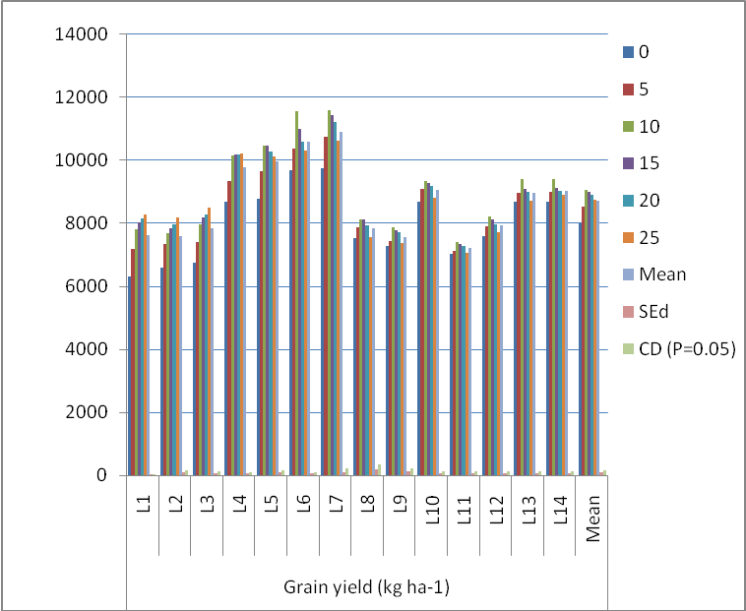

Fig 2. Effect of various levels of Mg on Stover yield (kg ha⁻¹) of maize hybrid.

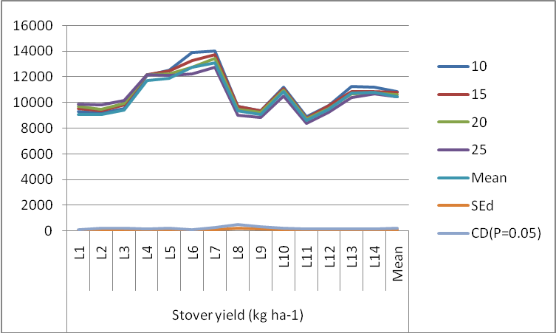

Fig 3. Effect of different levels of Mg on the DMP of Maize of at harvest

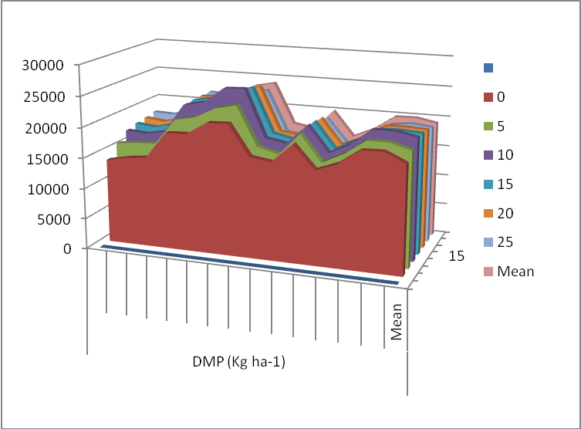

CONCLUSION
Dry matter production (DMP) of whole plant (above ground) at harvest stage of maize was significantly influenced by the application of 100% NPK + 10 kg Mg ha⁻¹ (T₃) and recorded the highest mean as 25620 kg ha⁻¹ at harvest stage. A noticeable increase in grain and stover yield of maize crop was manifested by the application of 100% NPK + 10 kg Mg ha⁻¹ (T₃) which recorded the highest mean yield as 11.6 t ha⁻¹ and 14.0 t ha⁻¹, respectively. It is therefore concluded that addition of Magnesium fertilizers at the optimal levels of 10 kg Mg ha⁻¹ along with the recommended levels of NPK fertilization (100 percent) has an evidence-based advantage in terms of increased yield and enhanced biomass.

Competing interests

There were no conflict of interest in the publication of this content

REFERENCES
Asangi A. M, Srinivasamurthy, C. A. and S. Bhaskar. 2018. Variation in growth parameters of maize (Zea mays L.) at different growth stages due to onetime application of distillery spent wash r o reject. Int. J. of Chemical Studies 6(3): 520-523.
Canizella, B. T., Souza, J. A., Moreira, A. and L. A. C. Moraes. 2017. Magnesium and zinc interaction in four soybean cultivars with different nutritional requirements. J. of Plant Nutrition. 41: 2189–99.
Chen, P., Du, Q., Liu, X., Zhou, L., Hussain, S., Lei, L. and F. Yang. 2017. Effects of reduced nitrogen inputs on crop yield and nitrogen use efficiency in a long-term maize-soybean relay strip intercropping system. PloS one, 12, e0184503.
Grzebisz Witold. 2013. Crop response to magnesium fertilization as affected by nitrogen supply. Plant and Soil. 368, 23–39.
Mengel, K. and E.A. Kirkby. 2001. Principles of Plant Nutrition. Kluwer Academic Publishers, Dordrecht, 849. http://dx.doi.org/10.1007/978-94-010-1009-2.
Ramanjineyulu, M., Srinivasa Reddy, M., and Ramesh Babu P. V. and P. Kavitha. 2018. Response of Maize (Zea mays L.) in Uptake of Micronutrients at Developmental Stages by Foliar Application of Secondary and Micronutrients. Int. J. Pure App. Biosci. 6(5): 297-303.
Zheng wang, Mahmood Ul Hassan, Faisal Nadeem, Liangquan Wu, Fusuo Zhang, and Xuexian Li. 2020. Magnesium Fertilization Improves Crop Yield in Most Production Systems: A Meta-Analysis. Front Plant Sci. 10: 1727.10.3389/fpls.2019.01727.
Zhang F. S., Wang J. Q., Zhang W. F., Cui Z. L., Ma W. Q., X. P. Chen. 2008. Nutrient use efficiencies of major cereal crops in China and measures for improvement. Acta PedologicaScienca 5(45): 915–924.10.1163/15693930878312278.
Sachdev, P., Dep, D. L. and D. K. Rastogi. 1988. Effect of varying levels of zinc and manganese on dry matter yield and mineral composition of wheat plant at maturity. J. Nuclear Agric. Biol., 17: 137- 143.
Siyal, A. A., Siyal, A. G. and Z. A. Abrol. 2002. Salt affected soils, their identification and reclamation. Pakistan J. of Appl. sci., 5: 537-540.

