RESEARCH ARTICLE
Preparation of 10% Dusting Powder Ready-to-Use Low Concentration Neem Botanical Formulation

ABSTRACT
Neem (Azadirachta indica) is the best potential alternative, as it exhibits sufficient insecticidal property. Formulation is the process of transforming an active ingredient into a product, applied on crop pest by practical methods to permit its effective, safe and economical use. Neem green fruits were blended with an inert material (dolomite) to obtain free-flowing fine powder . Increasing the active ingredient from 2.5 to 12.5 % had smooth blends in formation of the products. The nature of the neem fruits were contain latex, which is a water-soluble and act as emulsifier agent, which possess good adhesive properties. All formulations were recorded required formulation stability. However, the 10 per cent D.P. was found to be ready to use, easy for calculation and application by the farmers. All formulation noticed with no changes in color, odour, pH, curde lomonoids of accelerated condition. The natural seed based botanicals are in abundance production, renewable, green chemistry finding and better for environment. It has been found to be satisfactory for the formulation of neem based insecticide dusting powder. The size specification for diluents is to be 95 percent or more through 325-mesh (44 microns) or 95 percent through 200-mesh (75 microns).
Keywords: Neem Green Fruit, Dust Powder, Formulation, Botanicals

INTRODUCTION
Neem (Azadirachta indica) is the best potential alternative, as it exhibits sufficient insecticidal property. This tree is native to India as well as other southeastern countries on the globe. Neem based products are natural and non-toxic. It is 100% biodegradable and environment friendly. India's neem trees bear about 3.5 million tonnes of kernels each year and that, in principle, about 700000 tons of oil might be recoverable. The use of synthetic fertilizers and pesticides in agricultural practices causes serious environmental pollution. Therefore, to reduce the effect of agricultural practices on the environment, suitable natural materials are in need as insecticides and pesticides. Due to increased public concern relating to the toxicity of insecticide residues in grain and in the environment and the occurrence of insecticide resistant insect strains, there has been a need to search for new approaches for insect pest control. Triterpenoids are the key ingredients in neem-based bio-pesticide, which inhibits the growth of pests, insect antifeedant and growth regulator. Normally, oil seeds cannot be converted into fine powder because they contain oil. Thus, neem fruit powder is coarser, and is widely available in cake form (neem cakes), which have comparatively smaller surface area. However, this problem can be overcome by collectiing the whole green neem fruits near stage of harvesting before its converted into oil. Liquids are more economical and cleaner than dusts, but dust application are specific, low toxic and provide better pest management. In this current process, white clay or other carrier were used to pulverize and it is then blended with soap stone powder and after which liquid technical grade aredispersed on this blended material. Wheat flour, clay, talc, boric acid, and silicone dioxide are used as carriers in dust formulations and several inert dust formulations have been registered for the crop protection. Only few dust formulation were available for agricultural use and no botanical dust formulation developed until now (registered). In this study, a formulation is designed a ready-to-use low concentration botanical formulation for crop pest management.

MATERIAL AND METHODS
Formulation
In this study, whole neem green fruits were cogrinded with an inert material (dolomite) to obtain free-flowing fine powder. Dolomite is an anhydrous carbonate mineral composed of calcium magnesium carbonate [CaMg(CO₃)₂]. A grinding mill is the most suitable equipment for grinding dry neem fruits. The powder obtained by grinding has large surface area and shows better biological activity owing to the presence of limonoids (e.g., salannin and nimbolide), which also helps to increase the shelf life of the products.
Neem fruits collection and processing
Whole dry neem immature fruits (Figure 1) were subjected to a pretreatment method that included washing, cleaning, and drying. The cleaned dry green fruit was then pulverized (Figure 2).
Dusting powder formulation preparation
The pulverized sample was subjected for blending with 1:1 parts of carrier (dolomite) for uniform distribution with overhead stirrer followed by through hand blend mixing. The powdered dry fruit mixed with 1:5 part along with carrier in a grinding mills of milling applications. The test dusting powder formulation contains 2.5 to 12.5 % w/w neem powder. The size specification for carrier was prepared at < 95 per cent or more through 325-mesh (44 microns) or 95 per cent through 200-mesh (75 microns).
TLC analysis
The 200 mg powdered sample has been dissolved in 10ml of acetone. The filtered organic phase 2 ml was taken and spotted on silica gel F₂₅₄ plate. Then eluted with a mobile phase of methanol : ammonia (100:1.5) for alkaloid and for terpenoid using the mobile phase toluene : ethyl acetate (93:7). The chromophore was observed under UV₂₅₄ nm and UV₃₆₆ nm then also sprayed and derivatized with the coloring reagent dragendorf that produced orange color for alkaloid and sulfate vanillin that produced purple color for terpenoid. Analysis of secondary metabolites were done by measurement of R_{f} score. The formula of R_{f} score was distance of sample or reference compound divided to distance of the solvent.
Storage condition for product stability and evaluation parameters
Accelerated stability study and real time stability study was conducted as per ICH guideline storage condition as mentioned below,
• Accelerated stability : Temperature: 40 °C ± 2, Relative Humidity (RH): 75 % ± 5
• Real time stability : Temperature: 25 °C ± 2 , Relative Humidity (RH): 60 % ± 5
The change was observed during 15 days for accelerated stability and six month for real time stability study.
Colorimetric quantification of limonoids

A method for estimating the total limonoid concentrations in samples in terms of limonin was adopted (Ref ?). The colorimetric quantification was based on the formation of red to orange colored derivatives resulting from the treatment of limonin or limonin glucoside and possibly some co extracts. Absorbance maxima for the limonin and limonin glucoside derivatives were found to be 470 and 503 nm, respectively (Figure 3).

RESULTS AND DISCUSSION
Crystals of dolomite are common deposits, which makes up approximately 2 percent of the Earth’s crust. By volume, however, most dolomite occurs in its massive form as dolostone or mixed dolostone/limestone sedimentary rocks. Dolomite structure comprising calcium layer, a -CO₃ layer, a magnesium layer, another CO₃ layer, and so forth. This layers lattice space offers the active ingredient and the inert nature of the material is the unique feature. The crystals properties were useful viz., colourless, white, buff-coloured, pinkish, or bluish, while handling and coating over the mineral. The free flowing of the mineral is due to individual grains ranging in size 44 micron and lower after milling. This dolomite mineral and neem green fruits were blends to obtain free-flowing fine powder and materials.
The formulation formulated by different composition mixture from A to E by increasing the active ingredient from 2.5 to 12.5 % (Table 1). The smooth blends help in formation of the products A to E. The nature of the neem fruits contains latex at before ripening, which is a water-soluble and act as emulsifier agent, which possess good adhesive properties as nanofilm coating. These nanofilms open up the possibility of binderless and inert high surface area and spread on carrier. The nanofilm coating on carrier has efficiency of the secondary metabolites retained and the stability for the formulation also improved.
In the accelerated stability study was conducted at the temperature: 40°C ± 2 at Relative Humidity (RH): 75% ± 5 for up to 15 Days. 10% degradation was set to extrapolate of the accelerated stability data as the acceptable point. It is interpreted as length of time under specific conditions and storage that a product will remain within the predefined limits for all its important characteristics. The following parameters were observed for evaluation of stability study. Physico-chemical parameters like colour, odour, pH, curde lomonoids. All formulation noticed with no changes in color, odour, pH, curde lomonoids of accelerated condition (Table 4). It ensured the efficacy and quality of active compounds in product, to establish shelf life or expiration period.
Stability is aimed at assuring that the product remains within specifications established to ensure its identity, strength, quality and purity. Results showed stability of formulation sample A to E at real time and accelerated storage condition (Table 2 & 3). All formulation recorded required formulation stability. However, the 10 per cent D.P. (Sample D) has found to be ready to use, easy for calculation and application by the farmers.
The colorimetric quantification of color development and sensitivity were investigated and optimal assay conditions established (Table 6). With a UV-Vis spectroscopy, under these conditions, the limits of detection and quantification were determined to be 25 to 50 PPM for limonin. All the formulations from A to E met required specification for formulation and tested on rice crop at active tillering stage. The crop had not recorded with any adverse effect on rice phenology.
TLC profiling showed different Rf values the presence of number of phytochemicals in it. Different Rf values of the compound reflect an idea about their polarity. The presence of any significant bioactive natural product indicates the necessity of separation of the compound from the mixture of compounds through suitable chromatographic techniques.
Validation of 10% Dust formulation against Sorghum Stem borer (Chilo partellus)

The red soghum plant showed withering and drying of central shoot -“dead heart”, Red mining in the midrib, Bore holes visible on the stem near the nodes. Affected parts of stem had internal tunneling of caterpillars hiding inside. The plant parts treated with 10% D.P. developed for ready-to-use low concentration neem fruit based formulation showed effective and recorded no adverse effect on phenology of the sorghum. (Table 5).

CONCLUSION
From the present investigation, it is obvious that the performance of combined application of dolomite mineral and neem green fruits were blends to obtain free-flowing fine powder and materials also act as a source of calcium and magnesium, which promote plant growth too. This carrier is cheap and easily available, and also helps to neutralize the pH of acidic soil. The powder obtained by grinding has large surface area and shows better biological activity owing to the presence of limonoids, which also helps to increase the shelf life of the products. In agriculture, powdered dolomite is also an important component of many fertilizers and animal feeds. Smaller amounts of dolomite are also used for human consumption as a mineral supplement and as an antacid, although to a lesser degree than calcite. The natural seed based botanicals are in abundance production, renewable, green chemistry finding and better for environment. These formulations are having LD50 value of >5000mg / Kg of body weight and target the pest effectively. For ecologically sound, equitable, and ethical pest management, there is a need for control agents that are non pest-specific, nontoxic to humans and other biota, biodegradable, less prone to pest resistance and resurgence, and relatively less expensive.

Acknowledgement
The authors thank Department of Soils and Environment, AC&RI, TNAU Madurai and the DST-SERB Government of India for supporting this research.

REFERENCES
Balakrishnan S, Parthasarathy S, Kamalakannan A, Senthil K. (2017). A Novel Method to Develop Paste Formulation of Trichoderma harzianum. Int. J. Curr. Microbiol. App. Sci. 6 (11) 3286-3293.
Balakrishnan S, Parthasarathy S, Kamalakannan A, Senthil K and Gopalakrishnan C. 2017. Evaluation of antagonistic activity and plant growth promotion by paste formulation of Trichoderma Harzianum. Journal of Pharmacognosy and Phytochemistry. 6(6): 355-360.
Bankoti K, Rana MS, Bharadwaj MK. 2012. Accelerated stability study of herbal capsules. IOSR Journal of Pharmacy. 2 (5):1-6.
Central Insecticide Board and Registration Committee Guidelines (1997).
Chattopadhyay R.R. 1999. Possible mechanism of antihyperglycemic effect of Azadirachta Indica leaf extract. Journal of Ethnopharmacology, 67 (3): 373-376
Devakumar C, Sukh Dev, Chemistry, in Sukh Dev. 1996. Chemistry Neem edited by Randhawa NS and Parmar BS. (2nd edition); pp–77.
IS 6940:1982 Methods of test for pesticide and their formulation, Bureau of Indian Standards, New Delhi.
Nakka AK, Gaur A, Sunku SSK, Devakumar C. 1999. Performance of neem products on the storability of soybean (Glycine max L.). Seed Res. 26(2):138-146.
Renugadevi J, Natarajan N, Rajasekaran R, Srimathi P. 2000. Bioefficacy of promising botanicals against insect infesting cowpea cv. CO 4. Indian Journal of Agricultural Research. 4: 262-26
Rukmani N, Prabhaharan J, Senthil K Thiyageshwari S and Banumathy S. 2018. Interaction of Zinc with cationic micronutrients under graded levels of chelated Zn in typic haplustalf. Res. J. of Agricultural Sciences 9 (5):1010-1013.
Senthil K, Devakumar C, Kumar R, Tomar SMS. 2009. Synthesis and evaluation of oxanilates and oxamates as chemical hybridizing agents for wheat (Triticum aestivum L). Pesticide Research Journal 21 (2): 133-139.
Shah W., Rane N., Kekare M.B., Vaidya V., 2010. Estimation of two bioactive compounds from Azadiracta indica a.juss. leaves using HPLC. International Journal of Pharmaceutical Bioscience, 2: 185-192.
Table 1. Botanical neem fruit D.P formuolation composition.
S. No | Sample Codes | Dolomite | Technical
 | Sample A | 97.5%(w/w) clay | 2.5% (w/w) Technical
 | Sample B | 95%(w/w) clay | 5% (w/w) Technical
 | Sample C | 92.5% (w/w) clay | 7.5% (w/w) Technical
 | Sample D | 90%(w/w) clay | 10%(w/w) Technical
 | Sample E | 87.5%(w/w) clay | 12.5% (w/w) Technical
Table 2. Botanical neem fruit D.P formuolation quality requirement and observed values.
S.No | Characteristics | Requirement As Per Is 8960:1978 | Observed Values Sample D
1 | Material passing  through 75 micron  ASTM/BS SEIVE. | 90% | 98%
2 | Bulk density after compacting | Not to exceed the value obtained before compacting by more than 60% | 54%
3 | Alkalinity (as NaOH)  percent by mass, max | 0.1% | 0.01%
4 | Unburnt carbon % | - | 0.05%
5 | Moisture % | - | 7.5%
Table 3. Botanical neem fruit D.P formuolation and its characteristics.
S. No | Characteristics | Sample A | Sample B | Sample C | Sample D | Sample E
 | Description | Homogenous and free flowing powder | Homogenous and free flowing powder | Homogenous and free flowing powder | Homogenous and free flowing powder | Homogenous and free flowing powder
 | Material passing through 75 microns ASTM/BS SEIVE. % | 93.2% | 92% | 91% | 91.5% | 92%
 | Bulk Density after compacting, max 60% | 53% | 55% | 54% | 54% | 53%
 | Alkalinity as (NaOH) percent by mass max 0.1% | 0.01% | 0.01% | 0.01% | 0.01% | 0.01%
 | Crude terpenoid content % by mass (average of 5 analysis) | 2.6% | 2.6% | 2.6% | 2.6% | 2.6%

Table 4: Physico-chemical parameters

 | Condition: 40 °C ± 2 and 75% ± 5 RH
Parameters | Initial | 7 Day | 15 Days
pH | 6.2 | 6.7 | 6.7
Clod formation | NIL | NIL | NIL
Bulk density after compacting | 54 % | 55% | 55%
Alkalinity (as NaOH)  percent by mass, max | 0.01% | 0.01% | 0.01%
Unburnt carbon % | 0.05% | 0.05% | 0.05%
Moisture % | 7.5% | 6.6% | 6.1%

Table 5. Botanical neem fruit D.P formuolation and adverse effect of crop symptoms.
Crop | Area | Application Dose | Observation
Paddy | Pot Study | 10 D | No adverse change is observed in vegetative growth and yield of the crop is seen when it is applied with current formulation
Sorghum | Field | 10 D | Effect on larval period, further infestation stopped
Table 6. Summary of method characteristics.
S. No | Attribute | Value
 | Limit of detection | 0.1 ppm
 | Limit of quantification | 5 ppm
 | Linear range | 0.1 to 5000 mg / l
 | Recommended range | 1 to 5000 mg / l
 | Typical R² | 0.988

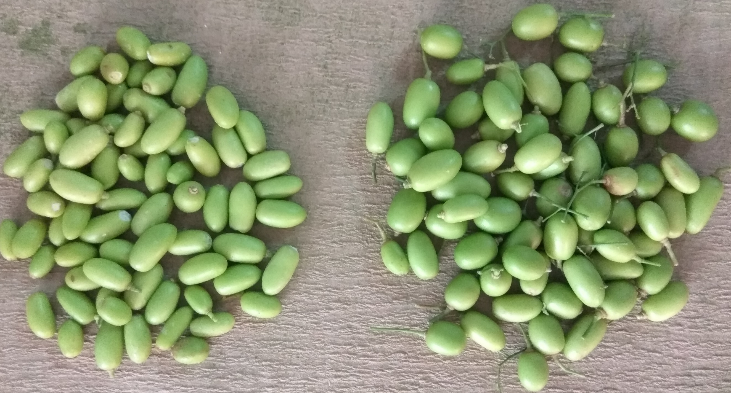
Figure 1. The green neem fruit harvested at near maturing stage for the formulation preparation.
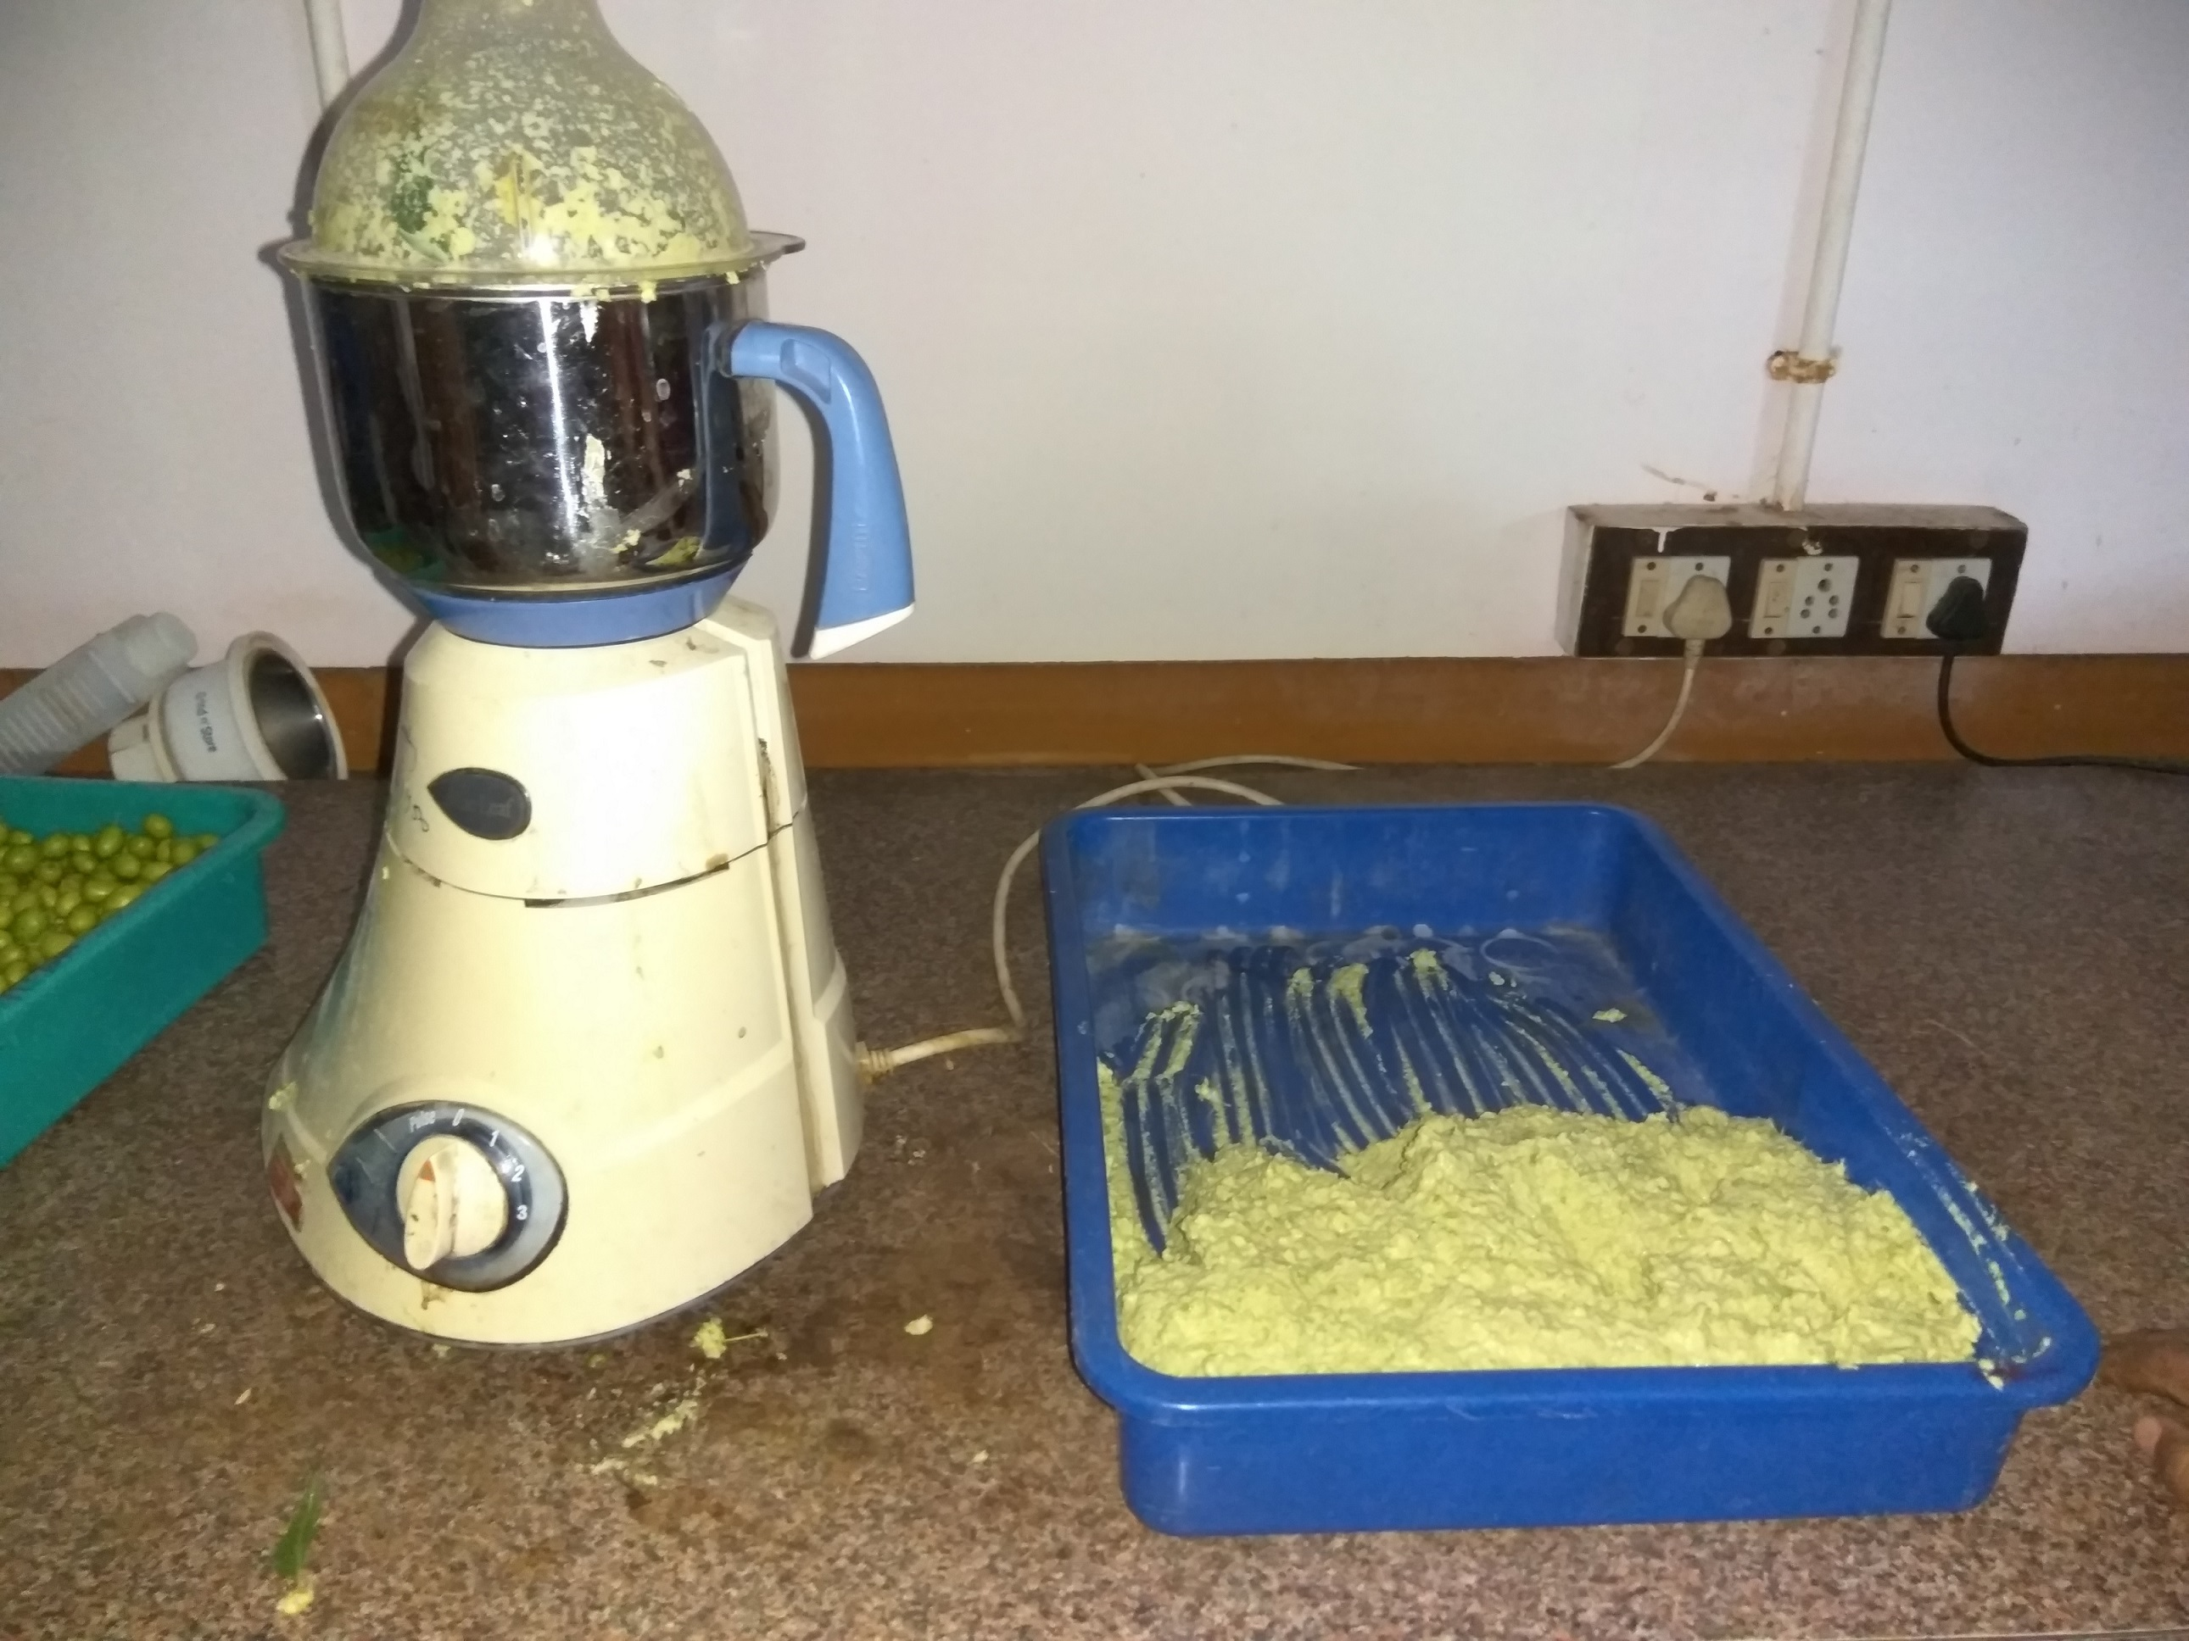
Figure 2. The green neem fruit harvested has been grinded with cost effective mixture grinder for the formulation preparation.
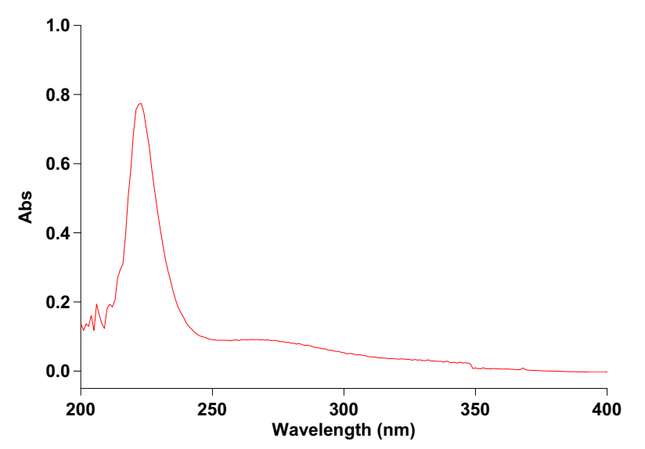
Figure 3. The extracted crude terpene showed strong absorption at 210- 245 nm and the λ_{max} of 225 nm.

