“Organoleptic evaluation of chutney powder from (Moringa oleifera) drumstick leaves powder”
Abstract
Drumstick leaves is one of the medicinally important tree got good nutritional and medicinal values and also having pharmacological effects based on the finding the main objective of this study is organoleptic evaluation of chutney powder from drumstick leaves powder, the chutney powder were prepared using standard procedure and were given for the sensory evaluation (Organoleptic evaluation) to 21 panellists to test for appearance, colour, texture, aroma, taste and overall acceptability using 9-Point hedonic scale. It was found that in control (without drumstick leaves powder) has got good sensory score in all the parameters. Among 5, 7 and 10% incorporated drumstick leaves powder the 7% per cent incorporated drumstick leaves powder scored highest in all the sensory attributes. Hence all the products were nutridense and got good sensory scores for the acceptability which can be promoted for regular consumption.
Keywords: Evaluation, sensory evaluation, chutney powder, drumstick leaves powder.
Introduction
The green leafy vegetables are always considered as an excellent component of the habitual diet in the tropical and also in temperate countries. They are protective foods and also highly beneficial for the maintenance of health and prevention of diseases. The diverse agro climatic condition of India ensures availability of different varieties of fresh fruits and vegetables. The production of fruits and vegetables in world, India stands second next to china. India produced 162.19 million metric tonnes of vegetables with cultivated area of 9.21 million hectares as per National Horticulture database published by National Horticulture Board of India, during 2012 -2013. Green leafy vegetables are perishable in nature). According to the report of 2016 vegetables are grown over 9.5 million hectares with the production of 168.30 million tonnes (Mazumder et al., 2016).
Moringa oleifera an aboriginal of India sub-continent is a member of the Moringaceae family of perennial angiosperm plants, which includes 13 other species. The plant is grown best in dry sandy or loamy soil that is slightly Alkaline. Although it is adaptable to various soil conditions from varying PH of 4.5 to 8.0. It is not able to tolerate water logging, freezing or frosts conditions. Leafy vegetables occupy an important position in the India diet. India produces about 12 % of the total world’s production of vegetables but it is not enough to meet this country’s requirement (Singh et al., 2012).
Moringa oleifera is a fast growing, deciduous tree. It can reach a height of 10–12 m (32–40 ft) and can also reach a diameter of 45 cm (1.5 ft). The bark has a whitish-gray color and is surrounded by a dense cork. The young shoots have a purple or greenish-white, hairy bark. The tree has an open crown of drooping, fragile branches, and the leaves form feathery leaves of tripinnate leaves. The flowers are bisexual and fragrant, united by five unequal, thinly veined, yellowish- white petals. The flowers are about 1.0-1.5 cm (1/2") long and 2.0 cm (3/4") broad. They grow on slender, hairy stalks in spreading or drooping later flower clusters which have a length of 10– 25 cm. The flowers are fragrant and bisexual, surrounded by five unequal, thinly veined, yellowish white petals. The flowers are about 1.0-1.5 cm (1/2") long and 2.0 cm (3/4") broad (Singh et al., 2003).
Moringa oleifera is one of the most helpful tropical trees and is generally grown at back side of the home. It is good sources of vitamins and minerals. It is significant source of B vitamins, vitamin C, provitamin A as beta carotene, vitamin K, dietary fiber, protein, potassium, manganese and magnesium and also rich source of many bioactive compounds viz. terpenoids, alkaloids, p – cymene, eugenol, chavicol, flavonoids, saponins, allyl catechol, cadinenecarvacrol, estragol, caryophyllene, chavibetol, cineole etc. It is recognized for its food and nutritional value, with forage, medicinal, and seasoning properties, being used in culinary, fuel, and cosmetics industries and in water treatment for human consumption (Singh et al., 2014).
Sample preparation
Collection of drumstick leaves
Medium mature leaves of drumstick were collected from a fully grown tree in University of Agricultural Sciences, GKVK campus, Bengaluru, Karnataka, India. The leaves were initially separated from the stalks and other extraneous matter was cleaned with brine and under running water.
Pre-treatment of the sample
The cleaned tender leaves were subjected to pre-treatment prior to dehydration. The tender leaves were blanched in hot water at 80⁰C for one minute and rapidly cooled in chilled water finally these for the same temperature, after dehydrated in hot air oven at 60⁰C after drying the tender leaves ground to powder and packed in aluminium foil covers.
Moisture content estimation of the sample
Moisture content was determined by taking 10 g of sample in petridish and followed by drying carried out in a hot air oven at 60⁰ C temperature, then cooled and weighed sample. (Reference)
Moisture per cent =
Fresh sample (g) – Dry sample (g) × 100
Fresh sample (g)
Protein content estimation of the sample
Protein content of the dried tender drumstick leaves sample was calculated as percent total nitrogen by the Kjeldhal method. (Reference)
Protein (g/100g) = Titre value × Normality of HCL × 14.001 × 6.25 × 100
Sample weight (g) × 1000
Fat content estimation of the sample
Fat content was determined as crude ether extract by using sample which is basically moisture free. For the removal of solvent evaporation process was adopted and the weighing was carried out for residue of the fat. (Reference)
Fat content (g/100g) =
Weight of the ether extracts ×100
Weight of the sample taken
Crude fiber content estimation of the sample
The estimation of crude fibre was carried out by using moisture and fat free samples and expressed as g/100 g of sample. (Reference)

Crude fibre (g/100g sample) =
[100-(moisture+fat)] × (We-Wa)
Wt. of sample taken (moisture and fat free)
Ash content estimation of the sample
5 grams of sample was taken in crucible. Then the charring carried out slowly in an muffle furnace for about 240 to 300 min at 6000C temperature. Later the sample was taken out cooled and weighing has done to know the ash content of the sample. (Reference)
Weight of the ash Ash content (g/100g sample) = ×100 Weight of the sample
Vitamin C content estimation of the sample
Ascorbic acid content was determined calorimetrically. Ascorbic acid was first dehydrogenated by abomination. The dehydroascorbic acid was then reacted with 2, 4 dinitrophenyl hydrazine to form ozone and dissolved in sulphuric acid to give an orange red colour solution which was measured at 540 nano meter. (Reference)
Preparation of mineral solution
Ash obtained from muffle furnace and dilute hydrochloric acid dissolved together to obtain mineral solution.
Calcium content estimation of the sample
Calcium oxalate and the solution of oxalate in dilute acid against standard potassium permanganate precipitation were done to estimate the calcium content of the sample.
Iron content estimation of the sample
Atomic absorption spectrophotometer was used to determine the Iron content of the sample and results were expressed in mg/100 g of sample.

Beta-carotene content estimation of the sample
The beta-carotene analysis was done by following procedure 5 to 10 g of sample was taken and acetone about 25 ml was added into it, then the mixture was transferred to an empty beaker grinding was done and allowed to stand for few minutes then filtration was carried out. The residue was subjected to decanting and later it was subjected to acetone extraction process. Then 100 ml of 5 % Na2SO4 solution and petroleum ether about 15 millilitre were added to extract. Then along with petroleum ether volume was made up to the quantity of 50 ml and 452 nm absorbance was used to measure beta-carotene content.
Composition of carbohydrates
Differential method was adopted to calculate Carbohydrates content of the sample.
CHO (g/100 g) = 100 – [Protein (g) +Fat (g) +Ash (g) + Fibre (g) +Moisture (%)]
Composition of energy
The composition of energy was computed for all the samples.
Energy (Kcal) = Protein (g) × 4 + Fat (g) × 9 + Carbohydrate (g) × 4
Statistical analysis (Fisher and Yates, 1963)
All the analyses were performed in triplicate and data was analysed using EXCEL and STATISTICA 7.1 (Stat Soft). Analysis of variance technique (ANOVA), Critical Difference and t-test were used to analyse the data. One-way analysis of variance (ANOVA) in randomized complete block design was followed to determine the level of significance. In the present study, F –Test was applied for the influence of pre-treatments on dehydration characteristics of the ivy gourd slices, sensory evaluation microbial load and moisture using CRD design. Paired t tests were used to analyse to compare with control peak blood glucose values and area under the curve (AUC). Differences between means were evaluated by Duncan’s test.
Formulations of products
Formulations of the products were carried out to know the acceptability at different level of incorporation in which the following products were prepared is chutney powders based on standard recipe.

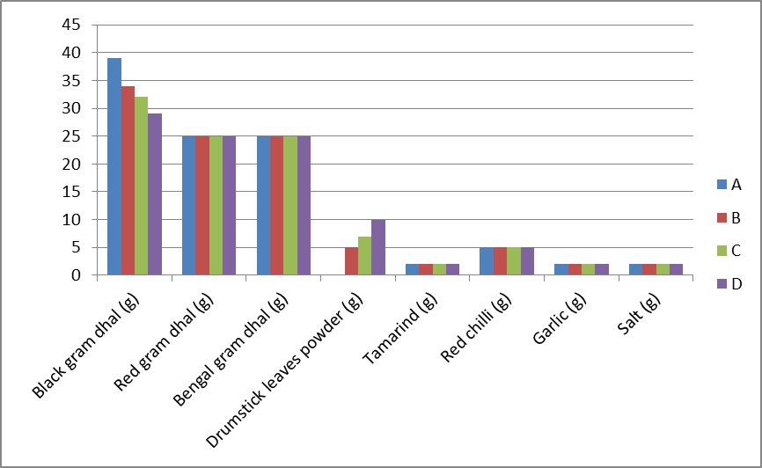
Image 1: Composition of chutney powder by incorporating drumstick leaves powder.
- Control, B- 5 % incorporated drumstick leaves powder, C- 7 % incorporated drumstick leaves powder, D- 10 % incorporated drumstick leaves powder
Table 1 depicts the composition of chutney powder by incorporating drumstick leaves powder. Control indicates without the incorporation of drumstick leaves powder. All others are incorporated with the drumstick leaves.
Drumstick leaves
Tray drying at 60⁰ C for 3 hours

Dried leaves

Drumstick leaves powder
Roasted bengal gram, urad dhal and red gram dhal powder
Blending
Coconut, cumin seeds, red chilli, tamarind, garlic and salt

Drumstick leaves chutney powder

Packaging in aluminium foil cover and sealed

Figure 1: Flow chart for preparation of chutney powder prepared by incorporating drumstick leaves powder.
Figure 1depicts the flow chart for preparation of chutney powder prepared by incorporating drumstick leaves powder. The drumstick leaves were dried at 60⁰ C for 3 hours in tray drying. The leaves were grinding to make powder. Then roast the bengal gram, urad gram, red gram dhal and red chilli. Grind bengal gram, urad dhal, red gram dhal, coconut, cumin seeds, red chilli, tamarind, garlic and salt. Add drumstick leaves powder to above ingredients. Mix it well.
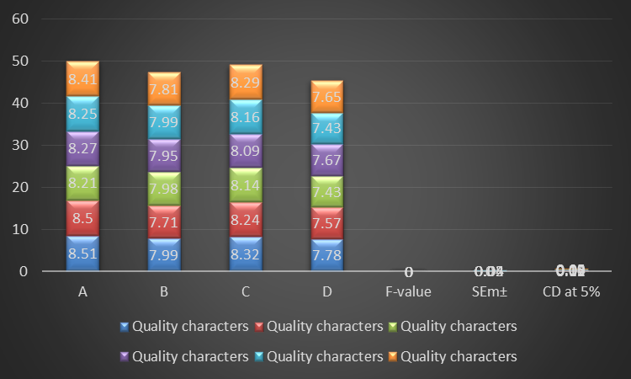
Image 2: Mean sensory score of chutney powder prepared by incorporating drumstick leaves powder.
* indicates Significant, NS- Non- Significant at 5%.
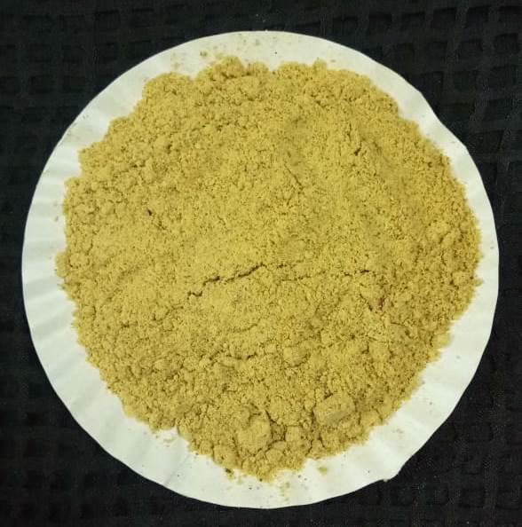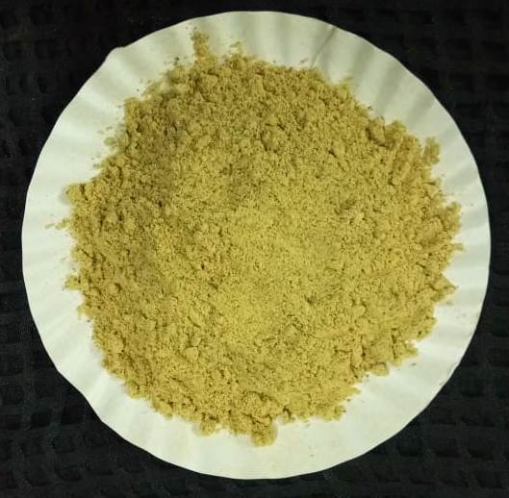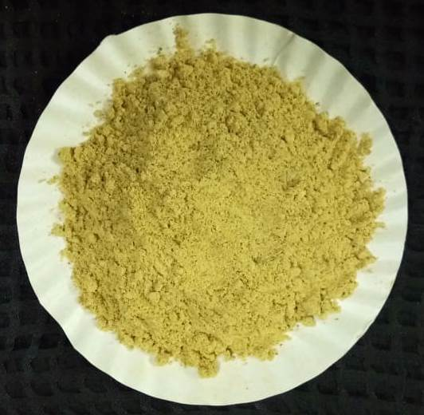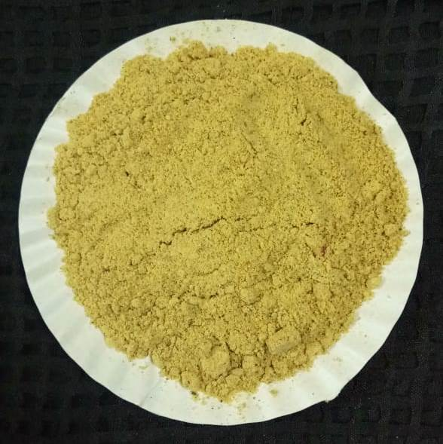

A- Control, B- 5 % incorporated drumstick leaves powder, C- 7% incorporated drumstick leaves powder, D- 10 % incorporated drumstick leaves powder
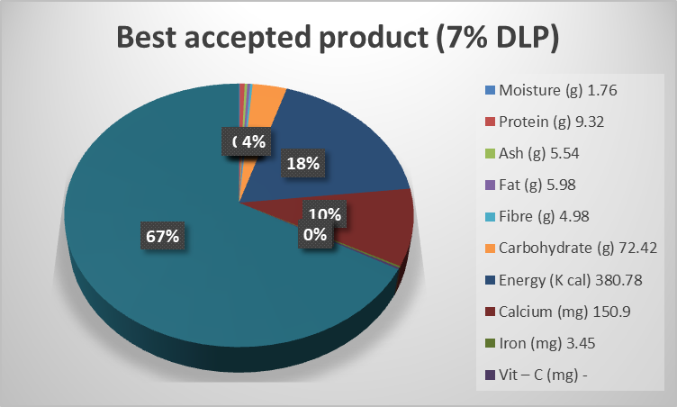
Image 3: Nutrient composition of chutney powder prepared by incorporating drumstick leaves powder/ 100g.
DLP- Drumstick leaves powder
Results and Discussion
Mean sensory score of chutney powder prepared by incorporating drumstick leaves powder
Sensory evaluation scores of chutney powder prepared by incorporating drumstick leaves powder is presented in Table 2. Chutney powder was prepared by incorporating drumstick leaves powder at three different levels viz 5, 7 and 10 per cent. The scores for appearance ranged from 8.51 to 7.78, for colour 8.50 to 7.57, for texture 8.21 to 7.43, for aroma 8.27 to 7.67, for taste 8.25 to 7.43 and overall acceptability it was 8.41 to 7.65. The control had highest scores for appearance (8.51), colour (8.50), texture (8.21), aroma (8.27), taste (8.25) and overall acceptability (8.41). Among the variations 5 per cent incorporated level had higher scores for overall acceptability (8.29) followed by 5 per cent incorporated i.e overall acceptability (7.81) and least scores for overall acceptability (7.65) was observed in 10 percent incorporation level. As the level of incorporation of drumstick leaves increased the overall acceptability score was decreased due to the bitter taste. The difference was found to be significant among the variations for all the mean sensory scores, except for the texture and aroma. Similar findings were reported by Islampure (2008), Deepak (2016) and Sudharani (2019).

Nutrient composition of chutney powder prepared by incorporating drumstick leaves powder.
The control and best accepted chutney powder were analysed. Between control and best accepted variations i.e., moisture (1.76), fat (5.98), carbohydrate (72.42) and energy (380.78 kcal) were highest in control sample. However, 7% incorporated drumstick leaves powder had higher in protein (10.1 g), ash (5.63 g), fibre (5.1 g), calcium (194.5 mg), iron (3.91 mg), phosphorus (142 mg), potassium (400.4 mg), sodium (4.25 mg), zinc (4.5 mg), vitamin C (4.3 mg) and beta carotene (1379.85 µg) as presented in the Table 3. Similar findings were reported by Shanthala and Prakash (2005), Islampure (2008), Deepak (2016) and Sudharani (2019).
Conclusion
The above study revealed the products formulated from that drumstick leaves powder contained appreciable quantity of nutrients, the products has got good acceptability hence the products can be promoted for regular use and also the drumstick leaves powder can be used in off seasons for souring curries, sauces and chutneys.
References
DEEPAK, 2016, Development of value added tender leaf tamarind (Tamarindus indica L.) products.
M.Sc Thesis, UAS, Bangalore.
FISHER, R. A. AND YATES, F., 1963, Statistical tables for biological, agricultural and medical research. Oliver and Boyd, Edinburg. 12-16.
ISLAMPURE,S, 2008, Nutritional Evaluation And Glycemic Index of Selected Varieties of Mulberry
leaves, M.Sc Thesis. UAS, Bangalore
MAZUMDER, S., ROYCHOWDHURY, A. AND BANERJEE, S., 2016, An overview of betel leaf
(Piper betel L.): A review. Annals of Food Sci. Tech., 17(2): 367- 376.
SHANTHALA, M. AND PRAKASH, J., 2005, Acceptability of curry leaf (Murraya koenigii)
incorporated products and attitude towards composition. J. Food process. Pres., 29(1): 33-44.
SINGH, P., AND AWASTHI, P., 2003, Sensory and nutritional quality evaluation of green leafy
vegetable (GLV) powder incorporated food products. Proceedings of International Food
Conference. 7(9):98-112.
SINGH, A., GROVER, K. AND SHARMA, N., 2014, Nutrition evaluation of value added products
using dehydrated greens for security of haematinic nutrient. Food Sci. Res. J. 5(2): 168- 173.
SUDHARANI, N., 2019, Malabar Tamarind (Garcinia gummigutta L.) Antioxidant, Antimicrobial
Properties and Development of value added products. Ph.D. Thesis., university of Agricultural
Sciences. Bangalore.

