(refer reviewer comments)

RESEARCH ARTICLE
Integrated advanced oxidation process for the treatment of pharmaceutical effluent

ABSTRACT
Increased exploitation of water resources by the industries has attained a level of saturation denoting the complete exploitation of water in the near future. The industrial effluents includes both organic and inorganic form of chemical substances, wherein the former one remains partially degraded at the end of conventional wastewater treatment technologies. The pharmaceutical effluent consists of organic contaminants that poses a challenge towards efficient treatment technologies. To overcome this, recent advances in advanced oxidation processes like Electrochemical Oxidation (EO) and UV oxidation has paved a way for the degradation of the aforesaid in pharmaceutical effluents. This experiment is focused on the integration of electrochemical oxidation and UV oxidation with the presence of Fenton’s reagent. The result shown that the effectiveness of Advanced Oxidation Process (AOPs) is high (>90%) when integrating electrochemical oxidation and photo-chemical oxidation with 500 mg L⁻¹ of Fenton’s Reagent.
Keywords: Electrochemical oxidation; Photo-chemical oxidation; Pharmaceutical effluent; Chemical oxygen demand.

INTRODUCTION
In the era of modern industrial revolution, there has been an intensive deterioration of natural resources that include air, water and soil. In rivers and lakes that receive wastewater, pharmaceuticals are often found in concentrations of 0.1 µg L⁻¹ to 1.0 µg L⁻¹ (Frank-Andreas Weber, 2014). The effluent from Pharmaceutical industries has derived an increased concern because of its contaminants that prevails even after conventional wastewater treatments (Domínguez et al., 2011). Water has been polluted from both point source and non-point source of pollutants. These pollutants may be of organic or inorganic form (Gadipelly et al., 2014). Pharmaceutical effluent mostly consists of disposed antibiotics, analgesics and other chemical substances that has the ability to persist in the environment over a period of time. As a result, these compounds enter into the humans through food chain thereby producing antibiotic resistance with higher vulnerability of disease incidence (Moreira et al., 2017).
In spite of implementing conventional treatment technologies, there is always a portion of pollutants that remains undisturbed without degradation, prevailing as a key factor in deciding the quality of water (Garcia-Segura et al., 2018). Various stimulated research activities has resulted in the introduction of a process named as advanced oxidation process. Advanced oxidation process has derived as an efficient technology in treating wastewater wherein both the organic and inorganic form of pollutants have been removed to an extent possible (Nidheesh et al., 2018). Advanced oxidation process involves in the production of highly reactive hydroxyl radicals as intermediates that helps in the destruction of target pollutants (Moreira et al., 2017). As a result of which, the organic form of pollutants will be oxidized and finally gets converted to carbon dioxide, water and inorganic forms, wherein, the latter is removed by electrochemical methods.
AOPs .OH + Pollutants CO₂ + H₂O + Inorganic Compounds
Various advanced oxidation process includes Photo catalysis, Ozone Oxidation, UV Oxidation, Fenton and Photo-Fenton Oxidation. The removal efficiency of 86% COD and 90% turbidity by the use of UV/H2O2 works best for wastewater with a high concentration of refractory chemicals (Boroski et al., 2009). Similar trends were obtained in the utilization of photo-Fenton oxidation with a retention time above 120 minutes (Kulik et al., 2008). The process was capable of achieving satisfactory levels of TOC removal at short treatment times (Domínguez et al., 2011). Every day, about 500 m3 of wastewater with high COD and BOD due to organic vapor contaminations has been released as an effluent. This water is also used as a coolant due to low inorganic salt concentration but it is inhibited by organic contamination. So, this denotes the necessity for removing the latter contaminants from the wastewater. This study ends up in checking the effectiveness of Electro-oxidation and UV oxidation particularly focused on removing COD and TOC from the pharmaceutical effluent.

MATERIAL AND METHODS

Sample collection
The effluent was collected from solvent extraction plant of M/s Orchid Chemicals and Pharmaceuticals Ltd., Alathur, Chennai, Tamil Nadu, India. The effluent was collected in air tight PPFE containers and stored at 4oC for further characterization.

Jar test
A preliminary Jar test (Table 1) has been conducted for solid-Liquid separation using polymeric coagulants and flocculants and the efficient one has been selected for further analysis. Lime, Alum and Poly aluminum chloride (PAC) are used as coagulants and CHEMPURE 9150 is used as Flocculants. The test jar-3 was selected and further used for the study.

Experimental Setup
The experiment was carried out in a laboratory equipped with electrochemical cell, UV reactor and filters for the EO and UV oxidation. The effluent was circulated through a dual media filter (DMF), UV Reactor, and EO Reactor for 60 minutes. The final treated effluent was passed through activated carbon filter (ACF). In regular interval, (15, 30, 45 & 60 minutes) the samples were taken for analysis.

Electrochemical oxidation reactor
Electrochemical oxidation was carried out in a batch recirculation setup of 5L capacity with constant agitation and temperature control (Fig. 1). The cells were powered by a manually controlled 0.3 kW (12V/25A) DC power supplier (rectifier) with proper electrical connections. The anode and cathode used for the study were titanium coated plate and SS316 plate, respectively, with dimensions of 125mm × 100mm and current density of 1000 Am⁻² at an electrode gap of 8mm.

UV reactor
Design tests were performed to measure the UV dosage required to achieve the desired effluent concentration. The dosage to be applied to a particular stream is determined in an iterative manner by examining the effect on treatment of selected process variables such as pH, oxidant concentration, and choice of catalyst. A 13W powered OSRAM/mercury UV lamp was used with a wastewater flow rate of 1 to 2L h⁻¹ at a wavelength of 254nm (Fig. 2).

Fenton’s reagent
The reagent was prepared by dissolving 2.48g of Fe₂SO₄ in 200ml distilled water and adjusting the pH between 4 and 5 using 0.01N H₂SO₄, followed by adding 6ml of H₂O₂ into the solution.

Experimental trails
The batch experiments of the advanced oxidation process were conducted by the integration of electrochemical oxidation (EO), UV oxidation (UV) and Fenton’s reagent at different pH. The pH adjustments were performed by 1M HCl and 1M NaOH solutions. The trails conducted for the current study are exhibited in the Table 2.

RESULTS AND DISCUSSION

Characteristics of raw effluent
The chemical characterization of raw effluent are listed in the Table 3. The pH of the effluent was slightly alkaline with higher salinity. The total solids and COD of the effluent were also found to be higher that paved way for the treatment through advanced oxidation process.

Jar test experiment
The results of the selected jar test experiment using the effluent are listed in the Table 4. The color and turbidity of the sample was much reduced while the COD reduction was less than 12% which indicated the non-suitability of clarification with the coagulant.

Batch experiments
Advanced oxidation process encompasses unique treatment technologies whose integration can lead to the efficient removal of the contaminants that remain persistent over a period of time. Combined EO & UV oxidation system can be installed prior to biological system in the case of effluents contaminated with recalcitrant (Gadipelly et al., 2014). It has been observed that there has been a high rate of oxidation within 15 minutes in all the trials. The rate of the oxidation has gradually reduced for higher circulation time. However, more circulation time (60 minutes) has given better performance in COD and TOC removal. The pH of the substrate has played a significant role throughout the process. Increased pH of the substrate accounts for an efficient removal of pollutants (Murugananthan et al., 2007). This is confirmed in the trail 11 wherein higher pH condition (8.65) has mediated towards the efficient removal of the contaminants from the pharmaceutical effluent. Moreover, higher circulation time has also contributed towards a cumulative removal of the contaminants with higher removal efficiency as depicted in the Fig. 3, 4 and 5.
The desirable result was achieved in trial 11 with the reduction of COD and TOC to 90% (Fig. 6). This was due to the combined influence of electrochemical oxidation and UV oxidation with the help of Fenton’s reagent as a catalyst. The removal of TOC from ≥90% to ≤3% denoted the efficiency of different combination of trials with EO and UV oxidation. Usage of Boron doped diamond has attained 97% TOC removal at 300 mA which is in line with the experiment conducted (Brillas et al., 2010). Optimum residence time of 77 minutes has mediated towards a complete removal of TOC from pharmaceutical effluent (Domínguez et al., 2011) so that it was clear that residence time more than 60 minutes favours complete removal of the contaminants from the effluent.

CONCLUSION
Combination of EO & UV oxidation can be efficiently used for pharmaceutical effluent treatment in TOC and COD removal process where biological treatment is not recommended. Use of hybrid technologies has been proved to be mandatory for the treatment of pharmaceutical compounds which are not completely eradicated by the single-stage treatment. The operation cost is Rs.33.75 m⁻³, which is acceptable in current industrial treatment practice. The combined EO & UV oxidation treatment can be studied with various other industrial effluent and can be implemented. More risk assessment studies investigating the ecological effects of pharmaceuticals and their metabolites should be performed. Future studies should consider developing AOP degradation protocols on mixtures of pharmaceutical, given that they do not occur individually in water bodies.

Funding and Acknowledgment

The authors are thankful to the Department of Environmental Sciences, Tamil Nadu Agricultural University for providing laboratory and characterization facilities.

Ethics statement

No specific permits were required for the described field studies because no human or animal subjects were involved in this research.
Originality and plagiarism
Authors ensure that the manuscript has been written and submitted only entirely original works,

Consent for publication

All the authors agreed to publish the content.

Competing interests

The authors declare no competing interests.

Data availability

All the data of this manuscript are included in the MS. No separate external data source is required. If anything is required from the MS, certainly, this will be extended by communicating with the corresponding author through corresponding official mail; paulsebastian.s@tnau.ac.in

Author contributions
Idea conceptualization | - | PS, SB
Experiments | - | SB
Guidance | - | PS
Writing-original draft | - | SO, PS, SB
Writing- reviewing &editing | - | VD, PK

REFERENCES
Boroski, M., Rodrigues, A. C., Garcia, J. C., Sampaio, L. C., Nozaki, J., & Hioka, N. (2009). Combined electrocoagulation and TiO(2) photoassisted treatment applied to wastewater effluents from pharmaceutical and cosmetic industries. J Hazard Mater, 162(1), 448-454. doi: 10.1016/j.jhazmat.2008.05.062
Brillas, E., Garcia-Segura, S., Skoumal, M., & Arias, C. (2010). Electrochemical incineration of diclofenac in neutral aqueous medium by anodic oxidation using Pt and boron-doped diamond anodes. Chemosphere, 79(6), 605-612. doi: 10.1016/j.chemosphere.2010.03.004
Domínguez, J. R., González, T., Palo, P., Sánchez-Martín, J., Rodrigo, M. A., & Sáez, C. (2011). Electrochemical Degradation of a Real Pharmaceutical Effluent. Water, Air, & Soil Pollution, 223(5), 2685-2694. doi: 10.1007/s11270-011-1059-3
Frank-Andreas Weber, T. a. D. B., Axel Bergmann, Alexander Carius, Gregor Grüttner, Silke Hickmann, Ina Ebert, Arne Hein, Anette Küster, Johanna Rose, Juliane Och-Jugl, Hans-Christian Stolzenberg. (2014). Pharmaceuticals in the environment – the global perspective. germany: Fedaral ministry for the environment, natural conservation, building and nuclear safety.
Gadipelly, C., Pérez-González, A., Yadav, G. D., Ortiz, I., Ibáñez, R., Rathod, V. K., & Marathe, K. V. (2014). Pharmaceutical Industry Wastewater: Review of the Technologies for Water Treatment and Reuse. Industrial & Engineering Chemistry Research, 53(29), 11571-11592. doi: 10.1021/ie501210j
Garcia-Segura, S., Ocon, J. D., & Chong, M. N. (2018). Electrochemical oxidation remediation of real wastewater effluents — A review. Process Safety and Environmental Protection, 113, 48-67. doi: 10.1016/j.psep.2017.09.014
Kulik, N., Trapido, M., Goi, A., Veressinina, Y., & Munter, R. (2008). Combined chemical treatment of pharmaceutical effluents from medical ointment production. Chemosphere, 70(8), 1525-1531. doi: 10.1016/j.chemosphere.2007.08.026
Moreira, F. C., Boaventura, R. a. R., Brillas, E., & Vilar, V. J. P. (2017). Electrochemical advanced oxidation processes: A review on their application to synthetic and real wastewaters. Applied Catalysis B: Environmental, 202, 217-261. doi: 10.1016/j.apcatb.2016.08.037
Murugananthan, M., Yoshihara, S., Rakuma, T., Uehara, N., & Shirakashi, T. (2007). Electrochemical degradation of 17β-estradiol (E2) at boron-doped diamond (Si/BDD) thin film electrode. Electrochimica Acta, 52(9), 3242-3249. doi: 10.1016/j.electacta.2006.09.073
Nidheesh, P. V., Zhou, M., & Oturan, M. A. (2018). An overview on the removal of synthetic dyes from water by electrochemical advanced oxidation processes. Chemosphere, 197, 210-227. doi: 10.1016/j.chemosphere.2017.12.195

Figure 1. Electrochemical oxidation reactor

Figure 2. UV reactor
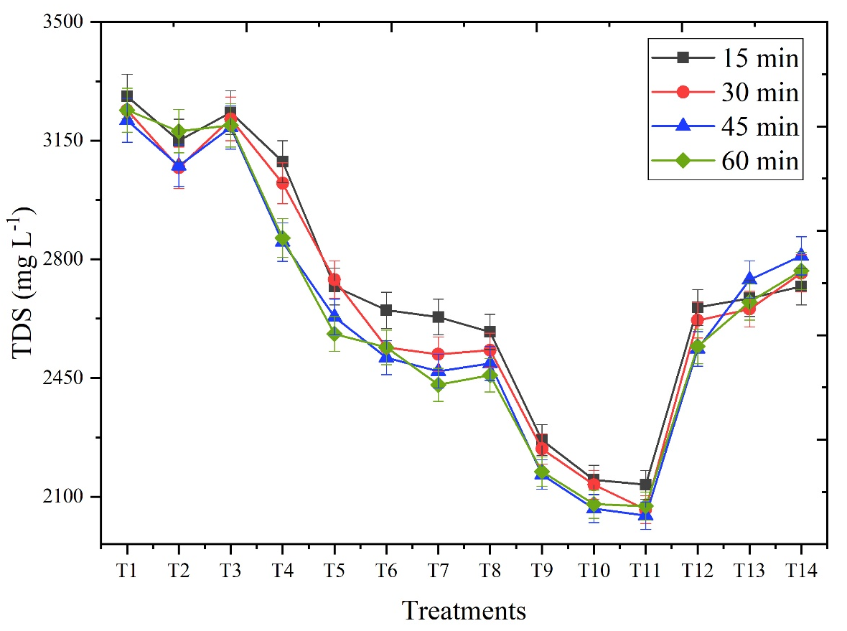
Figure 3. Effect of trials on TDS with respect to reaction time
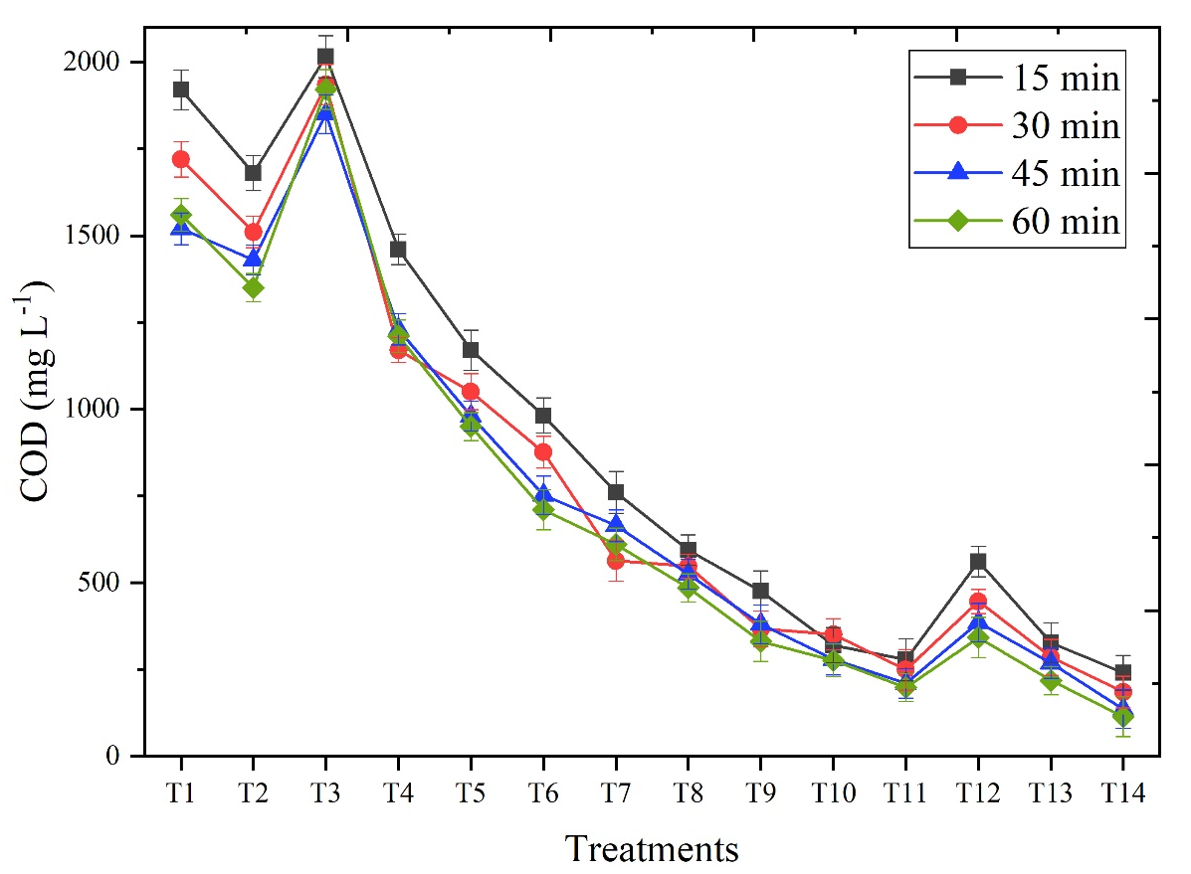
Figure 4. Effect of trials on COD with respect to reaction time
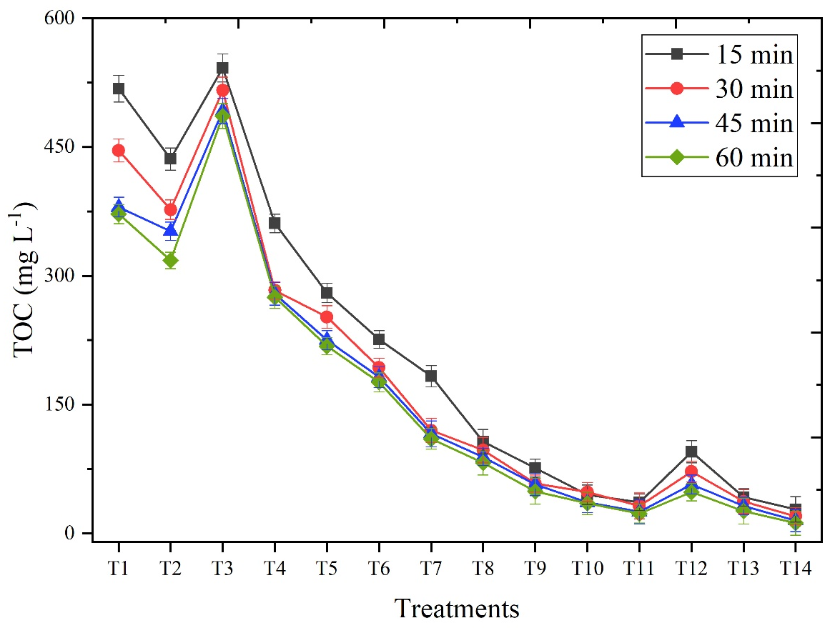
Figure 5. Effect of trials on TOC with respect to reaction time

Table 1. Details of preliminary jar test experiments
S. No. | Description | Test Jar - 1 | Test Jar - 2 | Test Jar -3
1 | Sample volume (ml) | 1000 | 1000 | 1000
2 | Lime Dosage (mg L⁻¹) | 300 | 500 | 600
3 | Coagulant dosage (mg L⁻¹) | Alum 200 | Alum 300 | PAC 300
4 | Polymer solution (Chempure-9150) (g L⁻¹) | 1 | 1 | 1
5 | Polymer dosage (mg L⁻¹) | 1 | 1 | 1
6 | Initial agitation time @ 100rpm (minutes) | 3 | 3 | 3
7 | Floc size | Smaller | Larger | Larger
8 | Settling rate | Slow | Slow | Fast
9 | Settle sludge volume | 2% | 3 % | 2%
10 | Supernatant color | Pale yellowish | Colorless | Colorless
11 | Supernatant clarity | Slightly turbid | Slightly turbid | Clear
12 | TSS in supernatant (mgL⁻¹) | 11.2 | 8.4 | 1.2
13 | Compactness of the settled sludge | Fine particles | Fine particles | Fine particles
14 | Overall efficiency | Not considerable | Not considerable | Considerable
15 | COD of the supernatant effluent (mgL⁻¹) | 2040 | 2018 | 1878
Table 2. Trail details for the advanced oxidation process
Treatment | Details
T1 | EO at pH 8.65
T2 | EO + UV at pH 8.65
T3 | UV + Fenton’s reagent (100 mg L⁻¹) at pH 8.65
T4 | EO + UV + Fenton’s reagent (50 mg L⁻¹) at pH 8.65
T5 | EO + UV + Fenton’s reagent (100 mg L⁻¹) at pH 8.65
T6 | EO + UV + Fenton’s reagent (150 mg L⁻¹) at pH 8.65
T7 | EO + UV + Fenton’s reagent (200 mg L⁻¹) at pH 8.65
T8 | EO + UV + Fenton’s reagent (250 mg L⁻¹) at pH 8.65
T9 | EO + UV + Fenton’s reagent (300 mg L⁻¹) at pH 8.65
T10 | EO + UV + Fenton’s reagent (400 mg L⁻¹) at pH 8.65
T11 | EO + UV + Fenton’s reagent (500 mg L⁻¹) at pH 8.65
T12 | EO + UV + Fenton’s reagent (500 mg L⁻¹) at pH 7.5
T13 | EO + UV + Fenton’s reagent (500 mg L⁻¹) at pH 6.5
T14 | EO + UV + Fenton’s reagent (500 mg L⁻¹) at pH 5.5

Table 3. Initial characteristics of the effluent
S. No. | Parameter | Value
1 | pH | 8.65
2 | Electrical Conductivity, dSm⁻¹ | 5.77
3 | Total Dissolved Solids, mg L⁻¹ | 3460
4 | Total Solids, mg L⁻¹ | 3506
5 | Total Suspended solids, mg L⁻¹ | 46
6 | Chlorides as CaCO₃, mg L⁻¹ | 80
7 | Silica as SiO₂, mg L⁻¹ | 11.5
8 | Iron as Fe, mg L⁻¹ | 0.01
9 | COD as O₂, mg L⁻¹ | 2120
10 | BOD as O₂, mg L⁻¹ | 354
11 | TOC as C, mg L⁻¹ | 573
Table 4. Characteristics of raw and treated effluent after Jar test
S. No. | Parameters | Raw sample | Treated sample
1 | Appearance | Slightly turbid | Clear
2 | Color | Pale yellowish | Colorless
3 | Odor | Characteristic | Odorless
4 | Turbidity, NTU | 18.4 | 1.2
5 | pH | 8.65 | 7.50
6 | TSS, mg L⁻¹ | 46 | 3.4
7 | TDS , mg L⁻¹ | 3460 | 3432
8 | COD , mg L⁻¹ | 2120 | 1878

