

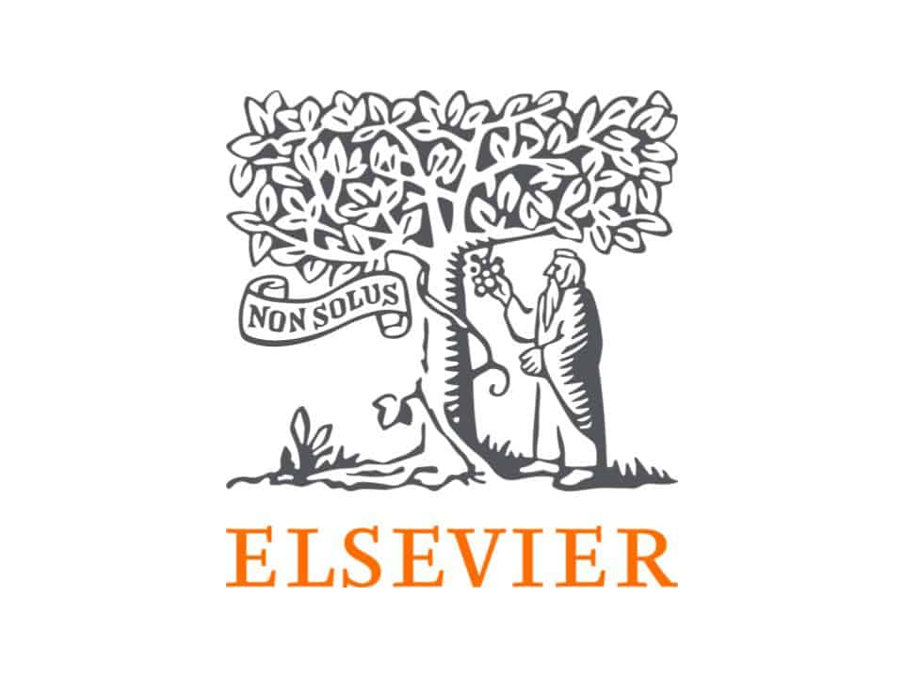



**Writeshop 2.0**

|  |  |  |
| --- | --- | --- |
| **Date and Time : 30.09.2021, 08:30 am**  **Venue: Anna Auditorium, TNAU, Coimbatore** | | |
| **Time** | **Programme Schedule** | |
| 08.30 -9.00 am | Reporting and registration | **All participants** |
| 09.00-9.10 am | Welcome | **Ms. S.Karthika**  II Ph.D. Environmental Science |
| 09.10-9.20 am | About the Writeshop 2.0 | **Dr. U.Sivakumar**  Editor in Chief, MAJ |
| 09.20-9.30 am | Felicitation | **Dr. K. Subramanian**  Director of Research |
| 09.30-9.40 am | Inaugural address | **Dr. A.S. Krishnamoorthy**  Registrar, TNAU |
| 09:40-10:40 am | New Generation Tools to Improve Visibility and Impact of Your Publications | **Dr. G. Rathinasabapathy**  University Librarian, TANUVAS |
| 10:40 – 10:55 am | Tea Break | |
| 10:55 – 12:55 pm | Understanding Research Metrics & How to Find Relevant Journals to Publish in | **Mr. Vishal Gupta**  Elsevier, New Delhi |
| 12.55-1.00 pm | Vote of thanks | **Dr. A. Kamalakannan**  President, MASU |
| 1:00-2.00 pm | **MASU GBM and Lunch** | |