REVIEW ARTICLE
Review of Genes Engineered for Abiotic Stress Tolerance in Rice

ABSTRACT
Abiotic stress adversely affects plant growth and productivity. Climate change has aggravated the negative impacts of unfavorable environmental conditions like drought, high and low temperature, salinity and flooding stress. The plants adapt, escape or tolerate the effects of these stress through various physiological and morphological mechanisms. However, they are insufficient to cope up the yield reductions, making it challenging to meet the current food demand of the increasing population. Rice being the staple food of majority of countries, has to be improved with better yield traits. Gradual advancement in productivity can be achieved through conventional breeding with modern speed breeding methods. It needs to be fueled with advanced tools such as genomics and molecular markers. This review highlights the identification of genes responsible for increased quality and quantity of rice and engineering to mitigate the undesirable impact of various abiotic stresses.
Keywords: Rice, Genes engineered, heat stress, drought stress, cold stress, salinity stress

INTRODUCTION

Rice is the most important cereal crop, leading as food crop with a cultivated area of 44500000 ha, yield of 38782 hg/ha and production of 172580000 tonnes in India and 167132623 ha of cultivated area, 46789 hg/ha of yield and 782000147 tonnes of production in the world (FAOSTAT, 2018). In today’s climate change scenario, breeding programmes and genomic researches focus on developing high-yielding stress-tolerant rice genotypes. The slow progress of conventional breeding methods has insisted on the importance of genetic engineering approaches, and it involves the identification and introduction of specific genes of interest that confers the tolerance to abiotic stress. These are followed by field trials at different locations and evaluated for their performance. In this review, we have discussed the genetic engineering studies for various abiotic stresses in rice.
Genes engineered for High and Low-Temperature Stress
Heat and Drought Tolerance
Rab7 which is one among the eight subfamilies of Rab protein has been found to enhance the plant tolerance towards various abiotic stresses (Agarwal et al., 2009). The transgenic rice lines overexpressing Rab7 (OsRab7) gene showed improved tolerance mechanisms to drought and heat stress (El-Esawi and Alayafi, 2019). The Physiological, biochemical and transcriptional analysis of the transformed rice lines had a higher percentage of survival rate under drought and heat stress. During the stress imposition the transgenic lines had higher growth characters and relative water content than the wild type lines. Moreover, they also aided the expression of OsCATA, OsCATB, OsAPX2, OsSOD-Cu/Zn genes encoding ROS scavenging enzymes and OsLEA3, OsRD29A, OsSNAC1, OsSNAC2, OsDREB2A, OsDREB2B, OsRAB16A, OsRAB16C genes exhibiting tolerance to various abiotic stresses. Together, the transgenic lines overexpressing OsRab7 gene recorded higher grain yields due to their tolerance against drought and heat stress. The performance of transgenic line with maximum expression level of OsRab7 in physiological and biochemical studies is given in the Table 1.
The WRKY genes encodes a wide group of transcription factors. Over 100 WRKY genes are present in rice. The OsWRKY11 gene was found to be induced under heat and drought stress. The promoter of HSP101 was fused with OsWRKY1cDNA in the rice lines of Sasanishiki and they were overexpression was induced with preheat treatment (Wu et al., 2009). The transgenic lines with higher levels of OsWRKY gene expression showed better heat and drought tolerance.
High Temperature Stress Tolerance
The enzyme sedoheptulose-1,7-bisphosphate is involved in the Calvin cycle at the regenerative phase. This enzyme aids in the commitment of carbon for RuBP regeneration. Hence, the reduction in this enzyme affects the rate of photosynthesis. Feng et al. (2007) reported that, overexpression of SBPase in the transgenic rice lines of zhonghua11 showed enhanced tolerance to high temperature by efficient CO2 assimilation due to the increased thermotolerance of Rubisco activase. The association of Rubisco activase was relatively higher in the wild types than the transgenic lines at higher temperatures.
Salinity, Cold and Drought Tolerance
Trehalose, a non-reducing sugar, protects the damage of biological molecules caused by various environmental stresses. The OtsA-OtsB pathway is the only trehalose biosynthesis pathway in plants. Trehalose-6-phosphate synthase (TPS) and Trehalose-6-phosphate phosphatase are the two key enzymes involved in the trehalose biosynthesis. Among the 11 OsTPS genes present in the rice genome only one OsTPS gene is involved in the trehalose synthesis. Li et al. (2011) overexpressed the OsTPS gene in rice lines and found enhanced tolerance of the transgenic lines towards salinity, cold and drought stress. Moreover various stress related genes like WSI18, RAB16C, HSP70 and ELIP were also upregulated only in the transgenic lines. The increased tolerance may due to the improved levels of proline and trehalose and the exspression of stress related genes (Fig.1).
The CIPK (calcineurin B-like [CBL] protein interaction protein kinase) is a sub-family of SnRK (Suc non-fermentation-related kinases) known as SnRKs3, one among 38 SnRKs. These are calcium sensing protein kinases involved in various stress responses. 30 putative CIPK genes are identified in the rice genome and explored for their response to various abiotic stresses. Xiang et al. (2017) reports that, 20 OsCIPK genes showed response to either one of the stress including, salinity, drought, cold, ABA treatment and polyethylene glycol treatment. The transgenic lines of japonica rice ‘Zhonghua 11’ overexpressing three OsCIPK genes (OsCIPK03, OsCIPK12 and OsCIPK15) were studied to prove those stress responsive genes had the potential to confer tolerance to cold, drought and salt stress (Fig.2). The transgenic lines with enhanced levels of OsCIPK03 and OsCIPK12 genes were able to tolerate drought and cold with increased levels of proline and soluble sugar synthesis (Table 2). Each stress induced the expression of different OsCIPK gene which conferred tolerance through different mechanisms. Moreover the transgenic lines also revealed increased expression of various other stress responsive genes like OsLEA3, OsDREB2A, OsDREB1A, OsP5CS, SNAC1 and OsCATA when subjected to drought and salinity stress.
Heat and UV-B Stress Tolerance
Heat Shock Proteins are involved in abiotic stress tolerance. In plants, mostly the small HSPs are induced in response to the high temperature stress. Murakami et al. (2004) subjected the rice seedlings to heat stress for 24 hrs which resulted in a significant resistance towards UV-B light stress. The basis was found to be a 2-fold increase in the expression of sHSP17.7 protein on exposure to heat. The transformed rice cultivar ‘Hoshinoyume’ with increased expression levels of sHSP17.7 showed elevated level of tolerance to heat stress compared to the control. They were also able to resist the UV-B damage because the survival rate of sHSP17.7 were increased by the heat stable properties of the chaperons that prevented the catalase from precicipitation.
Salinity and Drought Tolerance
Heat Shock Proteins OsHSP17.0 and OsHSP23.7 can be enhanced by preheat treatment or any other abiotic stresses. Zou et al. (2012) states that, though the wild types showed an increased level of HSPs, the transgenic lines recorded a comparatively higher level of OsHSP17.0 and OsHSP23.7 thus, displaying an enhanced level of drought and salt tolerance. The tolerance is attributed to higher proline and lower MDA content levels as shown in Table 3.
The transcription factors play an important role in plant response to abiotic stress. Some of the transcription factor involved in protection include AP2/ERF, MYB, NAC, WRKY, bZIP, and bHLH. The MYB transcription factor plays a significant role in the regulation of whole plant growth and development. In rice, the MYB transcription factor was isolated as OsMYB6 and was found to be induced by drought and salt stress. Tang et al. (2019) studied the overexpression of OsMYB6 in rice under drought and salt stress. The lines with increased expression of the transcription factor showed better tolerance towards the stress. The tolerance was conferred by various physiological alterations like increased proline content, catalase and super oxide dismutase activities (Table 4).
Salinity Tolerance
The Leaf Embryo Abundance proteins play a major role in desiccation tolerance mainly during the seed development. The genes encoding LEA proteins are activated under osmotic stress in response to salinity and cold stress. The Rab16A genes which belongs to the group @ LEA proteins have been found to confer tolerance against salinity stress. The Rab16A genes from indica rice Pokkali (salt-tolerant) was overexpressed in the indica rice variety Khitish (salt-susceptible) by Ganguly et al. (2012). The results stated that, the expression level increased with maturity of seed and was found to be maximum at seed maturity. The level of transgene expression and the protein were higher in the transformed lines than the wild types. This clearly exhibited the role of Rab16A gene i.e. the salinity tolerance at maturity stage with improved physiological traits (Fig. 3).
Conclusion
Climate change scenario has exposed the crops to various abiotic stresses like salinity, drought, cold, high temperature and flooding. Many genes have been identified in rice to mitigate the damage caused due to these stress. Although many stress responsive genes in rice have been addressed, their mechanism of tolerance in rice needs clear studies to meet the growing world population’s food demand. Hence, the detailed investigation into the physiological changes that takes place during the stress alleviation though overexpression of genes helps in developing more tolerant abiotic stress tolerant genotypes through genetic engineering tools.

Tables
Table.1. Percent increase or decrease of physiological and biochemical parameters in the lines overexpressing OsRab7 over the control under drought and heat stress
Gene overexpressed | Parameters |  | Percent increase/decrease over control under drought | Percent increase/decrease over control under heat
OsRab7 | Growth parameters | Plant height | -4 | -3
OsRab7 | Growth parameters | Root fresh weight | -1 | +4
OsRab7 | Growth parameters | Shoot fresh weight | -3 | -3
OsRab7 | Growth parameters | Relative water content | -23 | -7
OsRab7 | Enzyme activity | Hydrogen peroxide | +19 | -5
OsRab7 | Enzyme activity | MDA Content | +100 | +50
OsRab7 | Enzyme activity | Electrolyte leakage | +140 | +60
OsRab7 | Enzyme activity | Chlorophyll content | +53 | +60
OsRab7 | Photosynthetic parameters | Photosynthetic rate | -25 | -13
OsRab7 | Photosynthetic parameters | Stomatal conductance | -25 | -8
OsRab7 | Photosynthetic parameters | Transpiration rate | -17 | -3
OsRab7 | Osmolytes | Total soluble protein | +83 | +76
OsRab7 | Osmolytes | Total soluble sugars | +53 | +74
OsRab7 | Osmolytes | Proline | +106 | +115
OsRab7 | Antioxidant activity | Catalase | +48 | +60
OsRab7 | Antioxidant activity | Superoxide dismutase | +109 | +119
OsRab7 | Antioxidant activity | Ascorbate peroxidase | +36 | +46
OsRab7 | Antioxidant activity | Peroxidase | +39 | +34

Table.2. Percent increase in the soluble sugars and proline content in the lines overexpressing OsCIPK15 gene over the control during drought and cold stress
Gene overexpressed | Parameters | Percent increase over control under drought | Percent increase over control under cold
OsCIPK03 and OsCIPK12 | Soluble sugars | +79 | +74
OsCIPK03 and OsCIPK12 | Proline content | +83 | +96

Table.3. Percent change in the drought and salt tolerance parameters in the lines overexpressing OsHSP17.0 and OsHSP23.7 genes under stress
Gene overexpressed | Parameters | Percent increase/decrease over control under drought | Percent increase/decrease over control under salinity
OsHsp17.0 | Germination rate | -65 | -66
OsHsp17.0 | Shoot height | -92 | -57
OsHsp17.0 | Root length | +35 | +80
OsHsp17.0 | Proline content | +150 | +175
OsHsp17.0 | MDA content | +92 | +89
OsHsp23.7 | Germination rate | -75 | -75
OsHsp23.7 | Shoot height | -99 | -62
OsHsp23.7 | Root length | +25 | +75
OsHsp23.7 | Proline content | +155 | +171
OsHsp23.7 | MDA content | +82 | +100

Table.4. Percent increase in the biochemical parameters conferring drought and salt tolerance in transgenic lines overexpressing OsMYB6 genes
Gene overexpressed | Parameters |  | Percent increase over control under drought | Percent increase over control under Salinity
OsMYB6 | Enzyme activity | MDA Content | +99 | +73
OsMYB6 | Enzyme activity | Electrolyte leakage | +143 | +158
OsMYB6 | Osmolytes | Proline | +143 | +145
OsMYB6 | Antioxidant activity | Catalase | +89 | +88
OsMYB6 | Antioxidant activity | Superoxide dismutase | +105 | +83

Figures and Structures
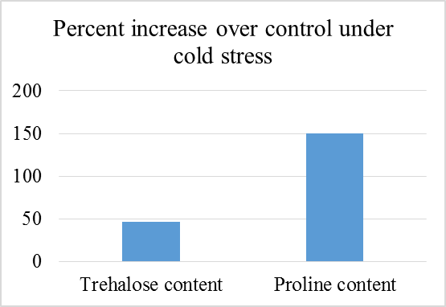

Fig. 1. Increase in proline and trehalose content in the lines overexpressing OsTPS gene under cold stress
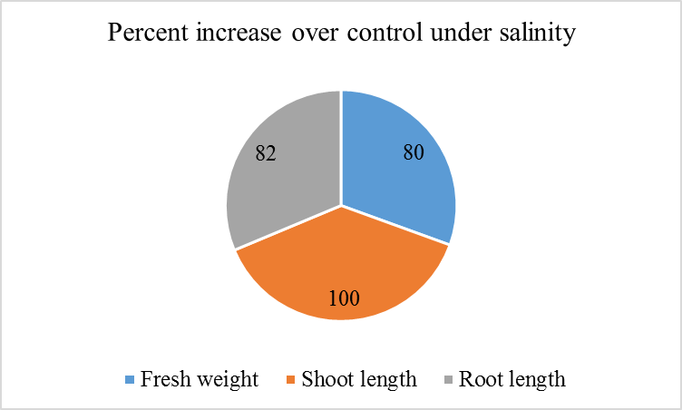

Fig.2. Percent increase in the morphological parameters in the lines overexpressing OsCIPK15 gene over the control during salinity stress
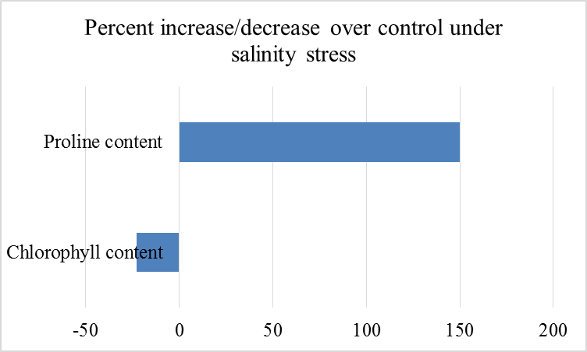

Fig.3. Transgenic lines overexpressing Rab16A gene with increased proline and decreased chlorophyll content over the control

REFERENCES
Agarwal, P., Reddy, M. K., Sopory, S. K. and Agarwal, P. K. 2009. Plant rabs: characterization, functional diversity, and role in stress tolerance. Plant Mol Biol Rep, 27(4): 417.
El-Esawi, M. A. and Alayafi, A. A. 2019. Overexpression of Rice Rab7 Gene Improves Drought and Heat Tolerance and Increases Grain Yield in Rice (Oryza sativa L.). Genes, 10(1): 56. doi:10.3390/genes10010056
FAOSTAT. 2020. http://faostat.fao.org/site/567/default.aspx#ancor (accessed 10 September 2020).
Feng, L., Wang, K., Li, Y., Tan, Y., Kong, J., Li, H., Li, Y. and Zhu, Y. 2007. Overexpression of SBPase enhances photosynthesis against high temperature stress in transgenic rice plants. Plant Cell Rep, 26(9): 1635-1646.
Ganguly, M., Datta, K., Roychoudhury, A., Gayen, D., Sengupta, D. N. and Datta, S. K. 2012. Overexpression of Rab16A gene in indica rice variety for generating enhanced salt tolerance. Plant signaling & behavior, 7(4): 502-509. doi:10.4161/psb.19646
Li, H.-W., Zang, B.-S., Deng, X.-W. and Wang, X.-P. 2011. Overexpression of the trehalose-6-phosphate synthase gene OsTPS1 enhances abiotic stress tolerance in rice. Planta, 234(5): 1007-1018. doi:10.1007/s00425-011-1458-0
Murakami, T., Matsuba, S., Funatsuki, H., Kawaguchi, K., Saruyama, H., Tanida, M. and Sato, Y. 2004. Over-expression of a small heat shock protein, sHSP17.7, confers both heat tolerance and UV-B resistance to rice plants. Molecular Breeding, 13(2): 165-175. doi:10.1023/B:MOLB.0000018764.30795.c1
Tang, Y., Bao, X., Zhi, Y., Wu, Q., Guo, Y., Yin, X., Zeng, L., Li, J., He, W., Liu, W., Wang, ., Jia, C., Li, Z. and Liu, K. 2019. Overexpression of a MYB Family Gene, OsMYB6, Increases Drought and Salinity Stress Tolerance in Transgenic Rice. Frontiers in plant science, 10(168): doi:10.3389/fpls.2019.00168
Wu, X., Shiroto, Y., Kishitani, S., Ito, Y. and Toriyama, K. 2009. Enhanced heat and drought tolerance in transgenic rice seedlings overexpressing OsWRKY11 under the control of HSP101 promoter. Plant Cell Reports, 28(1): 21-30. doi:10.1007/s00299-008-0614-x
Xiang, Y., Huang, Y. and Xiong, L. 2007. Characterization of Stress-Responsive CIPK Genes in Rice for Stress Tolerance Improvement. Plant Physiology, 144: 1416–1428
Zou, J., Liu, C., Liu, A., Zou, D. and Chen, X. 2012. Overexpression of OsHsp17.0 and OsHsp23.7 enhances drought and salt tolerance in rice. Journal of Plant physiology, 169: 628-635. doi:10.1016/j.jplph.2011.12.014

