RESEARCH ARTICLE
Molecular Modeling and Dynamics Studies of Hexanal Release from Polyvinyl alcohol – β-Cyclodextrin Nano-fiber Composite for Extending Shelf-life of Mango

ABSTRACT
Postharvest losses are huge in fruits that can be reduced by exposing them to a biomolecule hexanal, which is known to alter the physiological changes resulting in an extension of shelf-life. Hexanal is a highly volatile compound, it is naturally produced by plants. Its external application extends shelf-life of fruits during storage by inhibiting phospholipase –D enzyme in the cell wall. A study was undertaken to examine the kinetics of hexanal release from the polyvinyl alcohol – β cyclodextrin encapsulated nanofiber composite using a molecular modeling approach. The present study focussed on the analysis of the influence of relative humidity and temperature on the nanofiber composite to release hexanal. The release and retention behavior of hexanal was investigated with the relative humidity range of 50%- 95% at 27 °C and 33 °C. The molecular modeling studies have confirmed that the hexanal vapor release is altered with humidity and temperature regimes. This can be used for the fabrication of a delivery system for hexanal in extending the shelf-life of fruits in storage godowns.

Keywords: Polymer, Molecular Modeling, Polyvinyl alcohol; Cyclodextrin; Hexanal; Release Kinetics

INTRODUCTION
Despite India’s statistics is very attractive in the production of many of the fruits, the per capita availability is deficit by 40% due to the postharvest loss. Postharvest food loss is defined as measurable qualitative and quantitative food loss along the supply chain, starting at the time of harvest until its consumption or other end uses (Hodges et al., 2011). The biggest problem affecting the country’s agriculture and the agricultural market is postharvest losses, and it adversely affects the Indian economy. These are due to poor infrastructure and transportation, insufficient or unavailability of cold storages in immediacy to farms, etc., which cause price fluctuations resulting in farmer’s frustrations of not getting remunerative prices besides rural economic failure (Ali, 2003; Maheshwar and Chanakwa, 2006; Rolle, 2006). Hence, minimizing the loss can increase the supply without bringing additional land under cultivation. These situations demand strategies to minimize postharvest losses and maximize the availability of fruits.
Electrospinning is a versatile technique for producing multifunctional nanofibers from various polymers, polymer blends, and composites(Greiner and Wendorff, 2007; Li and Xia, 2004). Polyvinyl alcohol (PVA) is used in food technology, pharmaceutical, and biomedical applications for controlled drug release with an added advantage of biodegradability and non-toxic properties (Reis et al., 2006). In the past few years, hexanal based formulations have been found very effective in fruit preservation. Hexanal, a naturally occurring volatile compound, is a potent inhibitor of Phospholipase D activity on the fruit skin. Hexanal is found in nearly 300 natural sources including apple, berries, apricot, banana, guava, sweet and sour cherries, citrus peel oil and juices, etc. with molecular formula C₆H₁₂O and molecular mass 100.1 a.m.u, present in a liquid state at Normal Temperature and Pressure (NTP). But hexanal has very low vapor pressure i.e. 10 mmHg at 20 ºC, and thus easily volatilized when the temperature rises. Exogenous application of hexanal treatment showed encouraging results in enhancing shelf-life of several fruits such as apple, banana, cherry, peach, strawberry as well as vegetables such as broccoli, tomato, and several fresh-cut vegetables, and flowers such as carnation and rose (Paliyath et al., 1999).
Several novel methods have been used to control postharvest losses. Some of them are viz., use of hot water with fungicides to reduce postharvest losses caused by fungal diseases (Iram and Ahmad, 2013), dynamic controlled atmosphere (Kader, 2003), ethylene inhibition technology (Lurie and Paliyath, 2009) and hexanal technology for extended shelf-life (Anusuya et al., 2016; Jincy et al., 2017). Many researchers are interested in β cyclodextrin (β-CD) nanofiber because it can dramatically improve desirable properties by an increase of the specific surface area. In food technology (Kayaci et al., 2014), incorporated Geraniol-cyclodextrin inclusion complex in electrospun fiber composites having prolonged release and preserve the food for a long time.
Up to date, some studies focussed on the morphology improvement of electrospinning nanofibers, but very few researchers take into account the ability of composite nanofibers for capturing guest molecules. To gain further knowledge and precisely to predict the release kinetics, molecular modeling approach was attempted. In recent times, molecular modeling methods have found a wide range of applications in diverse fields and are used to investigate the structure and behavior properties of many polymeric and biological systems. It comprises computational methods and simulations which configures and studies how all molecules behave, ranging from small chemical systems to large molecules and material assemblies. Atomistic modeling is the most common feature and a powerful tool that helps in studying the structural properties of polymer composites (Radosinski and Labus, 2017). Modeling helps in simulating the behavior of a system and provides complete structure and intermolecular interactions (Wu, 2010). Hexanal is entrapped in β cyclodextrin and PVA and used as a composite to enhance the shelf-life of fruits. With this view, the present research focuses on molecular modeling of hexanal vaporization, where it is entrapped in PVA and cyclodextrin nanofibers in temperature and relative humidity (RH) regimes. PVA-β Cyclodextrin serves as a template to develop nanofiber composite, which effectively entraps hexanal vapor and regulates its release for an extended period of fruits. Such a process enables the extension of shelf-life of mango fruits under storage conditions.

MATERIAL AND METHODS

Structure generation
Schrodinger materials science suite (v.2017-3) was used to study the molecular dynamics (MD) and simulation of the nanofiber composites. A primary system was built for PVA- β cyclodextrin and hexanal. The structure of hexanal (PubChem CID: 6184) and β cyclodextrin (PubChem CID: 444041) were retrieved from the PubChem database (https://pubchem.ncbi.nlm.nih.gov/). Polymer builder panel was used to generate an initial PVA structure (1750 monomers). The numbers of molecules were calculated based on mass percentage. Thirty-four molecules of β cyclodextrin and 51 molecules of hexanal were packed in 1 PVA polymer chain containing 438 monomers. The structures were built in a periodic boundary cell of size - 45× 51× 52 Å^{3,} and the molecular dynamics studies were carried.

Molecular dynamics and minimization
The molecular dynamics of hexanal release from the nanofiber composite was carried out simulating the experimental parameters such as relative humidity in fruit box i.e., [50 % to 95 %] and tropical mango harvesting temperatures 27 °C (300 Kelvin (K)) and 33 °C (303 Kelvin (K)) corresponds to the off-season and regular season of mango, respectively. The MD simulation was carried out for 5 ns duration at 27 °C (system I) and extended up to 10 ns period at 33 °C (system II). The recording interval for the trajectory generation was set as 5 picoseconds (ps). The approximate number of frames was set to 1000. The pressure was set to 1.01325 bars, and the time step was 2.0 femtosecond (fs). The simulations were run under NPT type, which consists of a constant number of atoms, constant pressure, and constant temperature. OPLS3 (Optimized Potentials for Liquid Simulations) force field was selected for the energy minimization option. The Energy plot (simulation quality analysis) and movement of hexanal release (RMSD) (simulation event analysis) were plotted for the trajectory data obtained for PVA- β cyclodextrin- hexanal complex at 27 °C and 33 °C that were recorded through MD simulations.

Simulation analysis
The Energy plot (simulation quality analysis), root mean square deviation (simulation event analysis) were plotted for the trajectory data obtained for PVA- β cyclodextrin- hexanal and water complex at 27 °C and 33 °C that were recorded through MD simulations.

Modeling the polymer chain backbone
To confirm the conformation of the PolyVinyl Alcohol chain in the complex, the torsion angle was calculated for the results obtained from the trajectory of molecular dynamics simulation after the 10 nanoseconds (ns) duration. Totally four atoms were selected sequentially for both chains. The torsion angle of the main chain is the Methyl Terminal Torsion (MTT), which is defined by MTT_{i} containing H_{i+2}-C_{i-1}-C_{i}-C_{i+1} and MTT_{i+1} containing C_{i-1}-C_{i}-C_{i+1}-C_{i+2} (Figure.1). The torsion angle of the side chain is the Hydroxyl Terminal Torsion (HTT), that is defined by HTT_{i} containing H_{i}-O_{i}-C_{i}-C_{i+1} and HTT_{i+1} containing O_{i}-C_{i}-C_{i+1}-C_{i+2} (Figure.2).

RESULTS AND DISCUSSION

Polymer builder and disordered system builder
Molecular dynamics is the best method when compared to conventional methods to study and predict the polymer blends (Moolman et al., 2005). Initially, one chain of atactic PVA with a 1750 degree of polymerization was built. A multicomponent system of hexanal and β cyclodextrin packed in PVA polymer was built that was randomly distributed in a simulation box (Figure.3). The whole system was studied under periodic boundary conditions. To conserve computational time, which enables the simulation to be performed using a relatively less number of monomers, another chain of PVA was built with 438 monomer units based on the mass percentage and used for subsequent simulations.

Effect of Temperature and Humidity on the release of Hexanal using Molecular dynamics simulation
MD simulation was carried out for the primary system at 27 °C and 33 °C for 5 ns and 10 ns, respectively, with relative humidity ranging from 50 % to 95 %, using Desmond software. The conformational changes were monitored using trajectory data obtained during the simulation. Results were obtained by the MD simulation. The trajectory result of 27 °C and 33 °C was considered a system I and system II, respectively. A PVA- β cyclodextrin- hexanal complex build for 50 % relative humidity is presented in (Figure.4).

Simulation analysis
The movement of hexanal, their release, and the potential energy were calculated and plotted using simulation quality analysis and simulation event analysis. The movement of hexanal release and energy of the whole system was plotted for 5000 ps and 10000 ps for the system I and II, respectively.

Simulation event analysis: Movement of hexanal release
The movement of hexanal release was analyzed through the MD simulation trajectory for systems I and II incorporated with water molecules corresponding to 50 % relative humidity to 95 % relative humidity at 27 °C and 33 °C for 5000 ps and 10000 ps, respectively. The values corresponding to the movement of hexanal from the nanofiber composite is given (Table 1).

Among the analysis of the MD simulation carried out for 5 ns at 27 °C, the minimum movement of hexanal release occurred when the relative humidity was at 60 % and the maximum movement was observed when the relative humidity was at 85 %. The movement of hexanal release values from the MD trajectory frame with respect to the initial structure of hexanal lies at around 19.8 (Å) at 60 % relative humidity and 25.5 (Å) at 85 % relative humidity. The relative humidity triggers the release of volatile compounds (Ayala‐Zavala et al., 2008). However, a slow release of the compound was observed at low relative humidity. The movement of hexanal release plot made for the PVA- β cyclodextrin- hexanal complex at 27 °C shows a little change in the initial position and revealed that the complex was stable throughout the simulation time of 5 ns. It is obvious that at lower or ambient room temperature, the release of hexanal from the PVA- β cyclodextrin composite is triggered by the presence of high relative humidity in the surrounding environment. This may be due to the high retention capacity of β cyclodextrin that is able to hold on hexanal for a longer period of time. When there is a prevalence of lower relative humidity the release of hexanal from the composite is retarded to some extent. Similarly, when the humidity level was increased, the release of volatile l-menthol blended in gum arabic and modified starch was also increased (Del Toro-Sánchez et al., 2010).
The movement of hexanal release values of the MD trajectory frame with respect to the initial structure of hexanal lies at around 23 (Å) at 80 % relative humidity and 26.3 (Å) at 60 % relative humidity. It reveals the change of the initial position of hexanal. From this result, it shows that when the temperature is increased, the hexanal release from the PVA- β cyclodextrin composite is induced when there is a low relative humidity in the environment. The water molecules got destructured when there is a high temperature (Chiessi et al., 2005), and there are changes in the polymer conformation. This confirms our data that at a high temperature of 33 °C, water molecules get destructured rapidly, and due to the polymer chain conformation, hexanal is released quickly at low relative humidity level. In the presence of higher temperatures, the water molecules are released from the composite rapidly from the complex. PVA nanofibers were promising materials for the volatile entrapment, and incorporation of β cyclodextrin helped in the encapsulation of a higher amount of volatiles (Aytac et al., 2014). The relevant graph for the movement of hexanal release from 50 % – 95 % relative humidity at both 27 °C and 33 °C are presented in Figure.5.

Simulation quality analysis: Energy of the nanofiber composite
The energy of the PVA- β cyclodextrin- the hexanalnano-fiber complex was analyzed (Figure.6). The energy scheme was plotted for the trajectory data obtained for the MD simulation result of the system I incorporated with water molecules corresponding to 50 % relative humidity to 95 % relative humidity at 27 °C for 5000 ps and system II at 33 °C for 10000 ps. The Energy plot explains that the PVA- β cyclodextrin- Hexanal nanofiber composite with water molecules were stable throughout every 5 ns and 10 ns simulation run at both 27 °C and 33 °C. The average potential energy was calculated for the data from 50 %- 95 % relative humidity at both the temperatures (Table 2).

The energy calculation done in simulation quality analysis revealed that at 27 °C with 60 % relative humidity, the total energy was 42703.182864 kJ/mol, potential energy was 14435.5128084 kJ /mol with 297.170 temperature (K) and the volume was 116808.775 (Å³), and the total energy was 42636.6839196 kJ /mol, potential energy was 14221.889712 kJ /mol with 297.000 temperature (K), and the volume was 116881.779 (Å³)with 85 % relative humidity. For the energy calculation done at 33 °C with 60 % relative humidity, the total energy was 43535.0037276 kJ/mol, potential energy was 14704.858026 kJ/mol with 303.083 temperature (K), and the volume was 114292.746 (Å³) and the total energy was 43714.0396692 kJ/mol, potential energy was 14751.0677376 kJ/mol with 303.127 temperature (K), and the volume was 118121.917 (Å³)with 80 % relative humidity. Cyclodextrin inclusion complex along with PVA can improve the stability and durability of vanillin (Kayaci and Uyar, 2012). The energy plot reveals that the energy of the whole PVA- β cyclodextrin- hexanalnano-fiber composite was relatively stable throughout the simulation in 5 ns and 10 ns simulation run done at 27 °C and 33 °C with relative humidity 50 % to 95 %. Nevertheless, potential energy is the responsible component for structural stability, which was equilibrated well during the simulation. When the guest molecules were introduced, the total energy-reduced enabling the complexation of volatile organic compound and cyclodextrin(Celebioglu et al., 2016).

The motion of the PVA backbone chain
The torsional angle conformers of the PVA chain were studied by the analysis of the main chain termed as Methyl Terminal Torsion (MTT) (Figure.7 a&b) and side-chain termed as Hydroxyl Terminal Torsion (HTT) (Figure.8 a&b). It is evident that the torsion angles of the PVA main chain showed a preferable transition in the range of +180º and -180º, +50º to +70^{o,} and -50º to -70º in MTT_{i}. The MTT_{i+1} torsion angle of the PVA side chain showed a preferable transition in the range of +180º, -180º, and +60º to +70º. The torsion angle of the main chain of PVA preferred to be in +90º, +180º, -90^{o,} and -180º (De La Rosa et al., 2002). The HTT_{i}torsion angles of the PVA side chain showed a preferable transition in the range of +60º to +120º and -60º to -120º. The HTT_{i+1} torsion angle of the PVA side chain showed a preferable transition in the range of +60º to +100º, +180^{o,} and -180º. The preferable angles for side chain to be in +40º, -160º, -180º (De La Rosa et al., 2002). PVA dihedral angle is to be around 68º, 290^{o,} and 179º. It was proved that in the main chain torsional angle, conformer was predominant, and PVA adopted gauche conformation, and the trans conformation was predominant in the PVA backbone (Merat et al., 2013).

CONCLUSION
Molecular dynamics simulation has been employed to study the release of hexanal from polyvinyl alcohol- β cyclodextrin- hexanal complex. We have investigated the release and retention behavior of hexanal from the complex composite with the relative humidity range of 50%- 95% at 27 °C (300 K) and 33 °C (303 K) and new, complementary information were presented in this work. Here, the present simulation study focussed on building a simplified model to describe the complexation of polyvinyl alcohol- β cyclodextrin- hexanal, which provides a close resemblance of their dynamic behavior in terms of root mean square deviation (RMSD), energy determination and conformational changes through determining the torsion angles. The effect of relative humidity on the Polyvinyl alcohol- β cyclodextrin- hexanal for the release of hexanal at room or low temperature indicates the need for high relative humidity for a sustainable release of hexanal. At the same time, at high temperatures, the release of hexanal is triggered rapidly by the water molecules from the polymer and β cyclodextrin complex. In particular, the generated model and the analysis have shown the importance of the relative humidity and temperature on the release of the volatile, hexanal from the complex. Further, these results help in the manipulation of the hexanal release by controlling the relative humidity and temperature in the storage condition for enhancing the shelf-life of perishables. The data demonstrated that hexanal vapor release from the nanocomposite of electrospun nanofibers composite is distinct between two temperature and RH regimes coincides with the fruit storage in the off-season and regular season mangoes. The kinetics of hexanal vapor release matched and well-fit with molecular modeling tools and techniques. Based on the above results, it is apparent that molecular dynamics have a great potential in predicting the complexation of polymer with the inclusion complex of β cyclodextrin and hexanal and its release, where it is difficult to determine through experimental analysis by the conventional method.

Funding and Acknowledgment
This work was supported by the Canadian International Development Agency (CIDA) and the International Development Research Centre (IDRC) through the CIFSRF project.

Consent for publication

All the authors agreed to publish the content.

Competing interests
There was no conflict of interest in the publication of this content

REFERENCES
Ali, N. 2003. Post Harvest Technology for Employment Generation in Rural Sector Of India. Paper presented at the Regional Seminar on Post-Harvest Technology for Major Crops 3-5 November 2003.
Anusuya, P., Nagaraj, R., Janavi, G. J., Subramanian, K. S., Paliyath, G., and Subramanian, J. 2016. Pre-harvest sprays of hexanal formulation for extending retention and shelf-life of mango (Mangifera indica L.) fruits. Scientia Horticulturae, 211: 231-240.
Ayala‐Zavala, J., Del‐Toro‐Sánchez, L., Alvarez‐Parrilla, E., and González‐Aguilar, G. 2008. High relative humidity in‐package of fresh‐cut fruits and vegetables: advantage or disadvantage considering microbiological problems and antimicrobial delivering systems? Journal of Food Science, 73(4): R41-R47.
Aytac, Z., Dogan, S. Y., Tekinay, T., and Uyar, T. 2014. Release and antibacterial activity of allyl isothiocyanate/β-cyclodextrin complex encapsulated in electrospun nanofibers. Colloids and Surfaces B: Biointerfaces, 120: 125-131.
Celebioglu, A., Sen, H. S., Durgun, E., and Uyar, T. 2016. Molecular entrapment of volatile organic compounds (VOCs) by electrospun cyclodextrin nanofibers. Chemosphere, 144: 736-744.
Chiessi, E., Cavalieri, F., and Paradossi, G. 2005. Supercooled water in PVA matrixes. II. A molecular dynamics simulation study and comparison with QENS results. The Journal of Physical Chemistry B, 109(16): 8091-8096.
De La Rosa, A., Heux, L., Cavaillé, J.-Y., and Mazeau, K. 2002. Molecular modeling of the mobility of poly (allyl alcohol), PAA, and poly (vinyl alcohol), PVA. Polymer, 43(21): 5665-5677.
Del Toro-Sánchez, C., Ayala-Zavala, J., Machi, L., Santacruz, H., Villegas-Ochoa, M., Alvarez-Parrilla, E., and González-Aguilar, G. 2010. Controlled release of antifungal volatiles of thyme essential oil from β-cyclodextrin capsules. Journal of inclusion phenomena and macrocyclic chemistry, 67(3-4): 431-441.
Greiner, A., and Wendorff, J. H. J. a. C. I. E. 2007. Electrospinning: a fascinating method for the preparation of ultrathin fibers.46(30): 5670-5703.
Hodges, R. J., Buzby, J. C., and Bennett, B. 2011. Postharvest losses and waste in developed and less developed countries: opportunities to improve resource use. The Journal of Agricultural Science, 149(S1): 37-45.
Iram, S., and Ahmad, H. 2013. Major post harvest diseases of Mango and their management. International Journal of Agronomy and Plant Production, 4(12): 3470-3484.
Jincy, M., Djanaguiraman, M., Jeyakumar, P., Subramanian, K., Jayasankar, S., and Paliyath, G. 2017. Inhibition of phospholipase D enzyme activity through hexanal leads to delayed mango (Mangifera indica L.) fruit ripening through changes in oxidants and antioxidant enzymes activity. Scientia Horticulturae, 218: 316-325.
Kader, A. A. 2003. A perspective on postharvest horticulture (1978-2003). HortScience, 38(5): 1004-1008.
Kayaci, F., Sen, H. S., Durgun, E., and Uyar, T. J. F. R. I. 2014. Functional electrospun polymeric nanofibers incorporating geraniol–cyclodextrin inclusion complexes: High thermal stability and enhanced durability of geraniol.62: 424-431.
Kayaci, F., and Uyar, T. 2012. Encapsulation of vanillin/cyclodextrin inclusion complex in electrospun polyvinyl alcohol (PVA) nanowebs: prolonged shelf-life and high temperature stability of vanillin. Food chemistry, 133(3): 641-649.
Li, D., and Xia, Y. J. a. M. 2004. Electrospinning of nanofibers: reinventing the wheel? , 16(14): 1151-1170.
Lurie, S., and Paliyath, G. 2009. Enhancing Postharvest Shelf Life and Quality in Horticultural Commodities. Postharvest Biology and Technology of Fruits, Vegetables, and Flowers, 139.
Maheshwar, C., and Chanakwa, T. 2006. Postharvest losses due to gaps in cold chain in India-a solution. Paper presented at the IV International Conference on Managing Quality in Chains-The Integrated View on Fruits and Vegetables Quality 712.
Merat, K., Chaodamrongsakul, J., Tanthanuch, W., and Vao-Soongnern, V. 2013. Atomistic solvation structure of calcium ion in poly (vinyl alcohol) as studied by molecular dynamics simulation and X-ray absorption spectroscopy. Journal of non-crystalline solids, 371: 47-52.
Moolman, F., Meunier, M., Labuschagne, P. W., and Truter, P.-A. 2005. Compatibility of polyvinyl alcohol and poly (methyl vinyl ether-co-maleic acid) blends estimated by molecular dynamics. Polymer, 46(16): 6192-6200.
Paliyath, G., Pinhero, R. G., Yada, R. Y., and Murr, D. P. 1999. Effect of processing conditions on phospholipase D activity of corn kernel subcellular fractions. Journal of agricultural and food chemistry, 47(7): 2579-2588.
Radosinski, L., and Labus, K. 2017. Molecular modeling studies of structural properties of polyvinyl alcohol: a comparative study using INTERFACE force field. Journal of molecular modeling, 23(11): 305.
Reis, E. F. D., Campos, F. S., Lage, A. P., Leite, R. C., Heneine, L. G., Vasconcelos, W. L., . . . Mansur, H. S. 2006. Synthesis and characterization of poly (vinyl alcohol) hydrogels and hybrids for rMPB70 protein adsorption. Materials Research, 9(2): 185-191.
Rolle, R. S. 2006. Improving postharvest management and marketing in the Asia-Pacific region: issues and challenges. Postharvest management of fruit and vegetables in the Asia-Pacific region, 1(1): 23-31.
Wu, C. 2010. Cooperative behavior of poly (vinyl alcohol) and water as revealed by molecular dynamics simulations. Polymer, 51(19): 4452-4460.

Figure.1.Mainchain Methyl Torsion Terminal (MTT_{i} and MTT_{i+1})


H_{i+2}
C_{i}
C_{i-1}
C_{i+1}
C_{i+2}
MTT_{i}
MTT_{i+1}

Figure.2.Side Chain Hydroxyl Torsion Terminal (HTT_{i} and HTT_{i+1})

H_{i}
O_{i}
C_{i}
C_{i+1}
HTT_{i}
HTT_{i+1}
C_{i-1}
C_{i+2}

Figure.3.A multicomponent system of β cyclodextrin and hexanal packed in PVA polymer was built that was randomly distributed in a simulation box. The green color matrix indicates the PVA polymer chain, in which the β cyclodextrin- Hexanal complex has been entrapped. It has been magnified in the right side image where the yellow matrix indicates β cyclodextrin and the red color compound is the entrapped hexanal
Figure.4. A disordered system of PVA- β-Cyclodextrin- hexanal complex- Green: PVA; Blue: β-Cyclodextrin; Red: Hexanal; Red dot: Water molecules  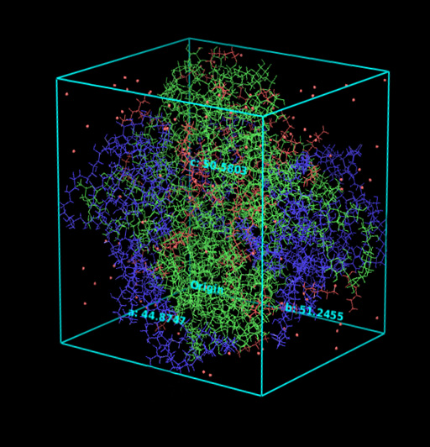  Figure.5.Effect of Temperature and Humidity on the release of Hexanal | 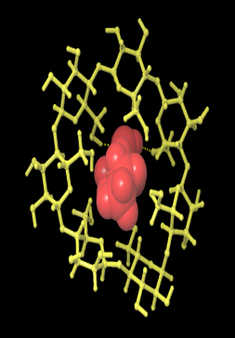
  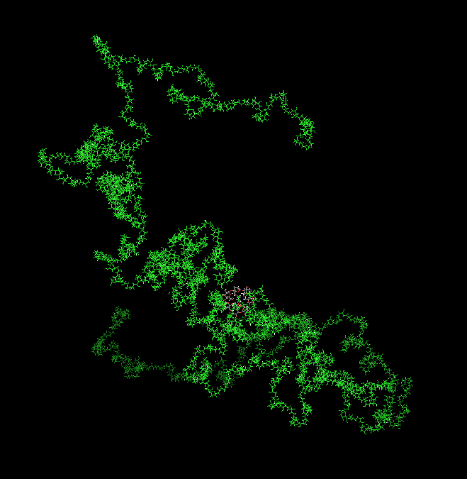
  β-Cyclodextrin – Hexanal complex
  PVA
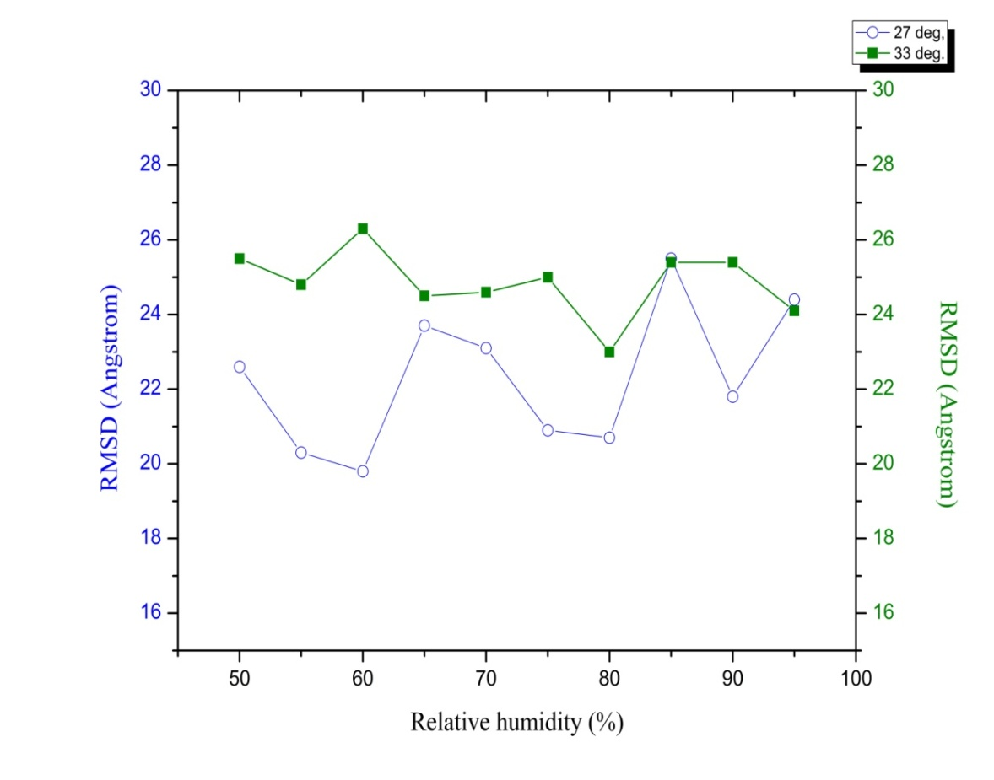

Figure.6. The energy trajectory of the PVA- β cyclodextrin- Hexanal

Potential energy (kJ/mol) | 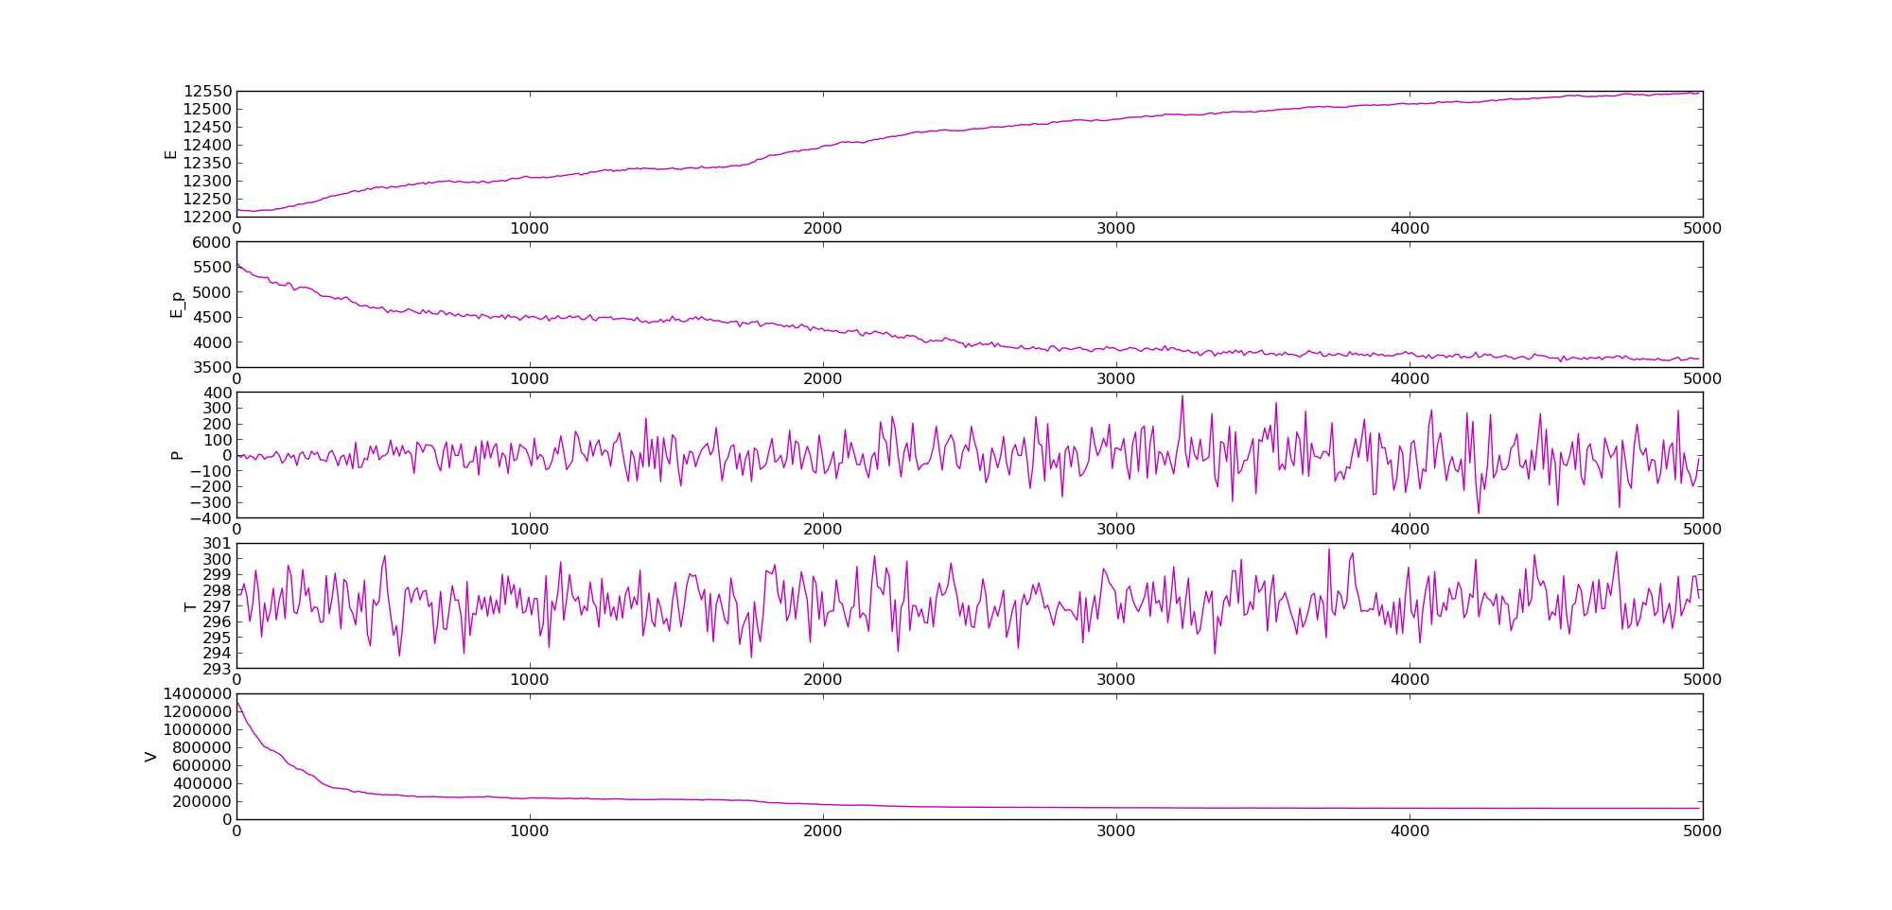
Time (ps)
Figure.7. Torsion angles of main chain atoms of PVA (MTT_{i} and MTT_{i+1})
a
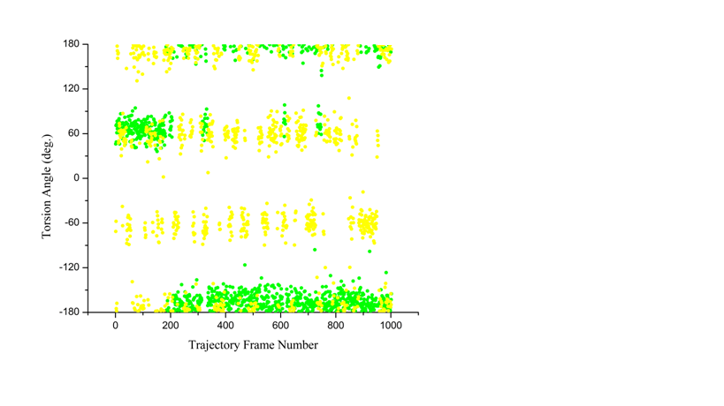 | MTT_{i}  MTT_{i+1}

b
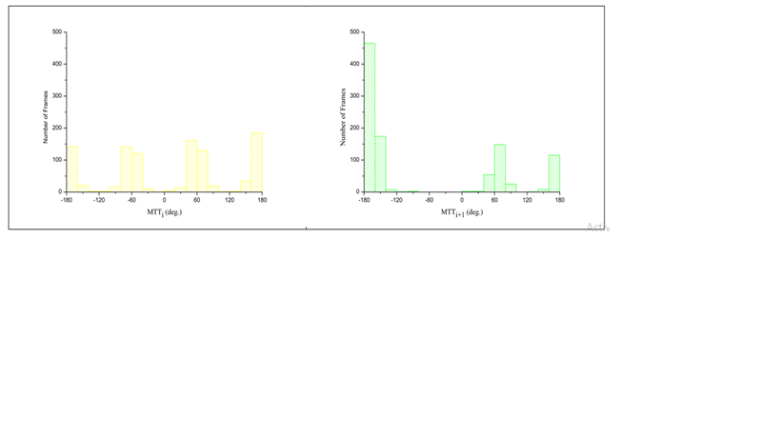

Figure.8. Torsion angles of side chain atoms of PVA (HTT_{i} and HTT_{i+1})

a

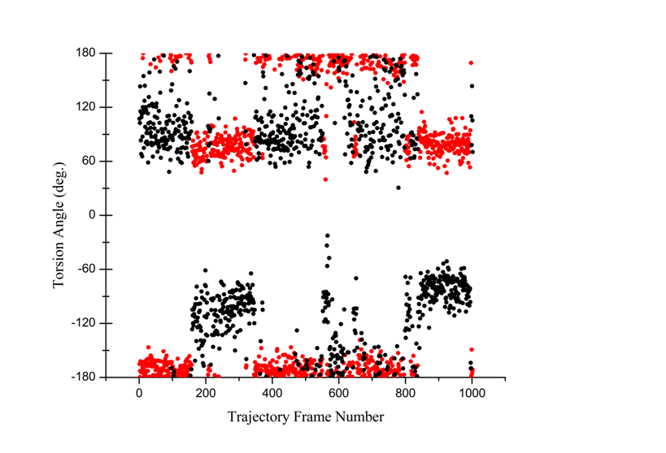 | HTT_{i}  HTT_{i+1}
b
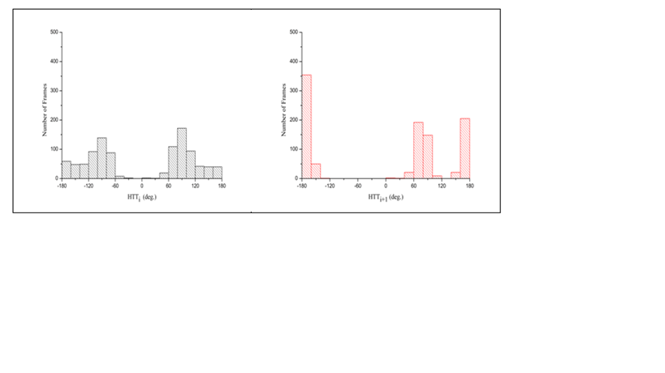

Table 1. Movement of hexanal release at 27 °C &33 °C

Relative Humidity (%) | @ 27 °C (Å) | @ 33 °C (Å)
50 | 22.6 | 25.5
55 | 20.3 | 24.8
60 | 19.8 | 26.3
65 | 23.7 | 24.5
70 | 23.1 | 24.6
75 | 20.9 | 25
80 | 20.7 | 23
85 | 25.5 | 25.4
90 | 21.8 | 25.4
95 | 24.4 | 24.1

Table 2. Average potential energy (kJ/mol)
Relative Humidity (%) | Average Potential Energy (kJ/mol) at 27 °C | Average Potential Energy (kJ/mol) at 33 °C
50 | 14608.9091304 | 14909.8939956
55 | 14418.7823556 | 14787.3044916
60 | 14435.5128084 | 14704.858026
65 | 14435.0773812 | 14776.4020644
70 | 14362.8341472 | 14541.991506
75 | 14364.764262 | 14608.9091304
80 | 14398.0535088 | 14751.0677376
85 | 14221.889712 | 14608.9091304
90 | 14222.9657196 | 14608.9091304
95 | 14256.2382192 | 14608.9091304

