RESEARCH ARTICLE
Inorganic Metaloxide Nanoparticles Seed Invigoration for Extended Storability of Sunflower (Helianthus annus) under Ambient Environment

ABSTRACT
The present study aimed to enhance the viability of sunflower seeds during ageing under ambient environment. Sunflower seeds were treated with nano-particles of Zinc oxide (ZnO NPs), Titanium oxide (TiO₂NPs), and Copper oxide (CuONPs) at 1000 mg kg⁻¹, 750 mg kg^{-1,} and 1250 mg kg⁻¹, packed in moisture impervious containers and stored under ambient conditions along with untreated seeds. Seed quality parameters such as physiology and biochemical attributes besides volatile organic compounds (VOCs) emanation were evaluated at a monthly interval. The results demonstrated that ZnONPs seed invigoration at 1000 mg kg⁻¹ excelled over the other metal oxides in maintaining the seed storability for six months of storage registering5 percent increase in germination over control (80% germination and seedling vigor of 2362). Similarly, the emanation of VOCs (aldehydes, ketones, alcohols, acids, esters, and ethers were found to be less (14 compounds) in ZnONPs invigored seeds than control wherein about 26 VOCs compounds were emanated. This study concluded that ZnONPs seed dressing could be a viable seed invigorant for extending the storability of sunflower under ambient conditions.

Keywords: Nano-particles, sunflower, volatile emission, seed quality.

INTRODUCTION
Sunflower (Helianthus annus) is one of the vital oilseed crop being cultivated in an area of 26 million hectares with the production of 45 million metric tonnes/annum in the world. Similarly in India, sunflower occupies 1.48 million hactares with 200 metric tonnes of production, In Tamil Nadu, it was 10 metric tonnes production. Sunflower seeds rich in nutrient components such as vitamins, minerals, antioxidants, dietary fibre, phytochemicals, and polyunsaturated fatty acids like linoleic and oleic constituted about 80%. In many parts of India and the world, sunflower seeds are usually stored for a period of about one year before sowing. Nevertheless, seed germinability deteriorates quickly due to lipid peroxidation (Kibinza et al., 2006) during storage. As the current technologies available to prolong the vigor and viability of sunflower seed on a large scale are not satisfactorily alleviating the practical problem, an alternative practicable and straightforward seed invigoration treatment to control seed deterioration of sunflower is need of the hour. These are scientific reports evidenced the nanomaterial's invigoration on seed quality enhancement in a wide array of crops (Raja et al., 2019; Dhileepkumar et al., 2015). Natarajan and Sivasubramanian (2008) stated various nanotechnological approaches that can be employed, which include nano-polymer for seed harding, Nano-Particles (NPs) for seed quality enhancement, nano-sensors, nano-barcodes, use of nano-magnetic particles for aerial seeding etc. Successful attempts were made in China to counteract free radicals in spinach by using titanium nano-particles and improve the germination (Lu et al., 2002). Krishnashyla et al., 2016 reported nano-particle treated seeds performed well in improving the seed germination, shoot length, root length and seedling vigor, and also it posses higher catalase, peroxidase and dehydrogenase activity with less amount of electrical conductivity volatile organic compounds emanated in groundnut under ambient environment. ZnO and ZVI nano-particles seed dry dressing found to be enhanced the quality of blackgram seeds under storage (Senthil kumar, 2011). Sridhar (2012) has shown that dry dressing of ZnO nanorods @ 1000 and 1250 mg kg⁻¹ had improved germination and vigor index and lipid peroxidase activity of tomato seeds stored under natural ageing. Therefore, this study focused on revealing the impact of metal-oxide nanoparticles such as ZnO, CuO, and TiO₂ NPs on the vigor and viability of sunflower seed.

MATERIAL AND METHODS
The present study was carried out at the Department of Seed Science and Technology and Department of Nano Science and Technology in Tamil Nadu Agricultural University, Coimbatore, during 2019-2020. Sunflower hybrid seeds (COH3) obtained from the Department of Oilseeds, Tamil Nadu Agricultural University, Coimbatore-3 constituted as a study material.

i)Metal oxides nano-particles seed invigoration
Freshly harvested seeds were dried to a moisture content of 6% by sun-drying and graded by specific gravity separator. After grading, seeds were dry dressed with ZnO,TiO₂, CuO @ 1000,750, and 1250 mg kg⁻¹ , respectively, as follows.

ii) Nano-particles seed invigoration (dry dressing)
Sunflower seeds and required doses of respective NPs were kept in screw-capped glass bottles at room temperature. The glass bottles were gently shaken for 5 times each at 3 times at an interval of 3h, manually. Seeds shaken without NPS considered as control. Then treated seeds were stored under ambient storage condition with (25±3 ºC) temperature and 95% RH. Seed samples were taken at monthly intervals up to 6 months and evaluated for the following seed quality attributes. The experiment was designed in Factorial Completely Randomized Design (FCRD) with four replication.

Germination (%)
The germination test was conducted in a germination room with a temperature of 25±3 ºC, and 4 replication of 100 seeds were tested. At the end of the 10th day (Final count), the normal, abnormal seedlings were counted, and mean data values were expressed as a percentage.

Root length (cm)
From the germination test, at the final count, ten normal seedlings were randomly selected, and then root length was measured from the root tip region to the collar region and expressed in centimeter.

Shoot length (cm)
The seedlings selected for measuring the root length were also used for taking shoot length and expressed in centimeter.

Vigour Index (Abdul-Anderson Bakiand(1973)
It was calculated using a formula of germination % and seedling length (cm) and expressed as a whole number.
(Eqn.1)
Vigour Index = Germination % × Seedling length (cm) (1)

Electrical conductivity (dSm¹) (Presley.1958)
Twenty-five seeds of each replication samples were soaked in 25 ml of distilled water for 6 h at normal room temperature. Then the seed leachate was decanted, and electrical conductivity was measured in electrical conductivity meter. Finally, the mean value was expressed in dSm⁻¹.

Dehydrogenase activity (OD) (Kittock and Law. 1968)
The 5 embryonic axes were soaked in 0.1% of the Tetrazolium solution incubated at 40 ºC in dark condition for 2h. Then the Stained embryonic axis washed with water and soaked in 5ml of 2 methoxy ethanol overnight period. Methyl cellosolve used as a blank and reading were taken using spectrophotometer @ 470nm.
Catalase Activity (µ H₂O₂mg⁻¹ min⁻¹)(Aebi 1984) and Peroxidase Activity (Malik and Singh 1980). Moreover, a volatile aldehyde profile was determined using Gas Chromatography-Mass Spectrometry(GC-MS) @ DSQII GC model with a carrier gas of Helium (99.99%) using source temperature of 200°C and injector temperature of 250 °C in order to find out the relationship with seed quality.

Statistical analysis:
The data recorded from different laboratory experiments were analyzed statistically by adopting the procedure described by Panse and Sukatme (1985). Whenever required, the percent values were transformed into angular values. At 5% probability level, the critical difference (CD) was computed. Volatiles emitted from the stored seeds were correlated with germination as per the procedure given by Dewey and Lu. (1959).

RESULTS AND DISCUSSION
The dissertation was conducted to assess the influence of metal-oxide NPs on seed storability of sunflower seeds (COH3) under natural ageing. Dry dressing of sunflower seeds with ZnO, TiO_{2,} and CuO NPs @ 1000, 750 and 1250 mg kg⁻¹ performed well as compared to control during ageing. Significance difference observed among NPs seed treatments. Seeds invigorated with ZnO at 1000 mg kg⁻¹ of seeds recorded higher germination percentage (85%), root length (25.9)cm & shoot length (14)cm, vigour index (2544) and dry matter production (0.300)(Table1,2 & 3). This was 5 percentage higher in germination, root & shoot length, vigor index and dry matter production over untreated seeds where the minimum germination of 80%,root length (23.8)cm, shoot length (13.3)cm, vigor index (2362) and dry matter production (0.261) were observed at the end of six months of storage. Similarly, the ZnO NPs treated seeds registered low electrical conductivity of seed leachate (1.003) at six months of ageing while it was higher in untreated seeds (1.175) (Table 3). The seeds treated with metal-oxide NPs have outperformed in recording dehydrogenase and antioxidant enzyme activity over a period of six months storage. Seeds treated with ZnO NPs had higher dehydrogenase activities than other metal-oxide NPs and control, which recorded the minimum dehydrogenase (1.280), catalase (1.273), and peroxidase (0.366) enzyme activities (Figure 1). The outperformance of ZnO NPs in maintaining the viability under ambient environment is by quenching of free radicals by donating free electrons to pair with unpaired electrons that protect the cell membrane integrity and avoid cell collapse (Krishnashyla et al., 2016) and this was also evidenced in observing less number of VOCs emanated from stored seeds in the present study (Figure 2). The higher germination and seedling vigor in ZnO NPs invigorated seeds is due to higher precursor activity of nanoscale zinc in auxin production (Kobayashi and Mizutani, 1970). Sagili et al., 2017 reported ZnO nano-particle improved seed quality parameters over control seeds in spinach. Anandaraj (2017) stated that ZnO NPs seed dry dressing at 1000 mg kg⁻¹ increased the seedling growth attributes and maintained the quality of the paddy seeds. Pandey et al., 2010 observed an increased level of Indole Acetic Acid (IAA) in roots, which can increase the growth rate of seedlings in Cicer arietinum treated ZnO NPs. Moreover, ageing was also associated with a decrease in the activity of superoxide dismutase, catalase, peroxidase enzyme activity (Kibinza et al., 2006). Seeds treated with nano-particles had low electrical conductivity in the seed leachate, implying the probable role of nano-particles in curing the damaged membranes and recording more of anti-oxidant enzymes such as catalase and peroxidase enzymes activities (Krishnashyla et al., 2016).

Effect of Nanoparticles treatment on seed volatile emission
A different type of volatile compounds were produced by seeds during storage suggesting that several reactions like (Maillard reaction and lipid peroxidation) occur during deterioration in seeds, some of which are detectable by volatile analysis (Zhang et al., 1997, Taylorson et al., 1999). Different types of volatiles molecules produced from the lipid peroxidation process can act as an indicator for detecting seed viability. This investigation was made to find out the influence of metal-oxide nano-particles on volatile emission of six months stored seeds. Nano-particle treated seeds emanated less number of volatile compounds as compared to untreated seeds under natural ageing. In this study, in ZnO NPs invigorated seeds, only 14 volatile compounds (Alcohols, acids, ether, aldehydes, ketones) were found to be emanated at six months of storage whereas about 26 VOCs were observed in untreated seeds (Figure 2). Akimoto et al., 2004 and Mira et al., 2010 who reported on the release of acetaldehyde, ethanol, and methanol as major volatile constituents of the seeds. Krishnashyla et al., 2016 reported that volatiles emanated from the seeds treated with NPs revealed that the number of compounds emitted under aldehydes, ketone, acids, ether, ester, and carboxyl groups was less (20) while the control had (36) compounds, expressing a negative correlation to the germination.

CONCLUSION
Finally it concluded that inorganic metal-oxide nano-particles, particularly Zinc oxide @ 1000 mg kg⁻¹ excelled other NPS and performed better over control. Also NPs increased the seedling growth characters viz., germination, root length, shoot length and vigor index, dry matter production while the control has less germination. ZnONPs maintain the quality attributes than control.

REFERENCES
Abdul-Baki, A. A. and J. D. Anderson. 1973. Vigour determination in soybean seed by multiple criteria. Crop Sci., 13: 630-633.
Akimoto, T. S. Y. Cho, H. Yoshida, H. Furuta and Y. Esashi. 2004. Involvement of acetaldehyde in seed deterioration of some recalcitrant woody species through the acceleration of aerobic respiration. Plant and Cell Physiology, 45: 201-210.
Dewey, J.R. and Lu, K.H. (1959). A correlation and path coefficient analysis of components of crested wheat seed production. Agron. J., 51:515-518.
Kittock, D.L. and A. G. Law. 1968. Relationship of seedling vigour, respiration and tetrazolium chloride reduction by germination of wheat seeds. Agron. J., 60: 286-288.
Kobayashi, Y. and S. Mizutani. 1970. Studies on the wilting treatment of corn plant: 3. The influence of the artificial auxin control in nodes on the behavior of rooting. Proceedings of the Crop Science Society of Japan, 39: 213-220.
K. Raja, R. Sowmya, R. Sudhagar, Pon, Satyamoorthy, K.Govindaraj and K. Subramanian. 2019. Biogenic ZnO and Cu nano particles to improve seed germination quality in black gram (Vigna mungo). Vol. 235:p 164-167.
Lu, C.M., Zhang, C.Y., Wen, J.Q., Wu, G.R. and Tao, T.X. (2002). Research of the effect of nanometer materials on germination and growth enhancement of Glycine max and its mechanism. Soybean Sci., 21: 168-172.
Malik, C. P. and M. B. Singh . 1980. Plant enzymology and histo enzymology. Kalyani Publishers, New Delhi. P. 286.
Mira, S., Gonzalez-Benito, M.E., Hill, M.L. and Walters, C. (2010). Characterization of volatile production during storage of lettuce (Lactuca sativa) seed. J.Exp.Bot., 61(14):39153924.
Natarajan, N. and Sivasubramanian, K. (2008). Nanotechnology application seed management. Nanotechnol. Appl. Agric., 43-52.
Panse, V.G. and Sukhatme, P.V. (1985). Statistical methods for agricultural workers. ICAR Publications, New Delhi, 359pp.
Presley, J. T. 1958. Relationship of protoplast permeability of cotton seed viability and predisposition of seedling disease. Pl. Dis. Reptr., 42: 582.
Sagili et al., 2017 Biosynthesis and Characterization of ZnO Nanoparticles from Spinach (Spinacia oleracea) Leaves and Its Effect on Seed Quality parameters of Greengram (Vigna radiata). Int.J.Curr.Microbiol.App.Sci. 2017:6(9):3376-3384.
Senthilkumar, S.(2011) . Customizing nano-particles for the maintanence of seed vigour and viability in Blackgram (Vigna mungo) cv. VBN-4.M.Sc.(Ageri.) Thesis.
Serge kibinza et al., 2006. Sunflower seed deterioration as related to moisture content during ageing, energy metabolism and active oxygen species scavenging, Physioligia Plantarum 128(3):496-506.
Shyla, K. K., & Natarajan, N. (2016). Synthesis of inorganic nano-particles for the enhancement storage of groundnut cv. VRI-2. Advance Research Journal of Crop Improvement, 7(1),32-39.
Sridhar, C. (2012). Effect of nano-particles for the maintence of tomato seed vigour and viability. M.Sc. (Agri.) Thesis.
Taylor, A.G., Lee, P.C. and Zhang, M. (1999). Volatile compounds as indicators of seed quality and their influence on seed ageing. Seed Technol., 21: 57-65.
Zhang, M, and Roos, E.E. (1997). Using seed volatiles as a possible indicator for seed deterioration during storage. Hort. Sci., 32:526.

Figure 1. Effect of nano-particles on dehydrogenase, catalase and peroxidase activity
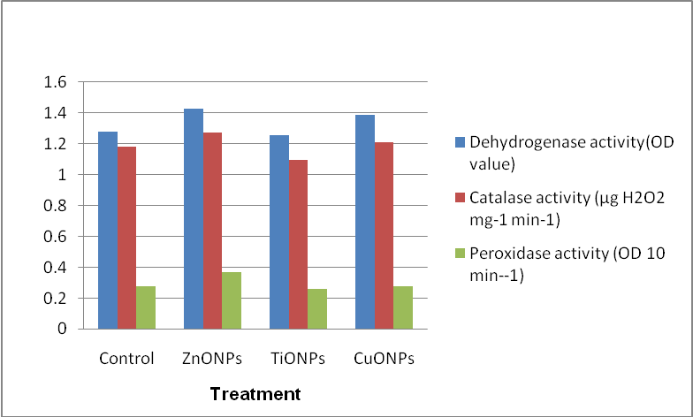
Figure 2. Effect of nano-particles on volatile emission
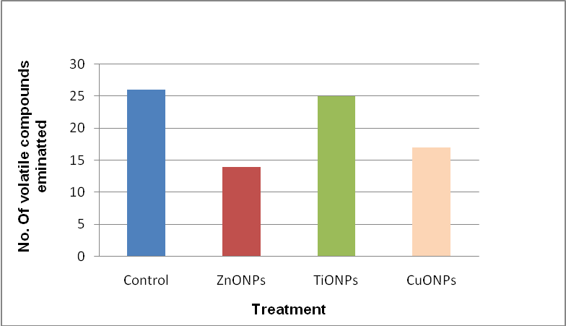
Figure 3. Effect of nano-particles on seed germintion 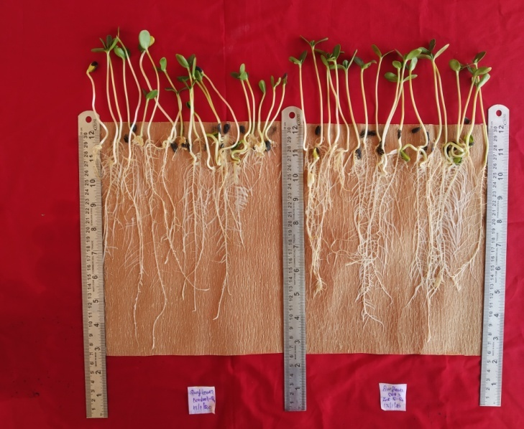
Control
ZnONPs Treated
Figure 4. SEM image of zinc oxide nano-particles (ZnONPs)
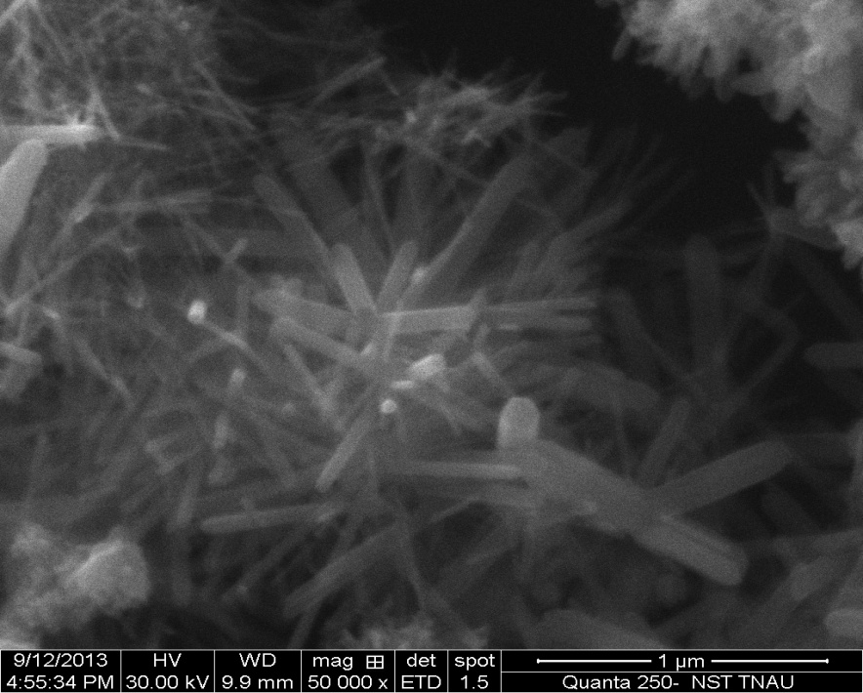
Table 1 Effect of nano-particles on germination (%) and vigor index of sunflower COH3 under natural ageing:
Treatment | Germination (%) |  |  |  |  |  |  | Mean A | Vigour index |  |  |  |  |  |  |  | MeanA
Treatment | Period of storage |  |  |  |  |  |  | Mean A | Period of storage |  |  |  |  |  |  |  | MeanA
Treatment | P0 | P1 | P2 | P3 | P4 | P5 | P6 |  | P0 |  | P1 | P2 | P3 | P4 | P5 | P6
Control | 97  (80.06) | 95  (77.61) | 94  (76.02) | 90  (72.33) | 89  (70.63) | 83  (65.66) | 80  (63.42) | 89  (72.25) |  | 3846 | 3732 | 3541 | 3199 | 2664 | 2537 | 2362 | 3126
ZnO1000mg | 97  (80.32) | 96  (78.59) | 94  (76.73) | 93  (74.81) | 91  (72.55) | 89  (70.63) | 85  (67.79) | 92  (74.49) |  | 3882 | 3952 | 3735 | 3517 | 2812 | 2759 | 2544 | 3314
TiO750mg | 97  (79.99) | 94  (76.16) | 92  (73.91) | 90  (71.55) | 88  (69.70) | 83  (65.64) | 81  (64.32) | 89  (71.61) |  | 3752 | 3541 | 3418 | 2930 | 2673 | 2430 | 2309 | 3008
CuO1250mg | 96  (79.60) | 95  (77.14) | 93  (74.65) | 91  (73.28) | 90  (71.64) | 86  (68.66) | 84  (66.39) | 91  (73.05) |  | 3866 | 3801 | 3663 | 2946 | 2733 | 2674 | 2473 | 3165
Mean B | 96  (79.99) | 95  (77.37) | 93  (75.33) | 91  (72.99) | 89  (71.13) | 85  (67.65) | 82  (65.48) |  |  | 3836 | 3756 | 3589 | 3148 | 2720 | 2600 | 2422
 | T |  |  | P |  |  | T×P |  | T |  |  |  | P |  |  | T×P
SEd | 0.442 |  |  | 0.585 |  |  | 1.170 |  | 16.765 |  |  |  | 22.179 |  |  | 44.357
CD | 0.881 |  |  | 1.165 |  |  | 2.331 |  | 33.400 |  |  |  | 44.184 |  |  | 88.368

Table 2 Effect of nano-particles on shoot length(cm) and root length(cm) of sunflower COH3 under natural ageing:
Treatment | Shoot length(cm) |  |  |  |  |  |  | Mean A | Root length(cm) |  |  |  |  |  |  | MeanA
Treatment | Period of storage |  |  |  |  |  |  | Mean A | Period of storage |  |  |  |  |  |  | MeanA
Treatment | P0 | P1 | P2 | P3 | P4 | P5 | P6 |  | P0 | P1 | P2 | P3 | P4 | P5 | P6
Control | 16.1 | 15.3 | 15.1 | 14.6 | 14.2 | 13.8 | 13.3 | 14.6 | 29.7 | 28.9 | 28.2 | 27.5 | 25.7 | 25.2 | 23.8 | 27.0
ZnO1000mg | 16.5 | 16.2 | 15.9 | 15.6 | 14.9 | 14.5 | 14.0 | 15.4 | 30.1 | 29.3 | 29.0 | 28.6 | 26.8 | 26.4 | 25.9 | 28.0
TiO750mg | 15.9 | 15.4 | 15.1 | 14.5 | 14.1 | 13.6 | 13.2 | 14.6 | 29.7 | 28.6 | 28.2 | 27.4 | 25.5 | 25.5 | 23.5 | 26.9
CuO1250mg | 16.3 | 15.8 | 15.6 | 14.9 | 14.5 | 14.0 | 13.8 | 15.0 | 30.0 | 29.0 | 28.8 | 27.9 | 26.4 | 26.0 | 24.9 | 27.5
Mean B | 16.2 | 15.7 | 15.4 | 14.9 | 14.4 | 13.9 | 13.6 |  | 29.9 | 28.9 | 28.5 | 27.8 | 26.1 | 25.7 | 24.5
 | T |  |  | P |  |  | T×P |  | T |  |  | P |  |  | T×P
SEd | 0.075 |  |  | 0.099 |  |  | 0.198 |  | 0.143 |  |  | 0.189 |  |  | 0.377
CD | 0.149 |  |  | 0.198 |  |  | 0.395 |  | 0.284 |  |  | 0.376 |  |  | 0.752

Table 3 Effect of nano-particles on dry matter production(g 10seedling⁻¹) and electrical conductivity of sunflower COH3 under natural ageing:
Treatment | Dry matter production(g 10seedling⁻¹) |  |  |  |  |  |  | Mean A | Electrical conductivity |  |  |  |  |  |  | MeanA
Treatment | Period of storage |  |  |  |  |  |  | Mean A | Period of storage |  |  |  |  |  |  | MeanA
Treatment | P0 | P1 | P2 | P3 | P4 | P5 | P6 |  | P0 | P1 | P2 | P3 | P4 | P5 | P6
Control | 0.537 | 0.413 | 0.368 | 0.352 | 0.292 | 0.285 | 0.261 | 0.358 | 0.594 | 0.631 | 0.698 | 0.744 | 0.896 | 0.988 | 1.175 | 0.818
ZnO1000mg | 0.584 | 0.460 | 0.395 | 0.354 | 0.328 | 0.309 | 0.300 | 0.390 | 0.530 | 0.628 | 0.661 | 0.702 | 0.831 | 0.927 | 1.003 | 0.755
TiO750  mg | 0.529 | 0.416 | 0.353 | 0.328 | 0.280 | 0.266 | 0.245 | 0.345 | 0.581 | 0.679 | 0.688 | 0.716 | 0.863 | 0.983 | 1.182 | 0.813
CuO1250mg | 0.542 | 0.435 | 0.379 | 0.350 | 0.320 | 0.300 | 0.284 | 0.373 | 0.562 | 0.641 | 0.673 | 0.721 | 0.875 | 0.945 | 1.163 | 0.797
Mean B | 0.548 | 0.431 | 0.374 | 0.346 | 0.305 | 0.290 | 0.273 |  | 0.567 | 0.645 | 0.680 | 0.721 | 0.866 | 0.961 | 1.131
 | T |  |  | P |  |  | T×P |  | T |  |  | P |  |  | T×P
SEd | 0.002 |  |  | 0.003 |  |  | 0.005 |  | 0.004 |  |  | 0.006 |  |  | 0.012
CD | 0.004 |  |  | 0.005 |  |  | 0.011 |  | 0.009 |  |  | 0.012 |  |  | 0.023

