RESEARCH ARTICLE
Auxin and Salicylic acid Nanoformulations for Mitigating Droughtstress in Tomato (Lycopersicon esculentum L.)

ABSTRACT
Tomato is adapted to a wide range of climatic conditions but most sensitive to water stress, especially at the flowering stage, causing drastic yield reduction. In the present study, a pot culture experiment was conducted to evaluate the efficacy of naphthalene acetic acid (NAA) and salicylic acid (SA) nanoformulations against drought effects in tomato during flowering stage. The drought was imposed at 50% flowering by withholding irrigation, and foliar application of nanoformulations was given when the reduction in soil moisture reaches 20 percent. The treatments include NAA (20 & 40 ppm), salicylic acid (50 & 100 ppm), and NAA (20 ppm) + Salicylic acid (50 ppm) as straight and nanoformulations along with a control. Observations done on first, second and third day after foliar application revealed a significant increase in chlorophyll index, relative water content, membrane stability index, and chlorophyll stability index due to the application of nanoformulation of NAA + Salicylic acid in the plants under drought. The results indicated the efficacy of nanoformulation of NAA + Salicylic acid in ameliorating the deteriorative effects of drought in tomato by improving the physiological traits compared to the application of the NAA and Salicylic acid as straight formulations.
Keywords: Tomato, Drought, Nanoformulations, NAA, Salicylic acid.

INTRODUCTION
Tomato is one of the most important commercial crops cultivated by small and medium-scale farmers. Tomato contains a rich source of vitamins, carotenoids, and phenolic compounds that are used for diet across the globe. The antioxidant compounds present in tomato fruits are used in anti- curative and anti-inflammatory properties . Tomato is cultivated in an area of 29.08 thousand hectares with a production of 887.08 thousand MT. The average productivity of tomato is about 30.51 MT ha⁻¹ . Abiotic stresses affect 70% of the world's staple food crop production. Drought is one of the major problems that affect crop growth, plant water relations, gas exchange parameters, metabolism, and yield. Tomato is adapted to a wide range of soil and climatic conditions. Tomato plants are most sensitive to water stress at the flowering stage, and flower and fruit drop is the major problem faced by the farmers under drought. The significant role of plant growth regulators in alleviating the ill effects of abiotic stresses has been established in many crops through a foliar application as straight formulations. Hayat et al. (2008) reported that the foliar application of salicylic acid showed a positive response in ameliorating drought in tomato. Salicylic acid has a significant role in the regulation of the number of flowers, early flower bud appearance, number of leaves, leaf chlorophyll content, and carotenoid content . Also, NAA plays major role in growth and development, number of seeds per pod, fruit set percent, number of branches, number of leaves, chlorophyll content, flower drop, and plant height, which result in increased yield and fruit quality . However, studies on the efficacy of nanoformulations of these plant growth regulators are very much limited. The research on understanding the alteration in the physiological and biochemical mechanisms of plants due to the application of plant growth regulators as nanoformulation under various abiotic stresses could pave the way for the establishment of an effective alternative approach to mitigate the stresses. With this background, a study was executed to assess the ameliorative potential of nanoformulated NAA and salicylic acid against drought deficit stressin tomato.

MATERIAL AND METHODS

Experimental setup
A pot culture experiment was carried out in the glass house of Department of Crop Physiology, Tamil Nadu Agricultural University (TNAU), Coimbatore (11°N latitude, 77°E longitude, and 426.7 MSL) to study the effect of auxin (NAA) and salicylic acid (SA) nanoformulations for mitigating drought stress. The tomato hybrid Sivam was used for this experiment. Twenty-one days old seedlings were transplanted in uniform size large pots filled with pot mixture composed of soil, sand, and compost in the ratio of 3:1:1. Nutrient management and plant protection were followed as per the Horticulture Crop Production Guide, TNAU, Coimbatore. The nanoformulations of SA and NAA were synthesized using 99 and 95 percent pure chemicals (Sigma- Aldrich), respectively, in the Department of Nano science and Technology, TNAU, Coimbatore.

Treatment details
The treatments applied in pot culture experiment were NAA nanoformulation - 20ppm (T1), Salicylic acid nanoformulation - 50ppm (T2), Naphthalene acetic acid - 20ppm + Salicylic acid - 50ppm nanoformulation (T3), Naphthalene acetic acid - 40ppm (T4), Salicylic acid - 100ppm (T5), irrigated control (T6) and drought control (T7). The drought was imposed at 50% flowering by withholding irrigation. The foliar application was made when soil moisture reduction reached 20 per cent. The physiological parameters were recorded at first (D1), second (D2), and third day (D3) after foliar spray.
The greenness in leaves in terms of chlorophyll index was measured using SPAD meter (model 502 of Minolta, Japan). The relative water content (RWC) was assessed as described by and expressed in per cent and calculated using the following formula - RWC (%) = [(Fresh weight – Dry weight) / (Turgid weight – Dry weight)] x 100.
Membrane stability index (MSI) determines the level of damage in the membrane caused during stress conditions. The leaf samples (250mg) were immersed in the test tube containing 10 mL double distilled water. The electrical conductivity was recorded after heating the test tubes in a water bath at two different sets of temperatures. One set of test tubes heated at 40 °C for 30 minutes (C1), and another set of test tubes heated at 100 °C for 10 minutes (C2). The level of membrane damage was expressed in per cent using the formula: MSI (%) = (1-C1/C2) X 100 .
Chlorophyll stability index (CSI) was assessed following . Two different sets of test tube (containing leaf samples) were taken: One set was taken as control, kept under room temperature, and other as treated one by keeping in a water bath at 55 °C for 30 mins. Leaf samples (0.25g) were homogenized using 80% acetone and centrifuged at 3000 rpm for 10 mins. The supernatant was collected and made up the volume to 25 mL. Absorbance was measured at the wavelength of 652 nm, and CSI was calculated using the following formula and expressed in percentage.
Total chlorophyll content (Treated)
Chlorophyll stability index (CSI %) = --------------------------------------------------------------- x 100
Total chlorophyll content (control)
Free proline was estimated by ninhydrin method by extracting 250mg leaf samples with sulphosalicylic acid. The supernatant was homogenized, and 2mL of orthophosphoric acid, glacial acetic acid and acid ninhydrin were added. 4 mL of toluene was added to the separating funnel after heating in a water bath at 60 °C for 1hr. The amount of proline was measured at an absorbance of 520 nm. The proline content was expressed in mg g⁻¹ of fresh weight.

Statistical analysis
The pot culture experiment was conducted following the Factorial Completely Randomized Block Design (FCRD) as described by with four replicates. The data were analyzed using SPSS 16.0 software packages. The treatment differences were analysed using LSD, critical difference at 5% level of probability, and standard error was calculated and denoted as (**), and non-significant values, and the values are presented in the relevant tables.

RESULTS AND DISCUSSION

Chlorophyll index
Chlorophyll is one of the major components present in the chloroplast that positively influence on photosynthetic rate. Chlorophyll content was reduced due to the oxidative damage caused by drought that resulted in photo-oxidation and chlorophyll degradation . In this study, the highestchlorophyll index was observed in irrigated control (T6), and the least was noticed in drought control (T7). Among the treatments, the combined application of NAA and SA nanoformulations (T3) showed maximum chlorophyll index (40.3 at D1, 38.7 at D2, 36.6 at D3) followed by T2 (38.3 at D1, 37.2 at D2, 35.9 at D3), and there was a decreasing trend of chlorophyll index observed across the days. Water stressed plants exhibited reduced chlorophyll content due to deprivation of crop relative water level . The increase in canopy temperature due to water deficit resulted in decreased SPAD value that resulted in the inhibition of photosynthesis under dry conditions compared to non-stressed plants . Khandaker et al. (2017) observed that NAA at 10 and 20 mg L-1 showed a significant increase in chlorophyll content in wax apple. The synthetic auxin NAA had a strong effect on chlorophyll that promoted the chlorophyll synthesis and increased the chlorophyll fluorescence . Similar results are reported by foliar application of salicylic acid in chilli , finger millet , and in blackgram . The significant difference was observed between the treatments, and the values are shown in Figure 1.

Leaf relative water content (RWC)
RWC is related to the water absorbed by roots and water lost through transpiration. RWC is increased during the early growth stages and declined gradually during the maturation. It was significantly increased in T3 (80.0 at D1, 77.1 at D2, 74.0 at D3) followed by T2 (79.1 at D1, 76.1 at D2, 72.7 at D3) and T1 (78.9 at D1, 73.8 at D2, 69.9 at D3) compared to T5 (77.5 at D1, 74.3 at D2, 71.3 at D3) and T4 (75.7 at D1, 72.5 at D2, 68.5 at D3). The lower f relative water content was observed in T7 (73.4 at D1, 69.5 at D2, 63.1 at D3) (Figure 2). Relative water content and canopy temperature influence the plant water relations that maintain the metabolic activity responsible for dehydration tolerance in plants. The plants under drought showed decreased leaf relative water content with increased drought intensity reported in lettuce , sunflower , and canola . Rao et al. (2012) reported that the foliar application of salicylic acid (100ppm) followed by L-tryptophan (15ppm) showed a significant increase in relative water content that results in stress tolerance in maize and conferred their defense role against stress condition. In the present investigation, also application of nanoformulations of NAA and SA exhibited better results under drought condition by maintaining the leaf water content in tomato. NAA @ 20 mg L⁻¹ induced the stomatal closure and improved the water balance in the plant system under field condition and foliar application of chitosan nanoemulsion in pearl millet enhanced the leaf water status of the plant by reducing the transpiration rate under drought condition .

Membrane stability index
The least membrane damage was recorded in T3 (67.6 at D1, 63.7 at D2, 59.0 at D3) followed by T2 (64.6 at D1, 60.9 at D2, 56.0 at D3) and T1 (60.6 at D1, 56.9 at D2, 52.5 at D3) compared to T5 (60.0 at D1, 54.0 at D2, 49.5 at D3) and T4 (58.5 at D1, 52.8 at D2, 47.7 at D3). Among the treatments, T7 was recorded with increased membrane damage (54.1 at D1, 48.8 at D2, 40.9 at D3), as given in Fig. 3. The membrane damage was least in T6 as the plants were given normal irrigation. The increasing trend of membrane damage was observed throughout the drought days. Among the days, D3 showed maximum membrane damage in treatment T7 followed by T4 and T5 compared to other treatments. Similar results were reported in wheat by the application of salicylic acid . Plant water relation was decreased due to the turgor loss that leads to the separation of the plasma membrane from the cell wall due to plasmolysis . The mechanical disruption of the cell wall component produces hydrolytic enzymes that result in membrane damage under drought condition . Almeselmani et al. (2012) reported that the membrane stability index was reduced in susceptible wheat varieties under drought conditions.

Chlorophyll stability index
The chlorophyll stability index showed a similar trend as observed in relative water content. The higher values were recorded in T3 followed by T2 and T1 compared to T5 and T4 (Table 1). Among the treatments, T7 was recorded with a lower chlorophyll stability index. The chlorophyll stability index showed a significant increase at the first day after foliar spray, and a decreasing trend was observed during the second and third days after foliar spray. Sairam (1994) observed decreased chlorophyll and chlorophyll stability index under drought and temperature stress conditions. Leaves exposed to drought and high temperature resulted in increased chlorophyllase activity that reduced the chlorophyll pigments. Alipoor and Moradi (2012) reported that the membrane stability index and chlorophyll stability index have a positive correlation with yield.

Proline content
Proline content showed significant increase due to increased activity of γ-glutamyl kinase and proline oxidase conferring the drought alleviation. In the present study T1, T2 and T3 resulted in maximum proline compared to T4, T5 and T7, and an increasing trend was observed during the first, second, and third days after foliar spray with increased drought intensity. Cell turgor is maintained by reduced osmotic potential due to the accumulation of proline, sucrose, glycine betaine in the cytoplasm that results in increased water uptake in plants. Among the solutes, proline is responsible for stress tolerance for maintaining the membrane integrity and reduced photo-oxidative damage in drought conditions . Stress tolerant cultivars showed increased proline accumulation than sensitive cultivars due to the dehydration tolerance in wheat plants .
Exogenous application of salicylic acid protects the plants by improving the defense mechanism under drought. Salicylic acid maintains cell turgor and membrane integrity, therefore enhances the ameliorative effects on relative water content and membrane stability index showing a significant increase in proline content under drought in onion . It is observed that the application of SA increased proline production, which results in the capability of plants to survive under drought. The osmolyte accumulation permits the water uptake and thereby reducing the effects of water shortage in plants . In the present study, the application of nanoformulations enhanced the proline accumulation and facilitated for drought tolerance in tomato (Table 2).

Tables
Table 1. Effect of foliar application of NAA and SA nanoformulations on chlorophyll stability index (CSI %)
Treatments | Day(s) after foliar spray (DAF) |  |  | Mean
 | 1 | 2 | 3
T1 - NAA nanoformulation @ 20ppm | 69.5 | 64.7 | 58.6 | 64.3
T2 - SA nanoformulation @ 50ppm | 71.5 | 66.9 | 63.1 | 67.2
T3 - NAA nanoformulation @ 20ppm + SA  nanoformulation @ 50ppm | 72.6 | 68.0 | 65.6 | 68.7
T4 - NAA @ 40ppm | 65.1 | 62.4 | 60.2 | 62.6
T5 - SA @ 100ppm | 68.1 | 63.1 | 62.4 | 64.5
T6 - Irrigated control | 76.3 | 73.8 | 74.4 | 74.8
T7 - Drought control | 62.5 | 54.0 | 47.9 | 54.8
Mean | 69.4 | 64.7 | 61.7 | 65.3
 | T | D |  | T*D
S. Ed | 0.756 | 0.495 | 1.310
CD (P ≤ 0.05) | 1.5** | 0.9** | 2.6**

** and NS denotes significance at 5% probability level and non-significant respectively

Table 2. Effect of foliar application of NAA and SA nanoformulations on leaf proline content (mg g⁻¹)
in tomato
Treatments | Days after foliar spray (DAF) |  |  | Mean
 | 1 | 2 | 3
T1 - NAA nanoformulation @ 20ppm | 0.44 | 0.65 | 1.00 | 0.70
T2 - SA nanoformulation @ 50ppm | 0.48 | 0.67 | 1.05 | 0.73
T3 - NAA nanoformulation @ 20ppm + SA  nanoformulation @ 50ppm | 0.51 | 0.70 | 1.10 | 0.77
T4 - NAA @ 40ppm | 0.39 | 0.61 | 0.94 | 0.65
T5 - SA @ 100ppm | 0.41 | 0.64 | 1.03 | 0.69
T6 - Irrigated control | 0.18 | 0.21 | 0.23 | 0.21
T7 - Drought control | 0.38 | 0.59 | 0.96 | 0.64
Mean | 0.40 | 0.58 | 0.90 | 0.63
 | T | D |  | T*D
S. Ed | 0.018 | 0.012 | 0.032
CD (P ≤ 0.05) | 0.03** | 0.02* | 0.06**

** and NS denotes significance at 5% probability level and non-significant respectively

Figures and Structures
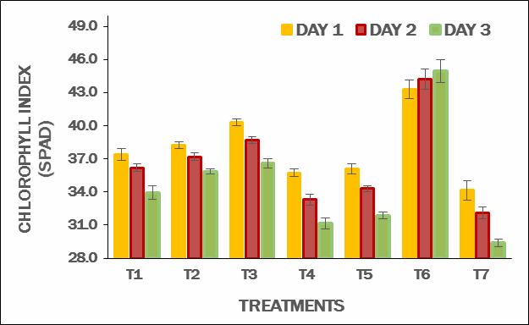
T1 - NAA nanoformulation @ 20ppm; T2 - SA nanoformulation @ 50ppm; T3 - NAA nanoformulation @ 20ppm
+ SA nanoformulation @ 50ppm; T4 - NAA @ 40ppm; T5 - SA @ 100ppm; T6 - absolute control; T7 - drought control.
(The data is expressed as mean ± SE. The treatment shows significant difference at 5% probability level).

Figure 1. Effect of foliar application of NAA and SA nanoformulations on chlorophyll index in tomato under drought condition.
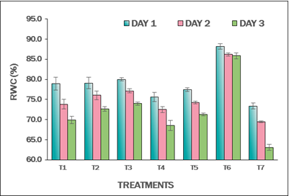
T1 - NAA nanoformulation @ 20ppm; T2 - SA nanoformulation @ 50ppm; T3 - NAA nanoformulation @ 20ppm
+ SA nanoformulation @ 50ppm; T4 - NAA @ 40ppm; T5 - SA @ 100ppm; T6 - absolute control; T7 - drought control.
(The data is expressed as mean ± SE. The treatments show significant difference at 5% probability level)
Figure 2. Effect of foliar application of auxin and salicylic acid nanoformulations on relative water content (RWC) in tomato under drought condition.
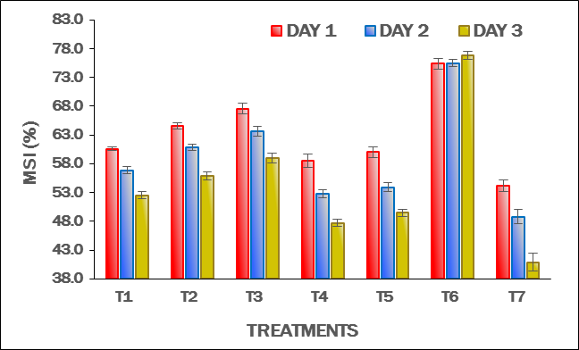
T1 - NAA nanoformulation @ 20ppm; T2 - SA nanoformulation @ 50ppm; T3 - NAA nanoformulation @ 20ppm
+ SA nanoformulation @ 50ppm; T4 - NAA @ 40ppm; T5 - SA @ 100ppm; T6 - absolute control; T7 - drought control.
(The data is expressed as mean ± SE. The treatments show significant difference at 5% probability level).

Figure 3. Effect of foliar application of auxin and salicylic acid nanoformulations on membrane stability index (MSI) in tomato under drought condition.

CONCLUSION
Combined application of salicylic acid and NAA as nanoformulation resulted higher chlorophyll index, relative water content, membrane integrity, chlorophyll stability index, and proline content under drought condition. The findings suggested that the application of PGRs as nanoformulations could increase the efficiency of foliar application. Further, synthesized SA and NAA nanoformulation showed positive results in alleviating the effects of drought stress in tomato compared to the application of straight formulations of SA and NAA. Hence, it is concluded that the foliar application of NAA + SA nanoformulation significantly performed better in ameliorating drought stress in tomato, which was exhibited in terms of better physiological, and biochemical traits.

REFERENCESx

